To amend your OSR submission in the Data Portal as a Submission Uploader, once it has been returned to you by the AIHW:
Amend your OSR Submission based on AIHW Feedback (Submission Uploader)
- Open the Data Portal through Health Data Portal.
- Log in using the information provided in the Register for and Log in to the Health Data Portal QRG.
The Data Portal home screen will display with the Reporting Dashboard open.
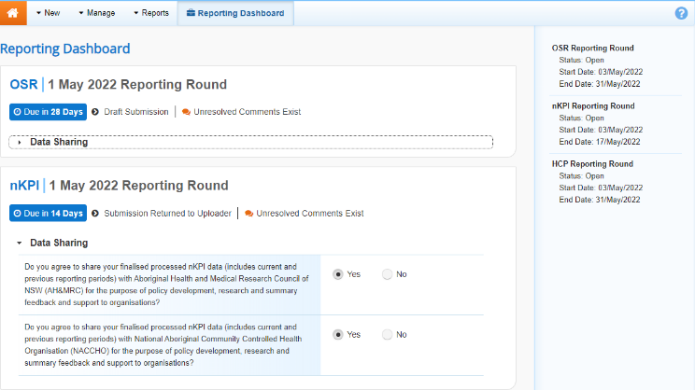
- To open your OSR form, hover your mouse pointer to the right of the OSR reporting round text in the Reporting Dashboard and select .
The OSR form will display.
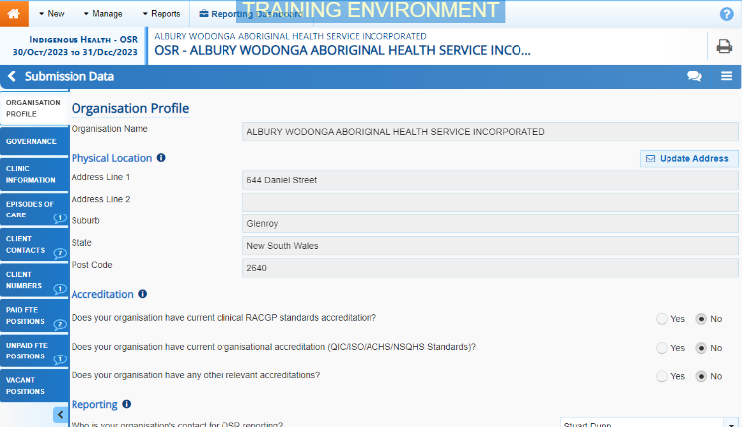
Any sections containing AIHW comments that need responding to will display a on the corresponding tab. The Notifications Tray will display as open for each of these sections in the top right-hand corner of the form, so you can see the detail of the comments the AIHW has made.
- For each section with data validation flags , review the comments made by the AIHW in the Notifications Tray.
- If a value needs to be changed to address the comment made by the AIHW, update the value(s) in the required cell(s).
If you are unsure which value(s) needs to be updated, in the Notifications Tray, select for the applicable data validation flag and the applicable cell(s) will be highlighted in red.
To add a comment about the unresolved data validation issues instead of amending the values, see the Work with Comments QRG for more information.
- To exit your OSR form and return to the Data Portal home screen, scroll to the bottom of the form, and select .
The Data Portal home screen will again display with the Reporting Dashboard open.
- To progress your OSR submission, select .
- In the Change Data Asset Status dialog box, select the in the Action field and select the action needed.
The available actions are:
- Request Review – Select this action to send your OSR submission to the internal Submission Reviewer for review again.
- Request Approval – Select this action to send your OSR submission back to your CEO or their representative for approval.
If you can approve your OSR submission yourself, you will also see the Approve for Submission option in the action list. This allows you to approve the submission and submit it directly to the AIHW for processing again.
- In the Comment field, enter any comments about the action being performed on the submission.
- One of the following buttons can now be selected when submitting your OSR, depending on the action you have selected:
  - To send your OSR submission to the Submission Reviewer for review again, select . See the Review your OSR Submission based on AIHW Feedback QRG for the next step in the process.
  - To send your OSR submission back to your CEO or their representative for approval, select .See the Approve an OSR Submission based on AIHW Feedback QRG for the next step in the process.
Amend your OSR Submission based on DSS Feedback (Submission Uploader)
Your OSR submission has now been amended and either sent back to your Submission Reviewer for further review or sent straight on to your CEO or their representative for approval.
An automated email will be sent to all users within your health service that have been assigned the applicable role in the Data Portal (Submission Reviewer or Submission Approver) notifying them the OSR submission has been sent to them again for action.

