Initiate Exception Reporting (the AIHW)
Step 1 – Set the submission’s status to Ready for Processing
To update the status of the submission in the Data Portal:
- Open the Data Portal through Health Data Portal.
- Log in using the information provided in the Register for and Log in to the Health Data Portal QRG.
The Data Portal home screen will display.
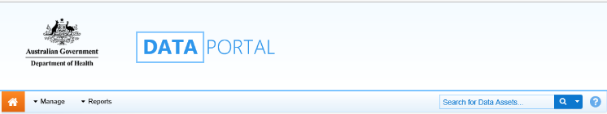
- From the Data Portal home screen, search for the submission to be amended.
For more information on how to search for a submission, see the Get Started in the Health Data Portal QRG.
To be eligible for processing, the submission’s status needs to be Submission Approved.
- In the Data Assets section of the Data Portal home screen, select the submission to be reviewed.
The Data Asset Details screen will display.
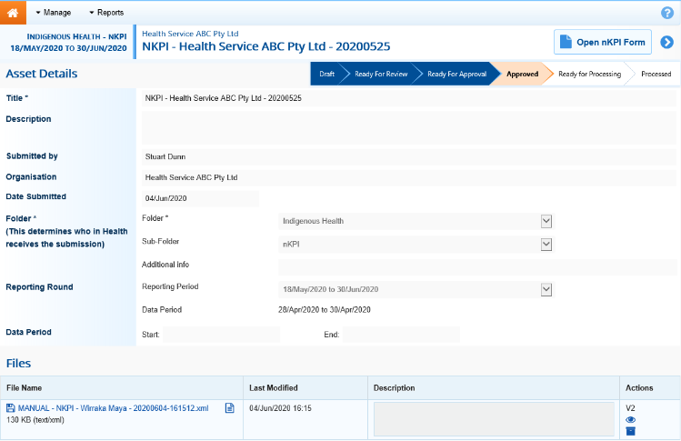
- Review the details of the submission as needed.
- To review the contents of the attached form to ensure it is the one you need to add comments to, select either or at the top of the screen.
- Once finished, select at the bottom of the form to exit the form and return to the Data Asset Details screen.
- Once the submission has been reviewed as needed, select either or the workflow progress bar and, in the Change Data Asset Status dialog box, in the Action field, select and select Ready for Processing to move the submission to the next step of the process.
If the health service has asked you to return the submission as it has been submitted in error, select Return to Uploader.
- In the Comment field, enter any comments about the action being performed on the submission.
- To set the submission to Ready for Processing, select .
The submission’s status will change to Ready for Processing, and you can now start the exception reporting process by adding comments to the form and returning the submission to the health service for amendment.
Step 2 – Add comments to the submission and return it to the Health Service for amendment
To add comments to a submission in the Data Portal:
- Ensure the Data Portal home screen is displayed.
- From the Data Portal home screen, search for the submission to be amended.
For more information on how to search for a submission, see the Get Started in the Health Data Portal QRG.
- Select the submission to be reviewed.
The Data Asset Details screen will display.
- To open the attached form, select either or at the top of the screen.
The applicable form (with the health service’s name at the top of the screen) will display containing the health service’s data, and any indicators/sections still containing data validation flags will show a on the corresponding tab.
You can now add comments about any data issues for each applicable indicator/section in the form and what needs to be done by the health service to resolve each issue.
Initiate Exception Reporting (the AIHW)
- To add a comment about a particular data value, in the Notifications Tray, hover your mouse pointer to the right of the applicable data validation flag title and select .
- In the Reason field that displays, select and select the reason the comment is being added. The options are Zero data, Excluded results, Change in values identified, Reporting issue, Validation issue identified by AIHW and Other.
- In the Additional Information field, enter the detail of the issue that has been identified and what needs to be done to resolve it.
- To save the comment, select .
- Repeat this process for any other values and indicators in the form you feel need to be amended or investigated further by the health service.
- To exit the form and return to the Data Asset Details screen, scroll to the bottom of the form, and select .
- To action the submission, select either or the workflow progress bar and, in the Change Data Asset Status dialog box, in the Action field, select and select Return to Uploader.
- In the Revision Due Date field that appears, select the new date the submission is due to be resubmitted to you for processing. This date will default to two weeks from today but can be changed if needed.
- In the Comment field, enter any comments about the action being performed on the submission.
- To send the submission back to the health service for amendment, select .

The submission’s status will change to Submission Returned to Uploader and the health service will now need to address the comments you have made in the form before sending the submission back through the submission approval process.
For more information, see the applicable Amend a Submission as Part of Exception Reporting (Health Service) QRG.

