Once a reporting round is complete, each health service will be able to access their National KPI Summary Presentaion, National KPI Health Service Results Over Time Presentation and National KPI Executive Summary Presentation for that reporting round directly through the Health Data Portal. Once a health service user accesses their presentations, they can save/print/share them as needed.
Access your Published nKPI Summary Reports

To be able to access your nKPI published reports, you need to have been assigned the Published Report Viewer role by your health service’s User Administrator. If you don’t have the Reports > Published reports option available, please contact your User Administrator so they can assign you the role. Please note as well that you will only have access to the reports that are published AFTER you have been given access, you will not be able to see previous reports.
To access your published nKPI reports through the Data Portal:
- From the Data Portal home screen, select Reports > Published Reports.
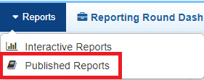
The Qlik NewsStand will display, showing your published reports for the most recent reporting round.
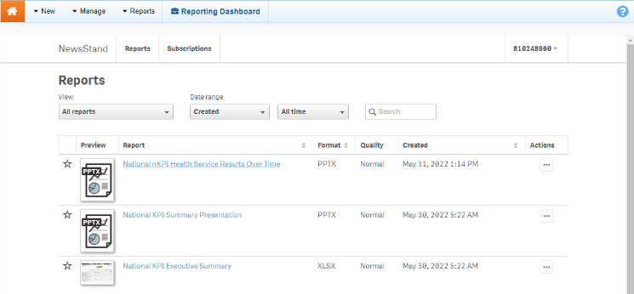
You will only ever see your reports for the most recently completed reporting round, you won’t see a list of historical reports. This means you should download and save each report as it becomes available so you have ongoing access to each report.

The National KPI Health Service Results Over Time presentation
The National KPI Health Services Results Over Time report is a PowerPoint presentation containing each of the graphs from your detailed individual indicator sheets in the Qlik Health Service nKPI and OSR Report, from the most recently completed collection period, back to December 2014.
To download your National KPI Health Service Results over Time Presentation:
- Select the National KPI Health Service Results Over Time link in the Report column.
will appear in the top-right hand corner of the web browser and the National KPI Health Service Results Over Time Presentation will begin to download. Once the download has completed, the will change to .
- To download the presentation, select and select the zip file from the list that displays.
The .zip file containing your presentation will open.
- Double-click on the PowerPoint presentation contained within the .zip file to open it.
The PowerPoint presentation containing your National KPI Health Service Results Over Time report will open.
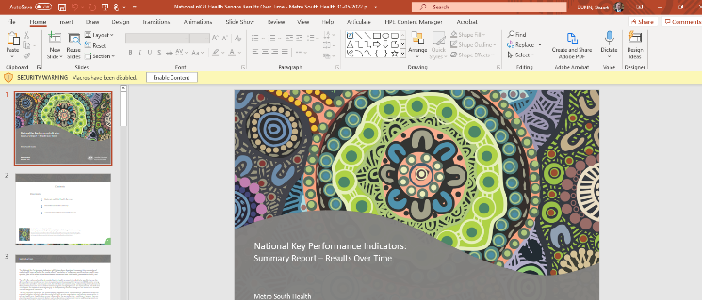
- You can now view/save/print the presentation as needed.
- To exit the presentation, simply close PowerPoint.

The National KPI Summary presentation
Access your Published nKPI Summary Reports

The National KPI Summary Presentation is a PowerPoint presentation containing each of the graphs from your summary sheets in the Qlik Health Service nKPI and OSR Report for the most recent reporting round.
To download your National KPI Summary Presentation:
- Select the National KPI Summary Presentation link in the Report column.
will appear in the top-right hand corner of the web browser and the National KPI Summary Presentation will begin to download. Once the download has completed, the will change to .
- To download the presentation, select and select the zip file from the list that displays.
The .zip file containing your presentation will open.
- Now double-click on the PowerPoint presentation contained within the .zip file to open it.
The PowerPoint presentation containing your nKPI Summary Report will open.
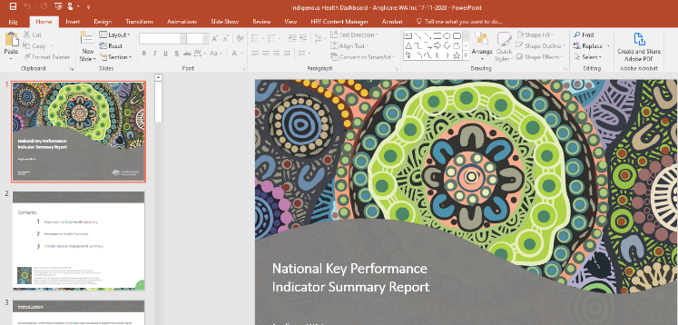
- You can now view/save/print the presentation as needed.
- To exit the presentation, simply close PowerPoint.

The National KPI Executive Summary
Your National KPI Executive Summary is a Microsoft Excel spreadsheet containing your health service’s results, for each indicator, for the current collection period and the previous two periods. It also contains the results for the comparison groups contained within the Qlik Health Service nKPI and OSR Report nKPI Summary sheets.
To download your National KPI Executive Summary:
- Select the National KPI Executive Summary link in the Report column.
A Download window will display.
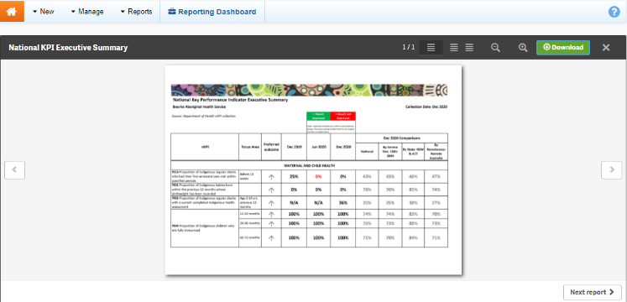
- To download your Executive Summary, select .
A Download window will display in the bottom left-hand corner of the screen and your nKPI Executive Summary will begin to download.
- Once the download has completed, select the arrow in the Download window and select Open.
The nKPI Executive Summary spreadsheet will display.
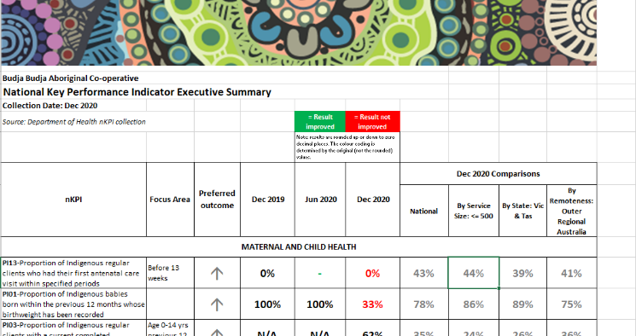
You can now view/save/print the report as needed.
- To exit the report, simply close Microsoft Excel.

