To assign roles and folders to a Child organisation user profile in the Data Portal:
Assign Roles and Folders to Users in a Child Organisation (User Administrator)
- Open the Data Portal through Health Data Portal.
- Log in using the information provided in the Register for and Log in to the Health Data Portal QRG.
The Data Portal home screen will display.
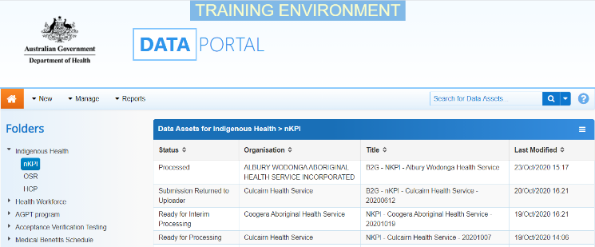
- From the Data Portal home screen, select and then select Users from the list that displays.
The Manage Users screen will display.
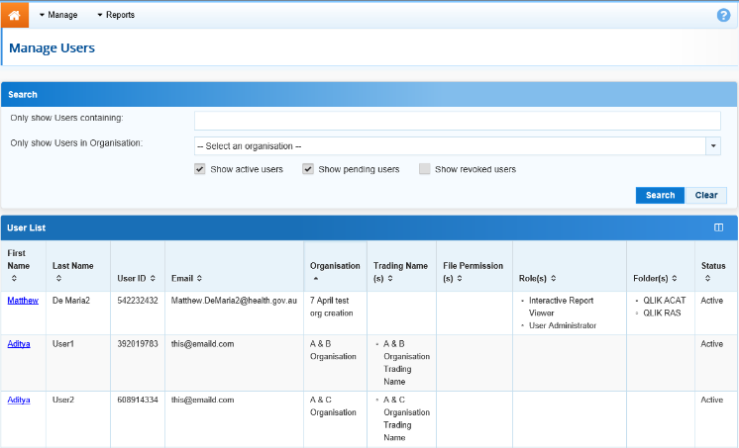
- To search for the user whose profile you wish to update, enter the user’s name in the Only show Users containing field.
- In the Only show Users in Organisation field, select and select the user’s Child organisation from the list.
- Once you have entered the required search criteria, select .
A list of matching users will display.
- To display the details for the selected user, select the first name link for the user.
The User Details screen will display.
- To open the user’s profile for editing, select at the top of the screen.
The User Details screen will update so the user’s profile can be edited.
- In the Roles section, select or deselect the relevant check box to add or remove a role to/from the user’s profile.
- In the File Permissions section, select .
- In the File Permissions dialog box, select the file permissions to be added to the user’s profile from the Available section and select .
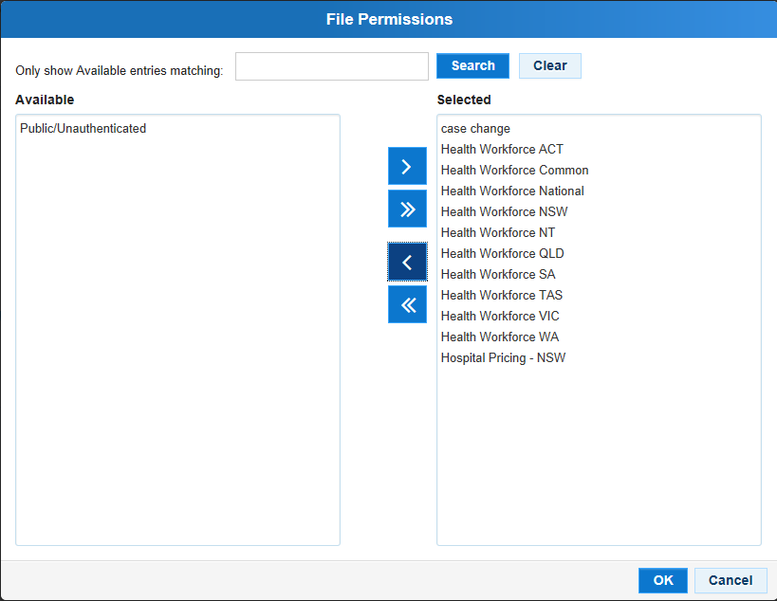
File permissions determine the published data assets a user will be able to see in the Data Portal.
- To continue, select .
- In the Folders section, select .
- In the Available section of the Folders dialog box, select the check boxes for the folders to be added to the user’s profile and select .
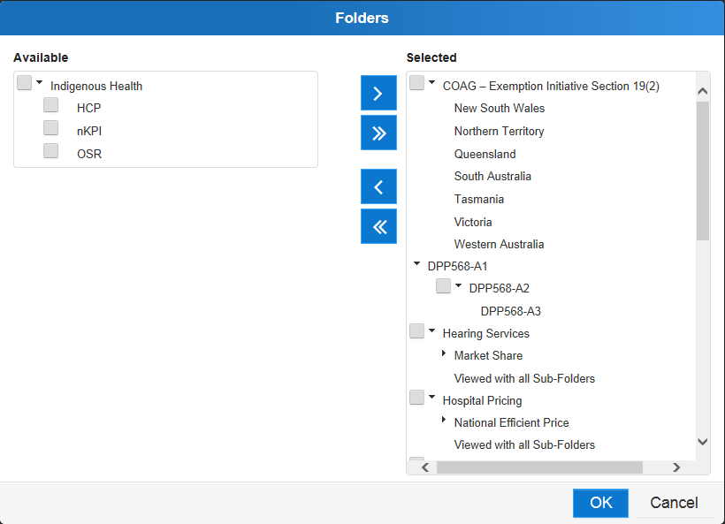
Where relevant, it is important to select both the top-level folder and at least one sub-level folder underneath for the user to be able to perform the required functions.
Assign Roles and Folders to Users in a Child Organisation (User Administrator)
Folders determine the data assets the user will be able to view and/or edit as the data assets go through the submission workflow process.
- To continue, select .
- To save the changes to the user’s profile, select .
- In the Save Changes dialog box, select .
You have now successfully added roles and folders to the user profile of a user in a Child organisation.

