Overview
The COVID De-identified indigenous App

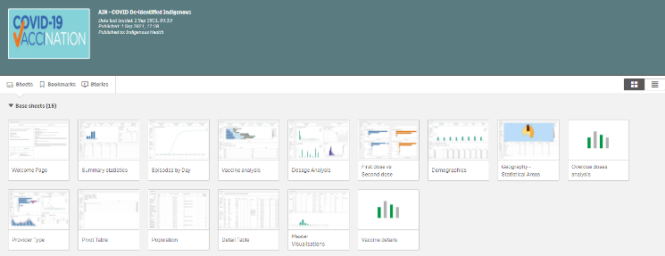
The COVID De-identified indigenous QLIK app contains 15 sheets that Health Services, NACCHO, state peak bodies and DSS Funding Agreement Managers (FAMs) can use to analyse data around the delivery of COVID-19 vaccinations amongst indigenous Australians. The data contained within the app is generally updated within five days of a particular vaccination episode being administered.
By default, total population is displayed in all sheets. To show only COVID19 vaccination data for people who registered as Indigenous, select Y in the Indigenous filter field in any of the sheets. You can then leave this filter applied as you move through the different sheets in the app, to continue to see data only for the Indigenous population.
Welcome Page
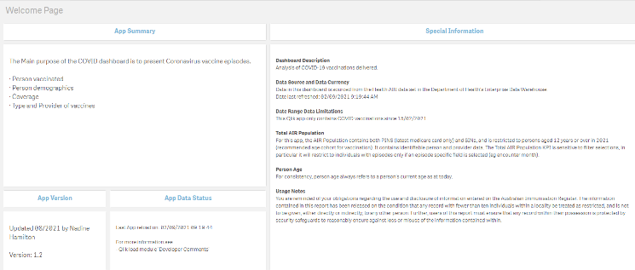
The Welcome Page provides overview information about the app, such as the kind of information it contains, where the information comes from and when the app was last updated. It also contains information on your obligations regarding the data contained within the app, under Usage Notes.
Data contained within the COVID De-identified indigenous QLIK app are for internal use only and not be reported publicly.

Summary statistics sheet
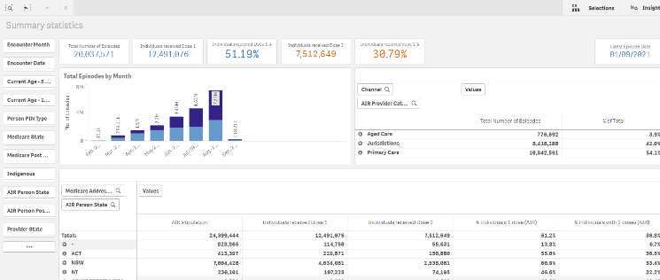
The Summary statistics sheet provides an overview of the vaccination process, with the Total Episodes per Month graph showing the number of vaccinations administered, per month, by vaccine type.
The Channel table summarises the vaccination episodes by channel, broken down by Aged Care, Jurisdictions and Primary Care.
The Address table summarises the vaccination episodes by channel, broken down by both Medicare Address state and Australian Immunisation Register (AIR) Person state.
Medicare Address State is the preferred option as it is used in NACCHO’s national reporting.
Episodes by Day sheet
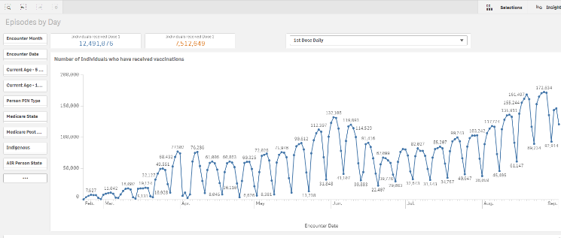
The Episodes by Day sheet details the number of vaccinations administered by day during the rollout.
It can be filtered by 1st and 2nd dose if needed using the filter field at the top of the sheet. You can select a range of dates in this graph, for example, if you have run a vaccination campaign and wish to see the impact this has had on vaccination numbers during the applicable period.

Vaccine analysis sheet
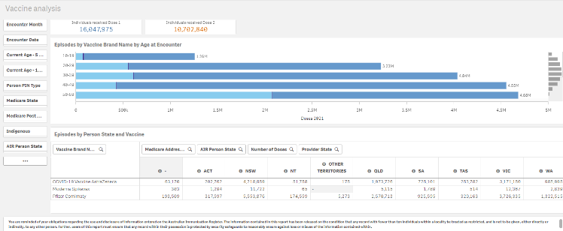
The Vaccine analysis sheet looks at the number of individuals, by age group, that have received the vaccine, broken down by Pfizer and Astra Zeneca.
This information is shown in both graphical and tabular format.
Dosage Analysis sheet
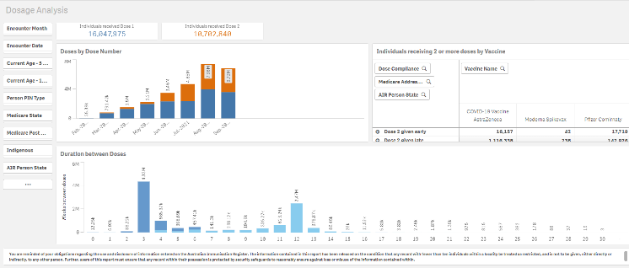
The COVID De-identified indigenous App

The Dosage Analysis sheet looks at the number of first and second doses administered each month during the rollout, in the Doses by Dose Number graph.
The Individuals receiving 2 or more doses by Vaccine table shows all fully immunised individuals, by state, given their 2nd dose early late or on time. The definitions of early, late and on time are based on the intervals described in the Vaccine Details sheet.
The Duration between Doses graph then looks at the number of weeks between doses and how many people waited for each period in the Duration between Doses graph.
First dose v Second dose sheet
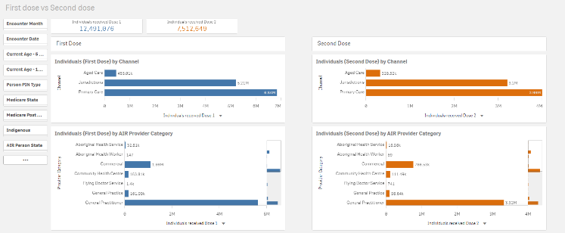
The First dose v second dose sheet focusses on the channels (aged care, jurisdictions, primary care) through which individuals have received their first and second doses. It then drills down into more detail regarding who administered the vaccinations (e.g General Practitioners, Community Health Centres).
Demographics
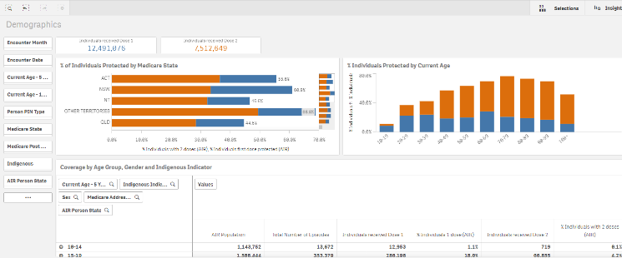
The Demographics sheet shows the percentage of individuals vaccinated by state and dose, in the % of Individuals Protected by Medicare State graph.
The % Individuals Protected by Current Age graph shows these percentages by age group and dose.
Finally, it contains a table that can be exported to Excel for use as required.
Geography – Statistical Areas
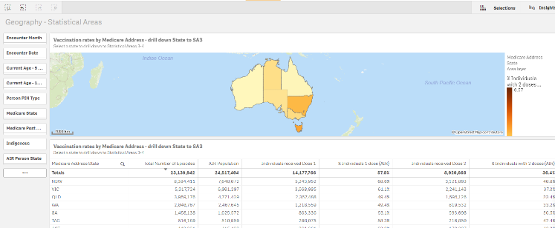
The Vaccination Rates by Medicare Address map shows the percentage of people, by state, that have received either one or two doses of the COVID19 vaccine.
By selecting a particular state in this map, you can see a breakdown of dose numbers and percentages by region in the Vaccination Rates by Medicare Address table at the bottom of the sheet.

Overdue doses analysis sheet
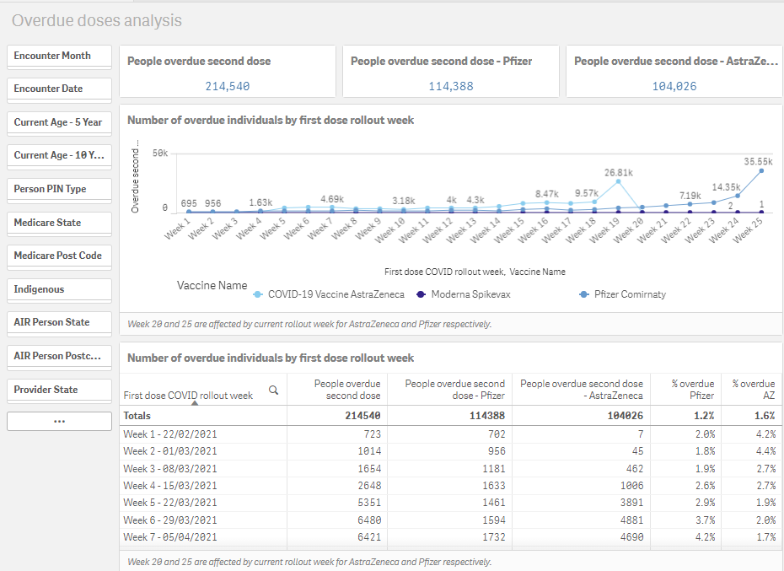
The Overdue doses analysis sheet starts by listing the number of people who are overdue to receive their second dose, broken down by vaccine type, at the top of the sheet.
It then breaks these overdue doses down by the week of the vaccine rollout the individuals received their first dose, by vaccine type.
The Number of overdue individuals by first dose rollout week table then provides this information in a table, with the addition of a percentage column.
Provider Type sheet
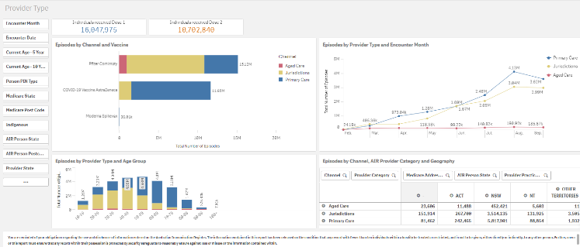
The Provider Type sheet allows you to analyse in more detail the number of vaccines distributed by vaccine type (Pfizer, Astra Zeneca and Moderna) and provider type (Aged Care providers, Primary Care or Jurisdictions).
The first section of the sheet shows the number of individuals across Australia who have received one dose and the number of individuals that have received two doses.
The Episodes by Channel and Vaccine graph shows the number of vaccines administered nationally by vaccine type. In addition, the graph shows the number of vaccines administered through Aged Care providers, Primary Care or Jurisdictions.
The Episodes by Provider Type and Age Group graph allows you to see the number of vaccinations administered nationally by age group and provider type (Aged Care providers, Primary Care or Jurisdictions).
The Episodes by Provider Type and Encounter Month line graph shows the number of vaccinations administered by month and provider type.
The Episodes by Channel, AIR Provider Category and Geography then presents you with a table, by provider type and state, that you can download into Microsoft Excel as needed.
Pivot Table
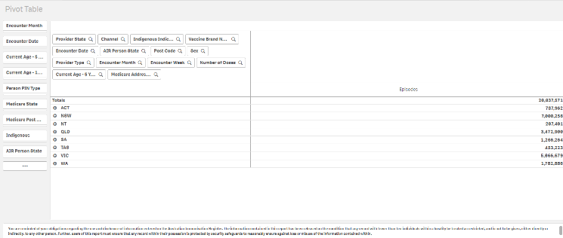
The Pivot Table sheet allows you to export vaccination data into a Microsoft Excel pivot table for filtering and analysis as required.
By default, the Pivot Table will show Episodes by State. You can then break this information down further by choosing the element you wish to break the information down by. To do this, drag the selected filter option on the left-hand side of the sheet to the right-hand side of the sheet.
The Pivot Table will now update to display the data broken down by your selected element. To break the information down further if needed, select the next element to be included and drag it across to the right-hand side of the sheet. Repeat this process for each element you wish to add to the table.
Population
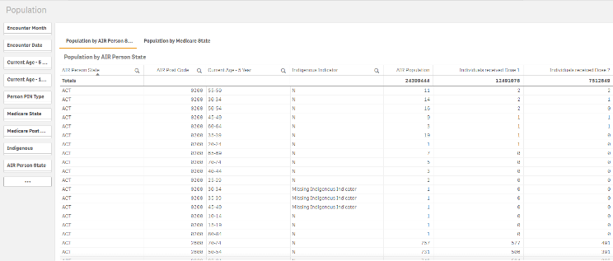
The COVID De-identified indigenous App

The Population table allows you to see the number of people by state (both AIR and Medicare) age group and indigenous indicator that have received the vaccine and whether they have received one or two doses.
Detail table
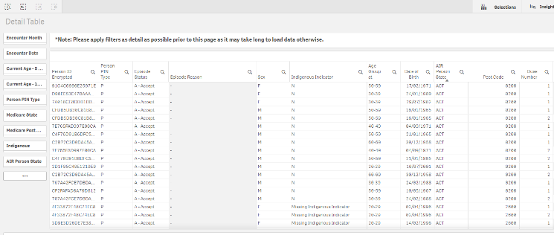
The Detail Table lists, by encrypted person ID, the details of every individual that has received a COVID19 vaccination. Some of the details listed include gender, indigenous indicator, age and state. The data in the table can be filtered by these characteristics but can also be filtered by the month the vaccination was administered and the type of provider that administered the vaccine.
Master Visualisations
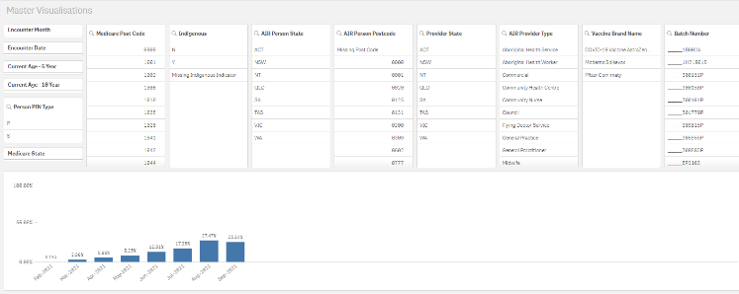
The Master Visualisations sheet contains a graph that shows the percentage of total vaccinations that have been administered, by month, from February to September 2021.
The results in this graph can then be filtered as needed by the following:
- Encounter Month
- Encounter Date
- Current Age – 5 year
- Current Age – 10 year
- Indigenous Status
- AIR Person State
- AIR Person Postcode
- Provider State
- AIR Provider type
- Vaccine Brand Name
- Batch Number
Vaccine Details
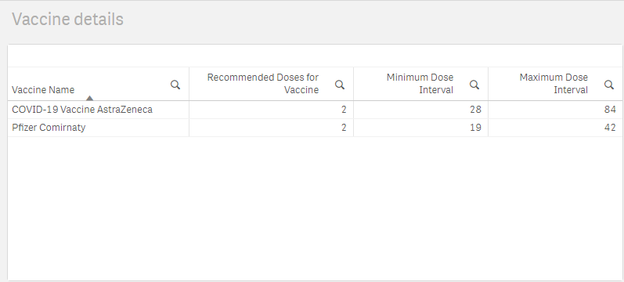
The Vaccine Details sheet shows some basic summary information regarding the two types of COVID19 vaccines being distributed, the number of doses required of both for a recipient to be considered fully vaccinated and the minimum and maximum number of days a patient needs to wait in between doses.
Export Data from the App
The COVID De-identified indigenous App

If needed, you can export data from any graph or table in the COVID De-identified indigenous QLIK app using the short cut menu.
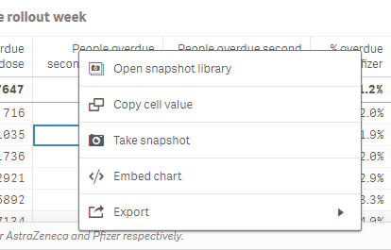
- Right click on the graph or table you wish to export.
- From the shortcut menu that displays, select Export.
- To export the graph as an image, select Export as an image.
- To export the graph or table straight into a PDF document, select Export as PDF.
- To export the data table to Excel, select Export as data. Them select the link that displays to download your Excel spreadsheet for use as needed.

Available Filters
The COVID De-identified indigenous App

There are several filter fields that display on each of the sheets in the COVID De-identified indigenous app. These filter fields can be used at any stage to filter the data contained in each of the sheets as needed.
The following are the filters available on most of the sheets in the app:
- Encounter Month – Allows you to filter the vaccination infromation by month, from February to August 2021
- Encounter Date – Allows you to filter vaccinations by specific dates if needed
- Current Age – 5 year – Allows you to filter sheets to see vaccination numbers and/or percentages by age groups
- Current Age – 10 year - Allows you to filter sheets to see vaccination numbers and/or percentages by age groups
- Person PIN Type – Allows you to flter the results on each sheet by Personal Identifer Number type (options are P – Primary and S - Supplementary)
- Medicare state – Allows you to filter the vaccination results by Medicare state. The state refers to the patient’s address
- Medicare Post Code - Allows you to filter the vaccination results by Medicare postcode. This allows you to select all the post codes covered by your Health Serice if needed
- Indigenous – Allows you to filter the results in the selected sheet by Indigenous identifier (the options are Yes, No and Missing Indigenous Indicator)
- AIR Person State - Allows you to filter the vaccination results by AIR state. The state refers to the patient’s address
- AIR Person Postcode - Allows you to filter the vaccination results by AIR postcode
- Provider State - Allows you to filter the vaccination results by provider state
- AIR Provider Type - Allows you to filter the vaccination results by provider type (e.g. Council, General Practitioner, Pharmacy)
- Vaccine Brand Name – Allows you to filter your results on each of the sheets by vaccine brand name (the options are Pfizer and Astra Zeneca)
- Batch Number – Allows you to filter your results on each sheet by batch number.
Data Caveats
There are some considerations that need to be taken into account when using the COVID De-identified Indigenous app to analyse vaccination data. These are:
- Indigenous status is based on self-reported data
- The AIR population is all persons recorded on the Australian Immunisation Register (which at an aggregate level will be higher than Estimated Residential Population from the ABS for the general population). For Aboriginal and Torres Strait Islander peoples, the AIR population is about 10% lower than the ERP in each jurisdiction.
- Generally, any numbers in cells smaller than 10 are suppressed in reporting, and for external publishing this may be increased to anything less than 20. This is to avoid the potential risk of persons being re-identified.
- A person’s address is derived from their geo-coded Medicare Address. This has resulted in around 25,000 ‘unknowns’ which disproportionately impacts remote areas.
- The coverage % displayed is based on the AIR population 12 & over for Aboriginal and Torres Strait Islander peoples.

