Once a data asset is drafted for publication, it can be sent for review prior to approval if needed. The publication can be reviewed in the Data Portal by anyone within Health with the Publication Reviewer role.
To review a draft publication in the Data Portal:
- Open the Data Portal through Health Data Portal.
- Log in using the information provided in the Registering for and Logging in to the Health Data Portal QRG.
The Data Portal home screen will display.
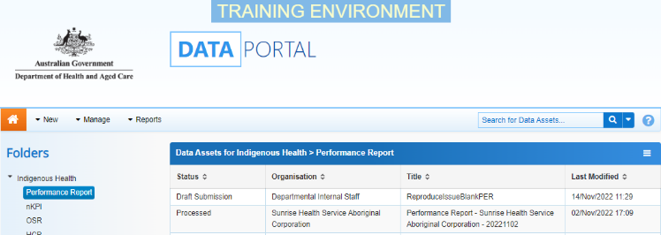
- From the Data Portal home screen, search for the data asset to be reviewed.
For more information on how to search for a data asset, see the Get Started in the Health Data Portal QRG.
To be eligible for review, the data asset’s status will need to be Ready for Review.
- Select the data asset to be reviewed.
The Data Asset Details screen will display.
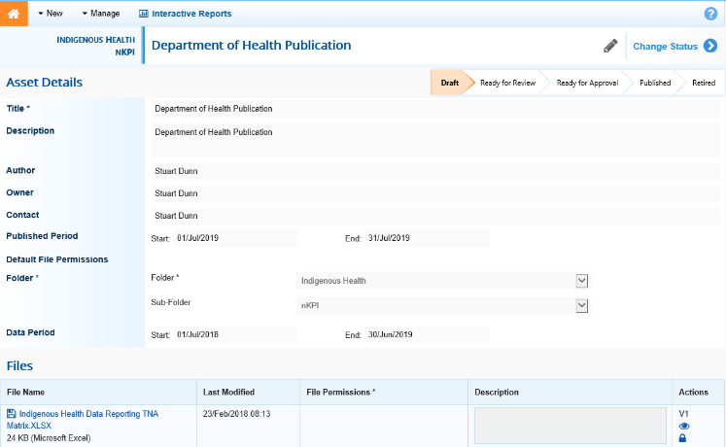
- To update the details of the data asset, including the attached publication, select at the top of the screen.
The Data Asset Details screen will update so active (white) fields on the screen can be edited if needed.
- Make any required changes to the active fields on the Data Asset Details screen.
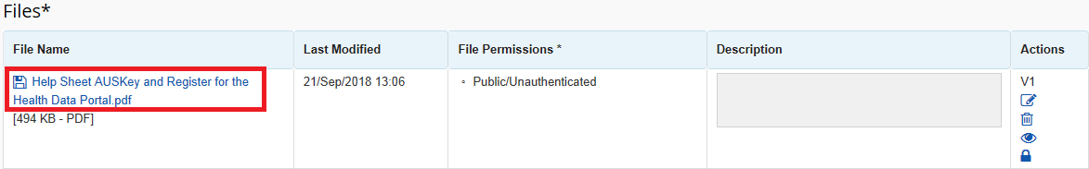
- To review the contents of the attached publication, select the link under File Name in the Files section.
- There are several actions that can be performed on the attached publication, in the Files section, if needed.
Button | Description
 | Select this button under File Name to download and view the publication. A pop up will appear in the bottom left-hand corner of the screen and you can open the file from here and save it as required.
 | Select this button under File Name to replace the file with another file if you have uploaded it incorrectly.
 | Select this button under Actions to view the publication’s previous versions.
 | Select this button under Actions to activate the Description field so a description of the file can be added if needed.
 | Select this button under Actions to remove the publication from the data asset.
 | Select this button under Actions to view the publication’s download history.
 | Select this button under Actions to see a list of users who will have the required file permissions to view the publication once it is published.
Select this button under Actions to add an updated version of the file if needed.
This will add a second file, rather than replace the existing one.
- To save your changes to the data asset details, select .
- Once the data asset and the attached file have been reviewed and updated as required, select either or the workflow progress bar at the top of the screen and, in the Change Data Asset Status dialog box, in the Action field, select and select the required action.
The available actions are:
- Request Approval – Select this action to send the data asset to the Publication Publisher for approval.
- Revision Required – Select this action to return the data asset to the Publication Producer for amendment.
If you have the access to approve the data asset for publication, you will also see the Approve for Publication option in the action list. This allows you to progress the data asset for publication to the status of Approved for Future Publication, where it will wait for the published period to start before being available for review and downloading by users with the required file permissions.
- In the Comment field, add any comments regarding the data asset if required.
- One of the following options can now be selected, depending on the action you have selected:
  - To send the data asset for approval, select . See the Approve a Data Asset for Publication QRG for the next step in the process.
  - To send the data asset back to the Publication Producer in your organisation for amendment, select . See the Amend a Draft Publication QRG for the next step in the process.
To save the data asset as a draft without sending it on to the next stage of the process, select .
The data asset has now been sent to the relevant party for the next step in the publication process.

