In addition to submitting nKPI data to the Health Data Portal every six months as part of the formal data collection periods, health services can submit their updated nKPI data from their CIS to the Data Portal as often as every month if needed as a Trial Submission. This allows the health service to track their data more easily through their Qlik Health Service nKPI and OSR Report by being able to see monthly trends and data points in the sheets contained in the report.
Review/Update your Trial Submission
To submit a direct load nKPI Trial Submission in the Data Portal:
- Open the Data Portal through Health Data Portal.
- Log in using the information provided in the Register for and Log in to the Health Data Portal QRG.
The Data Portal home screen will display, with the Reporting Dashboard open by default.
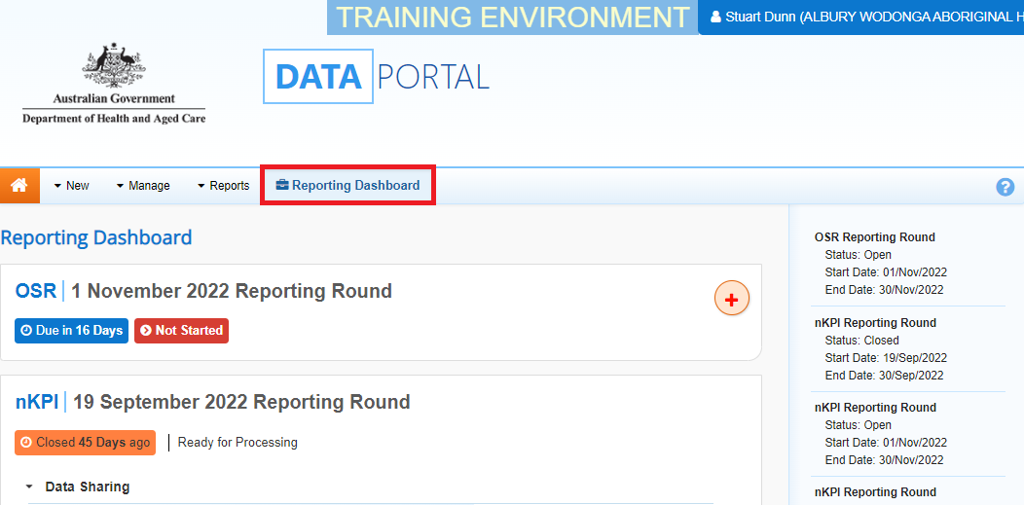
Trial Submissions are contained within the Data Assets table on the Data Portal home screen.
- To display the Data Assets table, select 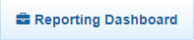 to close the Reporting Dashboard.
The Data Portal home screen will now update to display the Data Assets table.
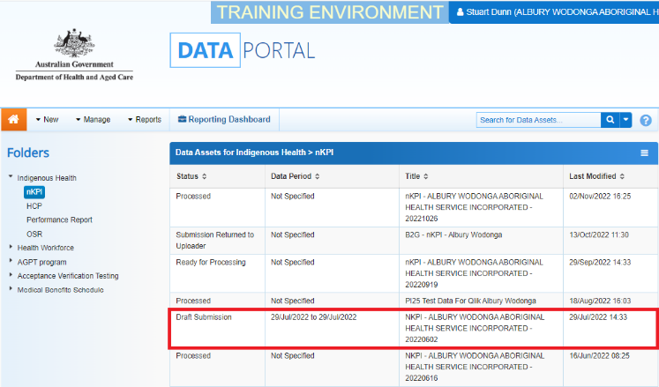
- With the nKPI folder selected on the left-hand side of the screen, on the right-hand side of the screen, select the Trial Submission you have submitted to the Data Portal from your CIS.
The draft submission’s status will be Draft Submission and the data contained within the submission will now be available in your Qlik report.
The Data Asset Details screen will display.
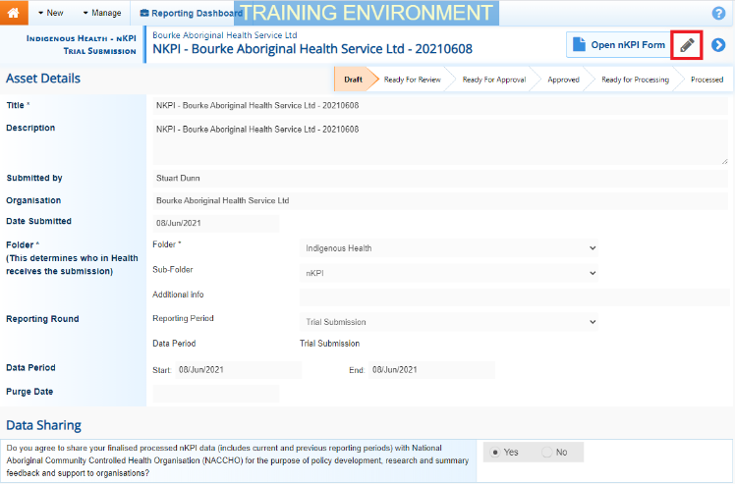
- To put the Data Asset Details screen into Edit mode, select in the top right-hand corner of the screen.
- If needed, update the Title and/or Description of the submission and ensure Trial Submission is selected in the Reporting Period field.
- In the Data Period fields, ensure the dates in these fields correctly reflect the period the trial data is for.
If you are submitting monthly trial data, ensure the first day of the applicable month is selected in the Start field and the last day of the applicable month is in the End field.
- To save any changes, select at the bottom of the screen.
To remove the Trial Submission, select at the top of the screen and in the window that displays, select the down arrow in the Action field and select Remove Data Asset from the list. Then select the Remove Data Asset button.
- To check the data in your Trial Submission to ensure it is correct, select at the top of the screen.

The nKPI form will display.
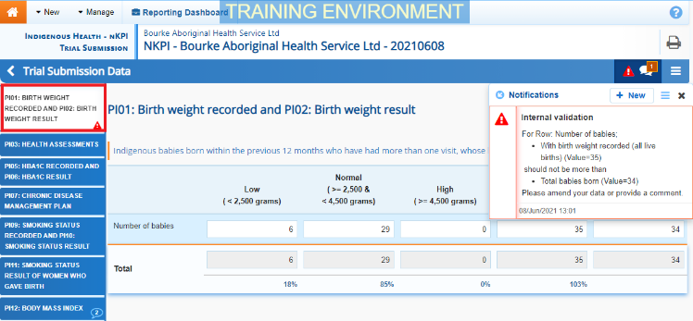
- Review your data and update any values as required, focussing on any indicators that contain a on the applicable tab on the left-hand side of the form.
- Once all required values have been updated to address any data validation issues in the nKPI form, to exit the form and return to the Data Portal home screen, scroll to the bottom of the form, and select 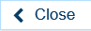.
Your Trial Submission data has now been updated as needed and will update in Qlik as well. There is no need to change the submission’s status – it can remain at Draft Submission.
View your Trial Submission data in Qlik
Once your Trial Submission has been submitted in the Health Data Portal, and the data contained within has been updated as needed, you will be able to view the data in your Qlik Health Service nKPI and OSR Report.
To view your Trial Submission data in your Qlik Health Service nKPI and OSR Report:
- From the Data Portal home screen, select 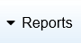 and then select Interactive Reports.
- Select Indigenous Health from the left-hand side of the screen and then select Health Service nKPI and OSR Report from the right-hand side of the screen.

The IHD Health Service nKPI and OSR Report screen will display.
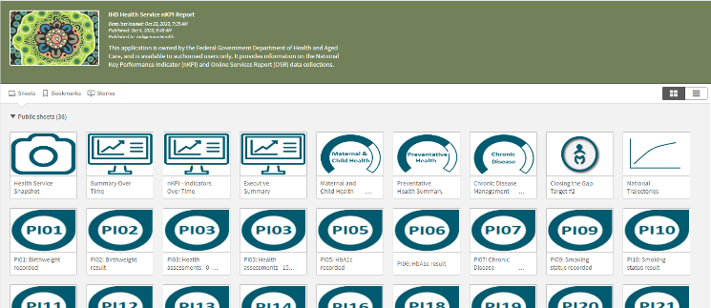
- To view your Trial Submission data in your Qlik report, select one of the detailed individual indicator sheets (we will select the PI01: Birthweight recorded sheet).
The applicable detailed individual indicator sheet will display.
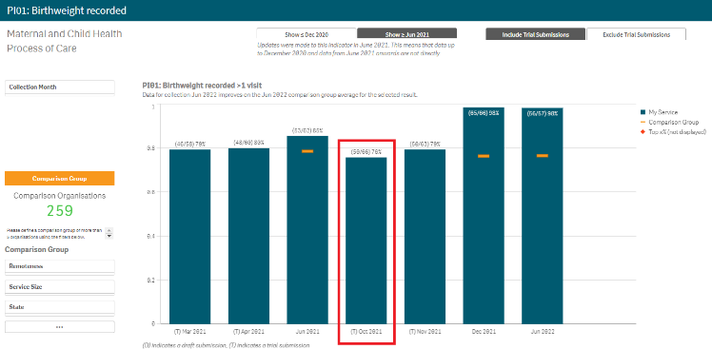
The Trial Submission data will appear as a blue bar on the graph in the sheet (highlighted above). This bar will be identified by a (T) before the date in the axis at the bottom of the graph. If you submit Trial Submission data to the Data Portal and Qlik each month, blue bars will appear next to each other in your Qlik sheets for each month you submit trial data for. Each of these bars will contain a (T) before the date in the bottom axis.

