To print or save a PDF version of your HCP form in the Data Portal:
Print/PDF Your HCP Form
- Open the Data Portal through Health Data Portal.
- Log in using the information provided in the Register for and Log in to the Health Data Portal QRG.
The Data Portal home screen will display.
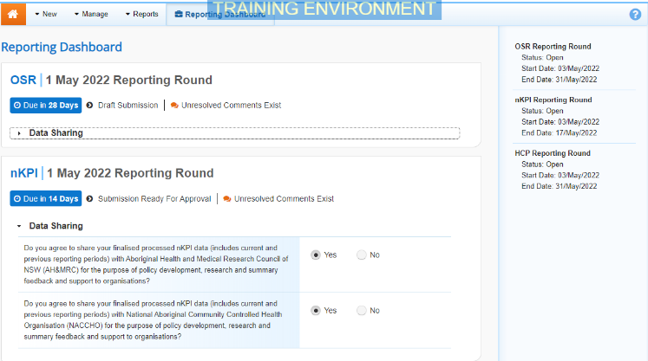
- To open your HCP form, hover your mouse pointer to the right of the Reporting Round text for your HCP data asset in the Reporting Dashboard and select .
The HCP form will display.
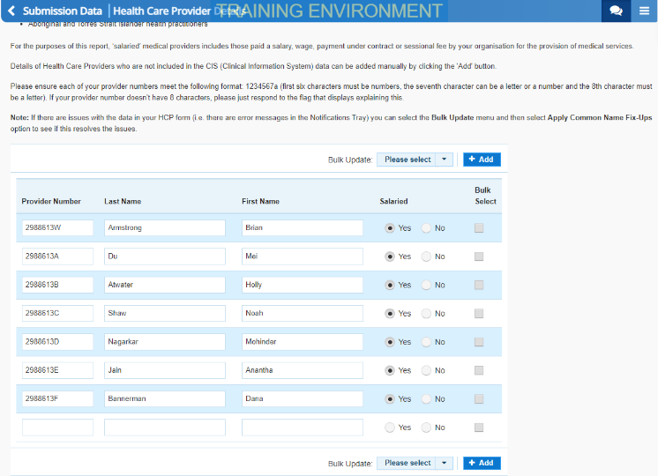
- To print or PDF the entire form, select .
The Print dialog box will display, showing a preview of the form, with any comments now showing in the section of the form they relate to.
- To continue, select the printer you wish to use.
To save the form as a PDF rather than print it, select the Save as PDF option, and then select the Save button and save the form to the desired location.
- To print the form, select .
Your form will now be printed at the selected printer.
Please note, the form will be long when printed in its entirety. You may wish to print individual sections where possible.

