Create a New Folder Record
Manage Folders and File Permissions
(Health Administrators)
As a Folder Administrator, you can create and update folders in the Data Portal as needed.
To create a new folder record in the Data Portal:
- Open the Data Portal through Health Data Portal.
- Log in using the information provided in the Initial Access to the Health Data Portal QRG.
The Data Portal home screen will display.
- From the Data Portal home screen, select and then select Folders from the list that displays.
The Manage Folders screen will display.
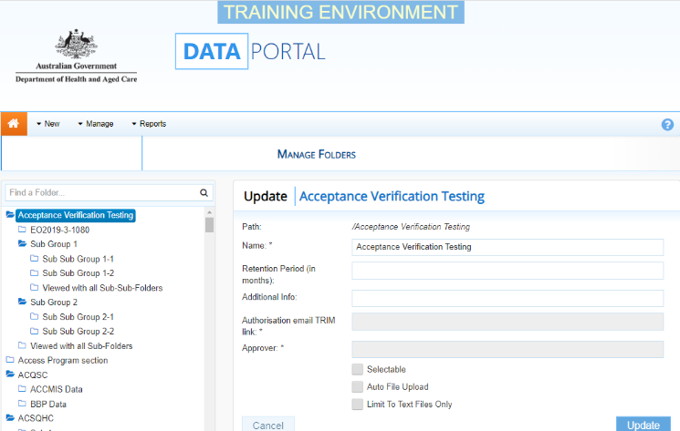
- To create a new folder, select any top-level folder on the left-hand side of the screen and right-click on it.
To create a sub-folder under an existing folder, right-click on the folder and select Create Sub Folder.
- Select Create Top Level Folder.
- Complete the fields on the screen as described below.
* indicates a mandatory field.
Field | Description  Manage Folders and File Permissions  (Health Administrators)  Manage Folders and File Permissions  (Health Administrators)
Name* | Enter the name of the new folder. This must be unique for the level the folder is being created on.
Retention Period (in months) | Enter the period of time the folder should be active for, if applicable.
Additional Info | Enter any additional information about the folder. This field is limited to 254 characters.
Authorisation email TRIM link* | Enter the TRIM reference of the email requesting the creation of the new folder.
Approver* | Enter the name of the contact from the business area that approved the folder creation.
Selectable | Select this check box to ensure the folder is selectable when users register for the Data Portal. Applicable for top level folders only.  Selecting the check box will reveal the Contact email field.
Contact email | Enter the email address or addresses emails are to be sent to when users register for the folder in the Data Portal and no one else in their organisation is registered. Applicable for top level folders only.
Auto File Upload | Select this check box if you want data assets submitted for this folder to be automatically saved once they are approved.  Selecting the check box will reveal the Export Folder Path field.
Export Folder Path* | Enter the export folder path if you have selected the Auto File Upload check box.
Limit To Text Files Only | Select the check box if you want the folder to only contain text files.
- To continue, select .
The new folder has now been created in the Data Portal.
Clone a Folder
If you need to create a folder that is very similar to one that already exists, you can clone that existing folder rather than creating a new folder from scratch.
To clone a folder in the Data Portal:
- Open the Data Portal through Health Data Portal.
- Log in using the information provided in the Initial Access to the Health Data Portal QRG.
The Data Portal home screen will display.
- From the Data Portal home screen, select and then select Folders from the list that displays.
Manage Folders and File Permissions
(Health Administrators)
The Manage Folders screen will display.
To clone a folder, right click on the folder to be cloned and select Clone Folder.
- Change the name of the folder and update any other details as needed.
- To continue, select .
The new folder has now been created, using the attributes of an existing folder.
Update a Folder’s Attributes
Once a folder has been created and is being assigned to your users as needed, you can update the folder’s attributes as/if needed.
To update a folder’s attributes in the Data Portal:
- Open the Data Portal through Health Data Portal.
- Log in using the information provided in the Initial Access to the Health Data Portal QRG.
The Data Portal home screen will display.
- From the Data Portal home screen, select and then select Folders from the list that displays.
The Manage Folders screen will display.
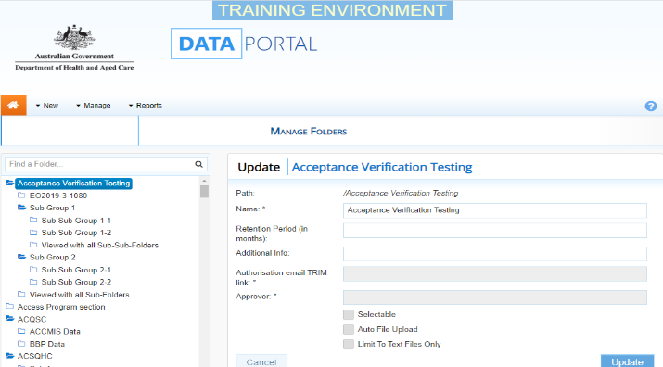
- To search for the folder to update, enter the folder’s name (or part of the name) in the Find a Folder… field on the left-hand side of the screen.
- To search for the folder, select .
- Select the folder from the list that displays.
The Manage Folders screen will update to display the folder’s details on the right-hand side of the screen.
- Complete the fields on the screen as described below.
* indicates a mandatory field.
Field | Description
Name* | Update the name of the folder if required.
Retention Period (in months) | Enter/update the period of time the folder should be active for, if applicable
Additional Info | Enter/update any additional information that is required for the folder.
Authorisation email TRIM link* | This field does not need to be entered when updating a folder
Approver* | This field does not need to be entered when updating a folder
Selectable | Select/deselect the check box as needed.  Please note that if the check box is deselected, the Contact email field will no longer display.
Contact email | Update the contact email for the folder if needed
Auto File Upload | Select/deselect the check box as needed.  Please note that if the check box is deselected, the Export Folder Path field will display.
Export Folder Path* | Enter the export folder path as needed.
Limit To Text Files Only | Select the check box.
- To save changes to the folder, select 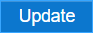.
To deactivate the folder so it no longer displays to users, select .
Manage Folders and File Permissions
(Health Administrators)
The folder’s attributes have now been updated.
Create a New File Permission
As a File Permission Administrator, you can create and update file permissions in the Data Portal as needed.
To create a new file permission record in the Data Portal:
- Open the Data Portal through Health Data Portal.
- Log in using the information provided in the Initial Access to the Health Data Portal QRG.
The Data Portal home screen will display.
- From the Data Portal home screen, select and then select File Permissions from the list that displays.
The Manage File Permissions screen will display.
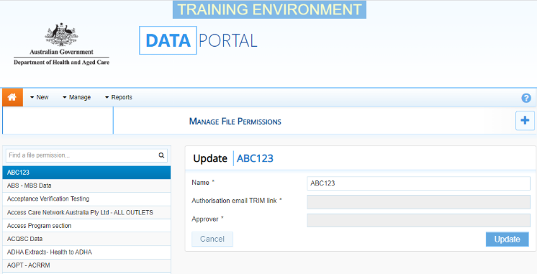
- To create a new file permission, select in the top right-hand corner of the screen.
The Manage File Permissions screen will update to display the New | File Permission Name field on the right-hand side of the screen.
- Complete the fields on the screen as described below.
* indicates a mandatory field.
Field | Description
Name* | Enter the name of the new file permission.
Authorisation email TRIM link* | Enter the TRIM reference of the email requesting the creation of the new file permission.
Approver* | Enter the name of the contact from the business area that approved the file permission creation.
- To continue, select .
The new file permission has now been saved and can be assigned to the applicable users as needed.
Update a File Permission’s Attributes
To change the name of a file permission record in the Data Portal:
- Open the Data Portal through Health Data Portal.
- Log in using the information provided in the Initial Access to the Health Data Portal QRG.
The Data Portal home screen will display.
- From the Data Portal home screen, select and then select File Permissions from the list that displays.
The Manage File Permissions screen will display.
- On the left-hand side of the screen, select the file permission to be updated.
- In the Name field on the right-hand side of the screen, update the name of the file permission as needed.
- To save changes to the folder, select .
The file permission’s name has now been updated.

