To review your nKPI submission after it has been amended by your Submission Uploader at the request of the AIHW:
Review your nKPI Submission based on AIHW Feedback (Submission Reviewer)
Review an nKPI Submission as Part of Exception Reporting (Health Service)
- Open the Data Portal through Health Data Portal.
- Log in using the information provided in the Register for and Log in to the Health Data Portal QRG.
The Data Portal home screen will display with the Reporting Dashboard open.
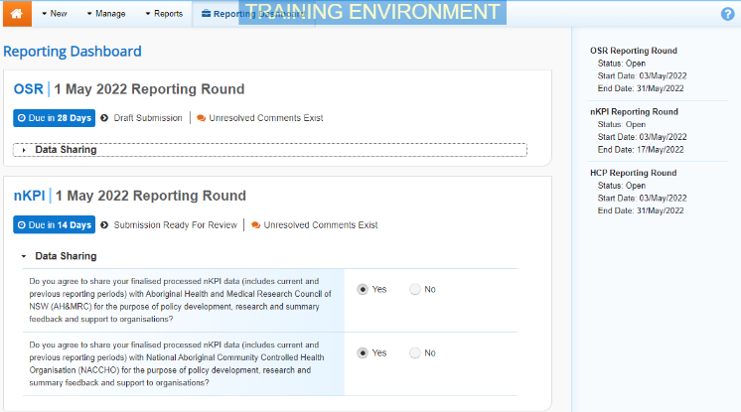
To be eligible for review, the submission/s status will need to be Submission Ready for Review.
- To open your health service’s nKPI form, hover your mouse pointer to the right of the nKPI reporting round text in the Reporting Dashboard and select .
The nKPI form will display.
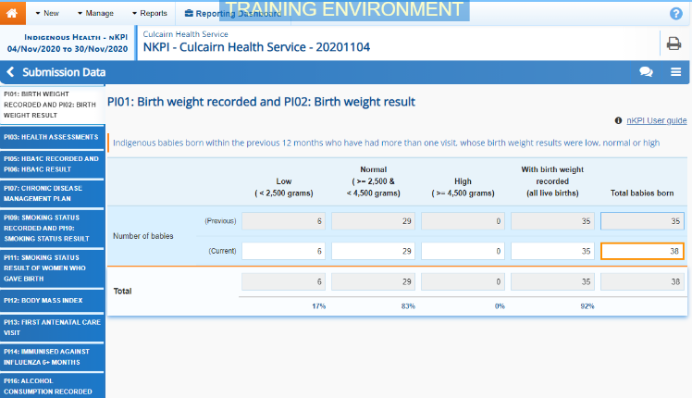
Any changes made to values in the form by your Submission Uploader in response to comments left by the AIHW will display in an additional row called Current. In addition, the cell(s) that has had its value changed will be highlighted with an orange border so anyone viewing the form can easily see the changes that have been made by your Submission Uploader based on AIHW feedback.
If your Submission Uploader responded to an AIHW comment in a particular section of the form rather than amending the values as requested, a will display on the corresponding tab.
- Review the data in each section of the form, focussing where applicable on any comments left by the AIHW and your Submission Uploader.
- If needed, update any values in the required cells.
- To save your changes, select at the bottom of the form.
If you have made changes to any values and would like to add a comment explaining this, select at the top of the Notifications Tray, select a Reason, add your comment in the Additional Information field and then select .
- To exit the nKPI form and return to the Data Portal home screen, scroll to the bottom of the form, and select .
The Data Portal home screen will again display with the Reporting Dashboard open.
- To progress the nKPI submission through the submission workflow, select .
- In the Change Data Asset Status dialog box, in the Action field, select and select the required action.
The available actions are:
- Request Approval – Select this action to send your nKPI submission to your CEO or their representative for approval again.
- Approve for Submission – Select this action if you are the health service’s CEO, or nominated representative, and are approving your submission as well as reviewing it.
- Request Interim Processing – Select this action to send your submission to the AIHW for review prior to it going to your CEO or their representative for approval. This process is known as Interim Processing.
- Revision Required – Select this action to return your submission back to your Submission Uploader for further amendment.
- In the Comment field, enter any comments regarding the action being performed on your submission.
- One of the following buttons can now be selected when submitting your report, depending on the action you have selected:
Review your nKPI Submission based on AIHW Feedback (Submission Reviewer)
  - To send your nKPI submission to your CEO or their representative for approval again, select . See the Approve an nKPI Submission based on AOHW feedback (Submission Approver) QRG for the next step in the process.
  - To approve your submission and send it directly to the AIHW for processing again, select . See the Process an nKPI Submission QRG for the next step in the process.
  - To send your submission to the AIHW for initial review prior to sending it to your CEO or their representative for approval, select . See the Interim Processing of an nKPI Submission QRG for the next step in the process.
  - To send your submission back to the Submission Uploader for amendment again, select . See the Amend an nKPI Submission based on AIHW feedback (Submission Uploader) QRG for the next step in the process.
Your nKPI submission has now been reviewed and either sent for re-approval or sent back to your Submission Uploader for further revision as required.

