Extract a Publication from the Health Data Portal
Once a file (known as a publication in the Data Portal) has been published in the Data Portal by the Department of Health, it can be viewed by users with the required permissions in the Data Portal, whether they are Health users or users from an external organisation.
There will be circumstances where external users will be asked to access a particular publication in the Data Portal so they can extract it for their own use as required.
To extract a publication from the Data Portal:
- Open the Health Data Portal through Health Data Portal.
- Log in using the information provided in the Registering for and Logging in to the Health Data Portal QRG.
The Data Portal home screen will display.
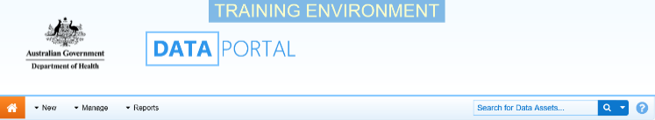
- From the Data Portal home screen, select the data asset the publication is contained in, or search for it if needed, in the Data Assets section of the screen.
For more information on how to search for a data asset, see the Get Started in the Health Data Portal QRG.
The data asset’s status should be Published
- Select the data asset to be viewed.
The Data Asset Details screen will display and the attached publication can be seen in the Files section.
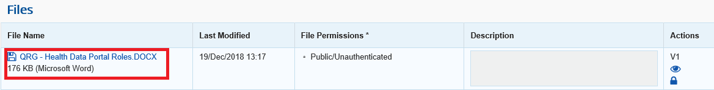
- To extract the publication, either select or the file name link.
A pop up similar to the one below will appear in the bottom left hand corner of the screen.
- To download the publication, select in the pop up and then select Open.
The file will now open in the applicable application (PDF, Excel, Word, etc.).
- Save the file/document to the required location as you normally would.
- Once the document has been saved as required, return to the Data Portal and in the open data asset, select .
You will be returned to the Data Portal Home screen and you have now successfully extracted the publication.
- When ready, log out of the Data Portal by selecting next to your name in the top right-hand corner of the screen and then Log Off.
Please note that administrators within the Department of Health can see that you have downloaded the publication by opening the Users that have downloaded a file from this data asset section of the data asset.

