Overview
The QLIK Health Service nKPI & OSR Report

The QLIK Health Service nKPI & OSR Report contains 35 sheets that health services can use to get a graphical view of their aggregated nKPI data, back to December 2014. These include 20 individual indicator sheets and three summary sheets, covering the three indicator groupings.
When working in these sheets, you can either compare your health service’s data for the current collection period to your data from previous periods or to other health services in a comparison group, which you can select from within the sheet. Comparison groups can be built using different information such as remoteness, service size, state, and workforce characteristics.
On opening QLIK, the initial view is the Health Service nKPI & OSR Report screen containing individual “apps” for all summary and indicator-level sheets, and the two data export sheets, amongst others.
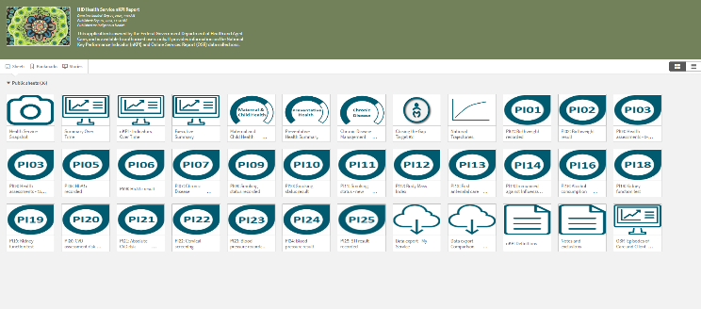
The Health Service Snapshot
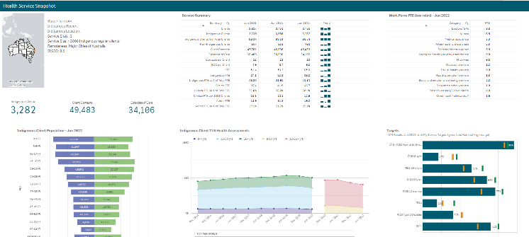
The Health Service Snapshot sheet allows you to view key summary nKPI and OSR information for your health service.
Summary Info – is located next to the map and shows information related to your service’s location, including the number of sites your organisation has, your remoteness category and your socio-economic IRSEO index number.
Indigenous Client Population – Jun 2023 demography graph – shows the gender breakdown (in numbers) for your Indigenous population, by age group, for the current collection period.
Service Summary table – shows key summary information for your service for the three most recently completed collection periods, such as your client numbers, episodes of care and FTE numbers. The table also contains a Trend column, which shows how you are trending for each of these elements.
Indigenous Client 715 Health Assessments graph – plots the number of health assessments your service has conducted, by age group, back to December 2014. The information displayed here can be filtered by age group, indigenous status, and gender using the buttons above the graph.
Work Force FTE (key roles) – Jun 2023 table – shows your FTE numbers for key position types, for the most recently completed collection period.
Targets graph – shows your self-determined targets for the applicable nKPIs, along with your actual results and the national average for each of these indicators, for the latest collection period. Also shows the Closing the Gap Target #2 for healthy birthweight, and your results and national average results against that target.
The Summary Over Time sheet
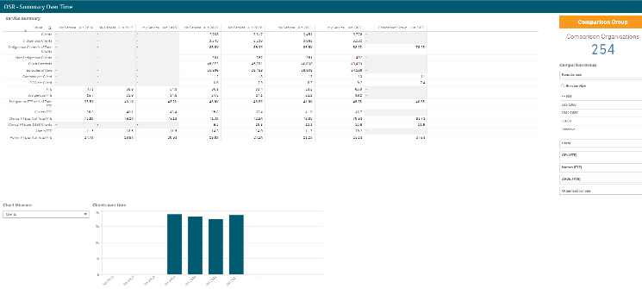
The Summary Over Time sheet allows you to see your key OSR summary information (such as client numbers, episodes of care and FTE numbers) for all collection periods, back to June 2016.
It also contains a comparison group column, which allows you to display data for the most recent collection period, for the comparison group of your choice, created using the Comparison Group section on the right-hand side of the sheet.
As well as a table, the sheet contains a graph that presents a pictorial representation of the selected measure, back to June 2016.
Using the Chart Measure field to the left of the graph, you can select the characteristic to display your data for in the graph, including clients, episodes of care and FTE.
The QLIK Health Service nKPI & OSR Report

The nKPI - Indicators Over Time sheet
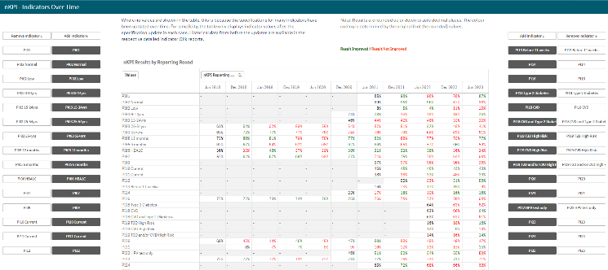
The nKPI – Indicators over Time sheet contains the Aggregated nKPI Results by Reporting Round table, which displays your results for all indicators/focus areas for all collection periods, back to June 2018. Where your results for an indicator/focus area are improving, the values will display in green. Where your results are getting worse over time, they will display in red.
Where there has been a change to an indicator’s specification, a – will display for that indicator prior to the specification change occurring.
- To remove an indicator’s/focus area’s results from the table, simply select the applicable button (e.g., ) in the Remove Indicator column.
The Executive Summary sheet
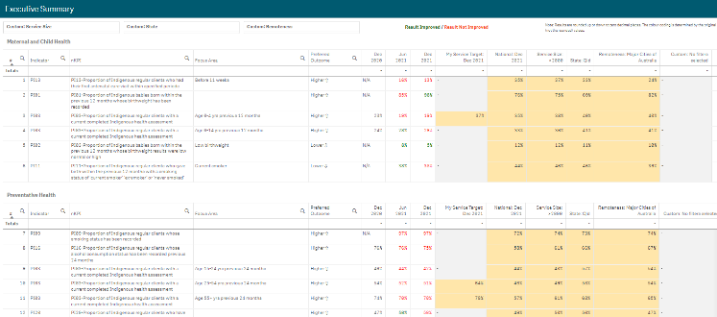
The Executive Summary sheet in the QLIK Health Service nKPI & OSR Report allows you to see your health service’s results for the three most recent collection periods, for each indicator, by indicator grouping. It also shows how your results compare to your own targets and the results of the pre-determined comparison groups sourced from the nKPI Summary sheets.
The following are the key elements of the Executive Summary sheet:
- Custom filter fields – allow you to build your own customised comparison group for which results will then display in the Custom column of the Comparison group table.
- Indicator and nKPI columns – describe each of the indicators included in the specified grouping.
- The focus area column - where applicable, displays the focus area for the indicator (for example Low birthweight for PI02 or Current smoker for PI10).
- The preferred outcome column – informs you whether the desired result for the indicator is a higher or lower result
- Collection period columns – shows your health service’s results for the last three collection periods for each of the indicators in the specified grouping.
- The My Service Target column – shows your self-determined target for the most recently completed collection period, for the applicable indicators.
- The National IP Goals column – shows the Implementation Plan goals trajectory set by the AIHW for the applicable indicators, for the most recently completed collection period.
- The comparison group table – shows the results for the most recently completed collection period for the comparison groups shown in the nKPI summary sheets and the customised comparison group, which can be set using the custom filter fields at the top of the sheet.
The nKPI Summary sheets
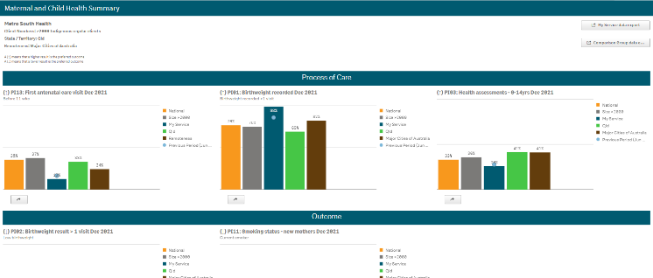
The QLIK Health Service nKPI & OSR Report contains three summary sheets:
- Maternal and Child Health (shown above)
- Preventative Health
- Chronic Disease Management
The top half of each of the summary sheets shows how your health service’s data for the selected Process of Care indicators, for the current and immediately previous collection periods, compares to the national averages and the results for services of the same size, state, remoteness, and client numbers.
The QLIK Health Service nKPI & OSR Report

The bottom half of the sheet contains the same information as the top half of the sheet, but for the applicable Outcome indicators.
For more information, see The Maternal and Child Health Time View Summary Sheet in the QLIK Health Service nKPI & OSR Report user guide in the User Support section of the Data Portal.
The Preventative Health and Chronic Disease Management Summary sheets are in the same format and contain the same parameters as the Maternal and Child Health Summary sheet.
The Closing the Gap Target #2 sheet
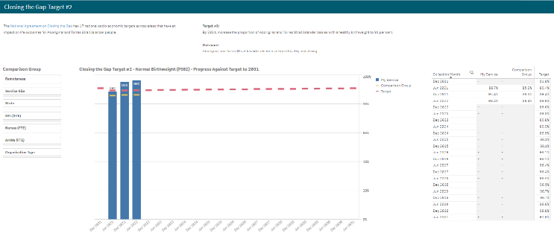
The Closing the Gap Target #2 sheet shows how your PI02 healthy birthweight results (the blue bars) compare to the Closing the Gap Target #2 (represented by ) which is to increase the proportion of Aboriginal and Torres Islander babies with a healthy birthweight to 91% by 2031.
The comparison group (displaying as ) that displays in the graph defaults to be the national average but can be changed if needed by creating your own customised comparison group using the Comparison Group section on the left-hand side of the sheet.
In addition to the graph, the data contained within this sheet will also display as a data table on the right-hand side of the sheet. The data in this table can be exported to Excel as needed by right-clicking on the table and selecting Download as… > Data.

The National Trajectories sheet
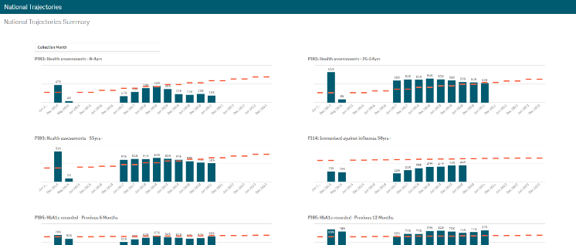
The National Trajectories sheet displays your nKPI results (represented by the blue bars) along with the corresponding national trajectories (represented by ) back to December 2014, for the five indicators that have had national trajectories set for them by the AIHW. There are eight graphs on the sheet across the five applicable indicators, due to some of the indicators containing multiple result bands.
The Individual Indicator sheets
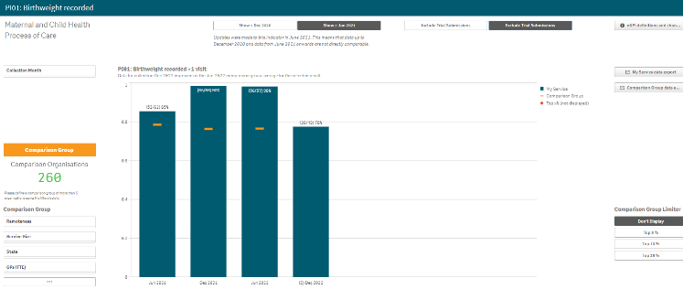
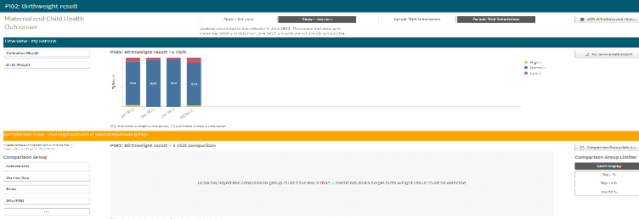
In addition to the summary sheets for the three indicator groupings, your QLIK Health Service nKPI & OSR Report also contains detailed reports for each indicator within these groupings.
The screenshots here are of PI01: Birthweight recorded and PI02 Birthweight results as they represent the two kinds of individual indicator sheets. The features detailed below are common to each of the individual indicator sheets contained within QLIK.

Layout view/Main Screen Window
The QLIK Health Service nKPI & OSR Report

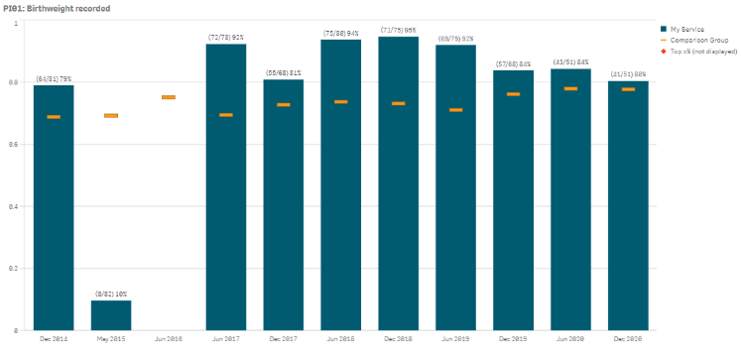
The main section of an individual indicator sheet shows your health service’s results for the selected indicator, back to December 2014, using a bar graph (showing your service’s results in blue).
The line on each bar of the graph represents the results of your selected comparison group for each collection period. If you have not created a comparison group, this will represent the national average.
Filter Fields
- The filter fields on the left-hand side of the sheet (e.g., Collection Month) allow you to filter the graph to display only your results for a particular selection (e.g., Collection Month, Service Mode, Gender, Age Group). When this is done, the selected filter will be added to the grey Selection Bar at the top of the screen.
- For some indicators, where the age groups reported on have changed, Age Groups filter fields will also display on the left-hand side of the sheet. These fields are used to select age groups you wish to display results for in the graph (s).
To remove your selection(s), simply select against the selection in the grey Selection Bar at the top of the sheet.
Comparison Group Selector
The Comparison Group Selector will appear in two different ways, depending on the type of individual indicator sheet you are in.
For indicators where comparison groups can be immediately applied, the Comparison Group Selector will appear in the bottom left hand corner of the sheet. For indicators where a selection needs to be made first, the Comparison Group Selector will populate the entire bottom half of the sheet.

Scenario 1
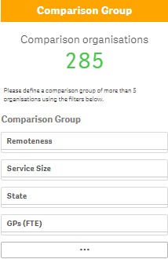
You can compare your health service’s results for a particular indicator against those of other health services sharing similar characteristics, using the Comparison Group section in the bottom left-hand corner of any indicator sheet.
To do this:
  - Select the characteristic(s) to be added to the comparison group.
  - Your selections have now been applied to the report and the number of services you are now comparing your results to, will display.
  - To remove your selections, simply select against the selection in the grey Selection Bar at the top of the sheet.
Scenario 2
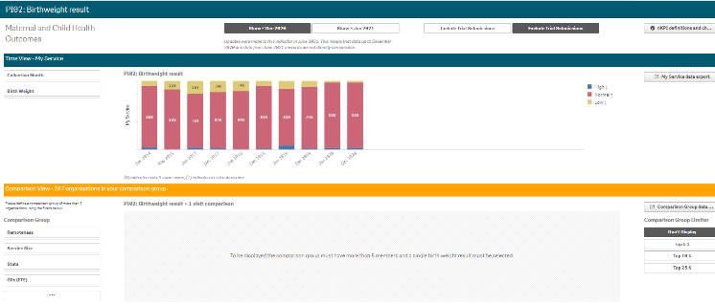
To display a comparison group in this scenario, you need to first filter the sheet by a particular result band (e.g., Gestational Age) in the top half of the sheet.
Once you have selected a result band, the Comparison View at the bottom of the sheet will update to show the results for your health service, by collection period, along with the Comparison Group results, indicated by .
The QLIK Health Service nKPI & OSR Report

To update/refine the comparison group shown, select at the bottom of the Comparison View to open the section in full screen mode so more options are available. Now make the additional selections as required.
nKPI Targets
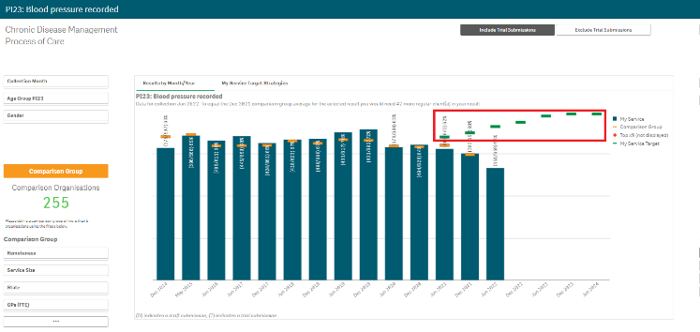
Once you have entered your self-determined targets for PI03, 05, 14, 18 and 23 into your nKPI form, these targets will then display as green lines () on the graphs within the applicable individual indicator sheets (as highlighted above). The target lines will allow you to see, for each collection period, whether you have reached or exceeded your targets for the selected indicator or are yet to do so.
While your targets for some of the indicators will display as soon as you select the applicable sheet, some selections will need to be made to get your targets to display for others. Bookmarks have been created in QLIK for these indicators to make it easier for you to display your targets.
To display your targets for each applicable indicator in QLIK:
- PI03 (0-4 years) – Open the PI03 0-14 yrs sheet, select and then right click on “My Service Targets-PI03-0-4YRS-In Person” and select Apply selections. Your targets will display.
- PI03 (25-54 years) - Open the PI03 15-65yrs+ sheet, select and then right click on “My Service Targets-PI03-25-54YRS-In Person” and select Apply selections. Your targets will display.
- PI03 (55YRS+) - Open the PI03 15-65yrs+ sheet, select and then right click on “My Service Targets-PI03-55yrs+-In Person” and select Apply selections. Your targets will display.
- PI05 – Open the PI05: HbA1c recorded sheet, select and then right click on “My Service Targets-PI05-Previous 12 months” and select Apply selections. Your targets will display.
- PI14 – Open the PI14: Immunised against influenza sheet and the targets will display. Your targets will display.
- PI18 – Open the PI18: Kidney function test sheet, select Type II Diabetes from the Chronic Disease PI18 filter field and the targets will display. Your targets will display.
- PI23 – Open the PI23: Blood pressure recorded sheet and the targets will display. Your targets will display.
If you have entered accompanying strategy text for the applicable indicator in the nKPI Targets tab of your nKPI form, this text can be seen by selecting the My Service Target Strategies tab in the applicable individual indicator sheet.
Other Sheet Elements
The Include Trial Submissions and Exclude Trial Submissions buttons will appear at the top right of the individual indicator sheets, and, by default, Include Trial Submissions will be selected.
If the Include Trial Submissions button is selected, trial submissions will be displayed as bars in the graph in the main screen window. These bars will have a (T) in brackets in the collection period label in the axis at the bottom of the graph.
To remove trial submission data from the graph, simply select the Exclude Trial Submissions button.
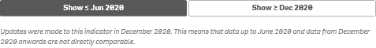
Some indicators have had changes made to their specifications over the last few collection periods, meaning the data for these indicators before and after these changes can’t directly be compared. The Show < Jun 2020 and Show > Dec 2020 buttons, for example, allow you to choose which time periods you wish to view the data for.
- Select this button to be taken to the nKPI Definitions sheet, which contains a detailed definition of each indicator, along with a summary of any changes that have been made to the specification of each indicator.
The QLIK Health Service nKPI & OSR Report

- Select this button to display (in table form) your health service’s nKPI data for every indicator, for every collection period, back to December 2014.
To reduce the data for a specific subset, you can filter on any column by clicking the magnifying glass icon and entering filter criteria. For example, you may only require data for a particular collection or for a smaller group of indicators.
To export your data to Excel, right click, select Download as… > Data and then select the link to download the file. This provides your finalised data so, if useful, you can create your own reports.
- Select this button to display (in table form) the national data averages (or the results for your comparison group, if you have selected one) for every indicator, for every collection period, back to December 2014.
To reduce the data for a specific subset, you can filter on any column by clicking the magnifying glass icon and entering filter criteria. For example, you may only require data for a particular collection or for a smaller group of indicators.
To export the data to Excel, right click, select Download as… > Data and then select the link to download the file.
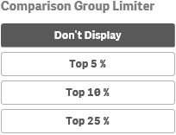
In addition to comparing your results for the current/latest collection period to other health services with similar characteristics, you can also compare your health service’s results for the selected indicator to the Top 5, 10 and 25 percent of health services in your selected comparison group.
To do this, simply select the applicable button in the Comparison Group Limiter section in the bottom right-hand corner of the sheet. Once selected, the average results for the selected grouping of higher performing organisations will display as in the graph, while the averages for the entire comparison group will continue to be represented by the .
The Data Export – My Service sheet
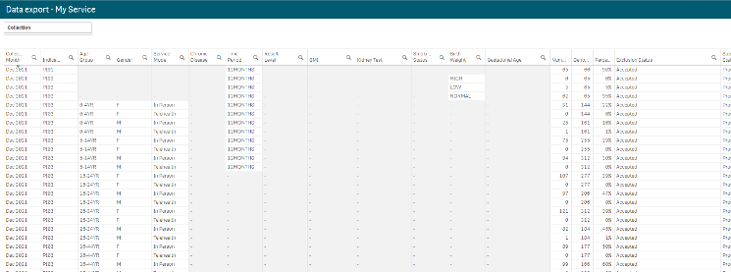
The Data Export – My Service sheet displays (in table form) your nKPI data for every collection period back to December 2014.
If you wish to, you can the filter the data displaying in the table by selecting at the top of any column and making the required selection. For example, you may only wish to see your data for a particular collection period or for a subset of indicators.
- To export the data to Excel right click anywhere on the table, select Download as… > Data and then select the link to download the file.
The selected data has now been downloaded into a Microsoft Excel spreadsheet for use as needed.
The Data Export – Comparison Group sheet
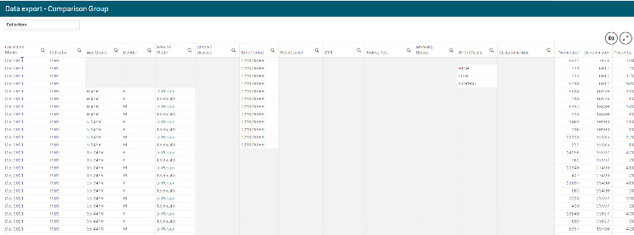
The Data Export – Comparison Group sheet displays (in table form) the national nKPI data set for every collection period back to December 2014.
- To filter the data that displays in the table, select the applicable filter field(s) above the table as required. For example, you may wish to export data only for services in Queensland without GPs.
- Select the applicable option from the list that displays, and then select .
The QLIK Health Service nKPI & OSR Report

If you wish to, you can the further filter the data by selecting at the top of any column in the table and making the required selection. For example, you may only require data for the latest collection period or for a subset of indicators.
- To export the data to Excel, right click anywhere on the table, select Download as… > Data and then select the link to download the file.
The selected data has now been downloaded into a Microsoft Excel spreadsheet for use as needed.
The nKPI Definitions sheet
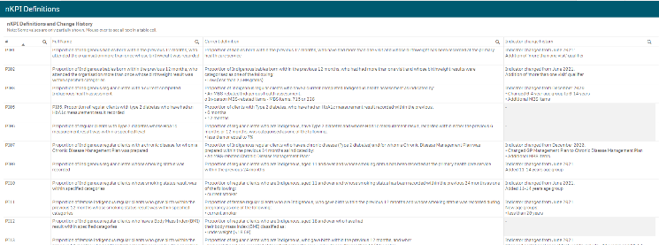
The nKPI Definitions sheet can be accessed from any individual indicator sheet within the QLIK Health Service nKPI & OSR Report by selecting the button, or by selecting the app on the home screen.
This sheet contains the number, name, and detailed current definition for each of the indicators contained within the Health Service Report. In addition, there is a column in the table that explains changes that have been made to any of the indicators, to assist you in interpreting each of the individual indicator sheets in the report.
Only a limited amount of text can be shown in the nKPI Definitions and Change History table. If the text in a section of the table is incomplete, simply hover your mouse pointer over the text and the rest of the text will display in a hover text box.

The Notes and exclusions sheet
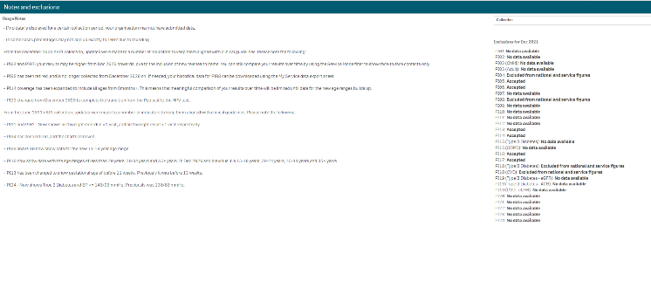
The Notes and exclusions sheet contains disclaimers and additional information regarding the different sheets in the report, in the Usage Notes section. The Exclusions section will show whether your data has been excluded or accepted by the AIHW for the most recent collection period.

