Submit a Data Asset
Submit a Data Asset
The Department of Health and Aged Care and other organisations can share data and information within the Health Data Portal using a data asset.
To be able to submit a data asset in the Data Portal, a user needs to have the role of Submission Uploader.
To submit a data asset in the Data Portal:
- Open the Data Portal through Health Data Portal.
- Log in using the information provided in the Registering for and Logging in to the Health Data Portal QRG.
The Data Portal home screen will display.
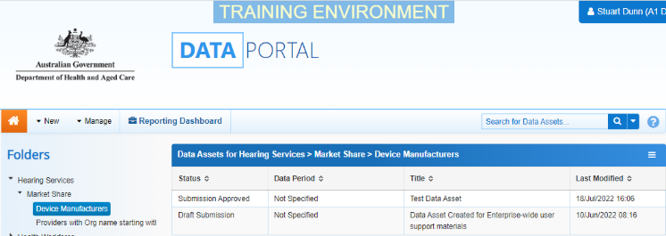
- From the home screen, select and select Asset for Submission from the list that displays.
The Data Asset Details screen will display and the details of the new data asset can be completed.
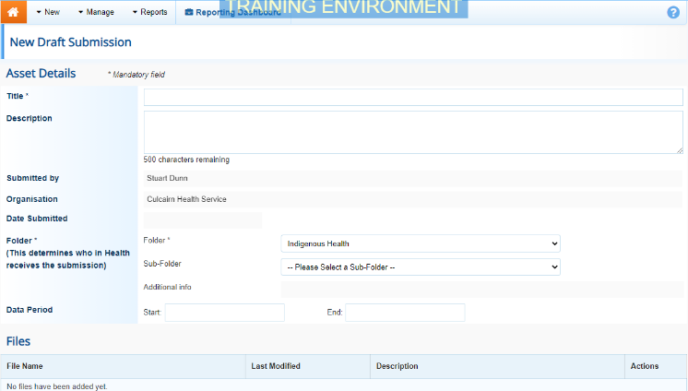
- Complete the fields on the screen as described below.
* indicates a mandatory field.
Field | Description
Title* | Enter a title for the new data asset. This should reflect the content of the data asset. The title is important as it will be used by others when they search for the data asset.
Description | Enter a description of the data asset. This would generally contain information regarding the content and purpose of the data contained within the asset.
Folder* | Select and select the folder that relates to the data you are submitting. Only users within your organisation with access to this folder will be able to see your data asset in the Data Portal once it is submitted.
Sub-Folder | Select the down arrow and select the type of data being submitted.  This field will only display, if applicable once a folder is selected in the Folder field.
Sub-Sub-Folder | Select the down arrow and select the type of data being submitted.  This field will only display, if applicable, for certain business areas once a sub folder is selected in the Sub-Folder field.
Data Period | If applicable, enter the start and end date for the time period the data being submitted relates to.  The date needs to be entered in the format dd/mm/yyyy.
Data Submission Questions | If submission questions display here, please answer either Yes or No for each question.
Purge Date | If you want the file attached to the new data asset to be removed from the Data Portal on a particular date, once it has been accessed as needed, enter/select this date here.  This field will only display if you have particular roles in the Data Portal.
- To upload the applicable file to the data asset, select .
The Upload Files dialog box will display.
- Select .
The Windows dialog box will display.
- Locate the file you wish to upload to the data asset (e.g. your PDF report).
- Select the file and then select .
The Data Assets Details screen will display, and the selected file will now appear in the Files section of the screen.
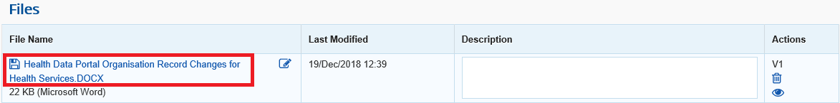
You can add a description of the file in the Description field, if needed.
- Once a file has been uploaded to the data asset, there are several actions that can be performed on the file.
Button | Description
 | Select this button under File Name to download and view the file. A pop up will appear in the bottom left-hand corner of the screen and you can open the file from here and save it as required.
 | Select this button under File Name to replace the file with another file if you have uploaded it incorrectly.
Select this under Actions to view the file’s previous versions.
There will be no previous versions of the file at this stage.
 | Select this button under Actions to remove the file from the data asset.
Select this button under Actions to view the file’s download history.
There will be no download history for the file at this stage.
Select this button under Actions to add an updated version of the file if needed.
This will add a second file, rather than replace the existing one.
- To save the details of the new data asset, select 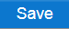.
- Select either or the workflow progress bar at the top of the screen and, in the Change Data Asset Status dialog box, in the Action field, select and select the required action.
The available actions are:
- Request Review – Select this action to send the data asset to someone within your organisation for review.
- Request Approval – Select this action to send the data asset to someone within your organisation for approval.
Submit a Data Asset
- Request Interim Processing – If you are a Submission Reviewer as well as a Submission Uploader, you can select this action to send the data asset to the external Data Receiver for review prior to it going to your CEO or their representative for approval. This process is known as Interim Processing.
- Remove Data Asset - Select this action to remove the data asset from the Data Portal (it may have been created in error).
If you can approve data asset submissions as well as create them, you will also see the Approve for Submission option in the action list. This allows you to approve the data asset and submit it directly to an external data receiver for viewing or processing.
- Add comments regarding the data asset in the Comment field if required.
- One of the following options can be selected:
Submit a Data Asset
  - To send the data asset on for review, select 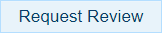. See the Review a Data Asset Submission QRG for the next step in the process.
  - To submit the data asset for approval, select 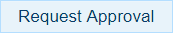. See the Approve a Data Asset Submission QRG for the next step in the process.
Submit a Data Asset
  - To send the data asset to the external Data Receiver for initial review prior to sending it to your CEO or their representative for approval, select 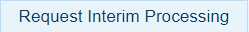.
  - To remove the data asset from the Data Portal (it may have been created in error) select .
To save the data asset as a draft select .
The data asset has now been completed and submitted to the next stage of the data asset submission process.

