To review your nKPI submission in the Data Portal as a *Submission Reviewer*:

**Review your nKPI Submission (Submission Reviewer)**

1. Open the Data Portal through [Health Data Portal](https://dataportal.health.gov.au/).
2. Log in using the information provided in the *Registering for and Logging in to the Health Data Portal* QRG.

The Data Portal home screen will display with the *Reporting Dashboard* open.

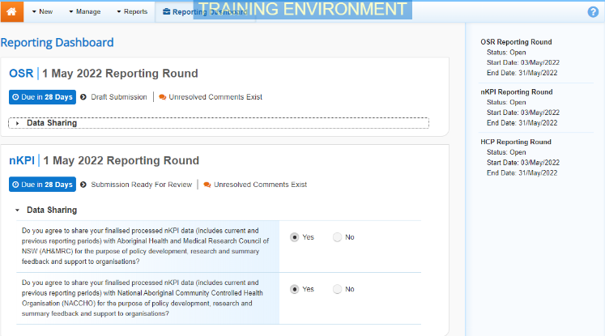

 To be eligible for review, your nKPI submission’s status will need to be *Submission Ready for Review*.

1. To open your nKPI form, hover your mouse pointer to the right of the nKPI reporting round text in the Reporting Dashboard and select Open Submission Form.

 If you need to change the *Title* or *Description* of the submission or switch it to a *Trial Submission*, you can do so in the Data Asset Details screen by selecting Nore Details next to Open Submission Form and then selecting *Open Data Asset.*

The nKPI form will display.

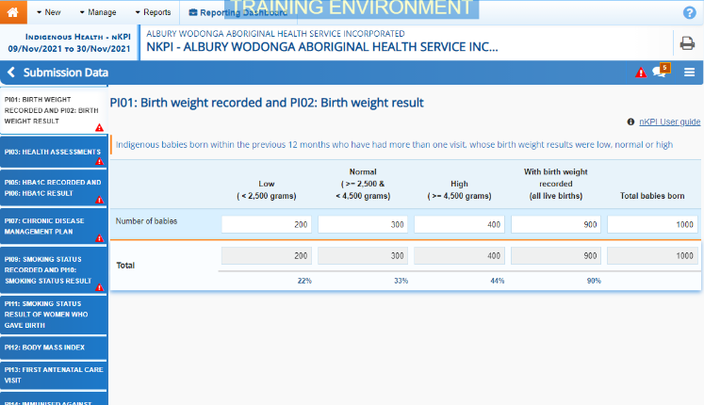

Any indicators that still have data validation flags to be addressed will display a data validation flag on the corresponding tab. If an indicator has a data validation flag that has been responded to by your *Submission* *Uploader* or a new internal comment entered by your *Submission* *Uploader*, it will show a speech bubble on the corresponding tab.

1. Review the data in each indicator and, if needed, update any values.
2. To add a comment about any changes you have made to the values or asking your *Submission Uploader* to amend the data, hover your mouse pointer to the right of the applicable data validation flag title in the **Notifications Tray**, and select the Respond button next to the most recent comment.

 If the *Notifications Tray* doesn’t display, select Open Notification tray - some comments require action or Open Notification tray - some comments require action at the top of the form to open it so you can address the data validation issues/read the comments that display.

1. Select the down arrow in the **Reason** field that displays and select the reason you are adding a comment from the drop-down list.
2. Enter your comment in the **Additional Information** field.
3. To save the comment, select the Save button.
4. Repeat this process for any other values in the form that need to be changed.

Your comment has been added and can be viewed by anyone accessing your nKPI submission.

Note If you wish to add an internal comment explaining the changes you have made, select Create New Comment at the top of the *Notifications Tray*, and add the details.

1. To exit the nKPI form and return to the Data Portal home screen, scroll to the bottom of the form, and select Close.

The Data Portal home screen will again display with the *Reporting Dashboard* open.

1. Before progressing your nKPI submission through the submission workflow, answer either **Yes** or **No** to the data sharing consent questions that display under **Data Sharing** if the questions have not already been answered.
2. To save the changes, select Save.
3. To progress your nKPI submission through the submission workflow, select the Submission Ready for Review link.

The Change Data Asset Status dialog box will display.

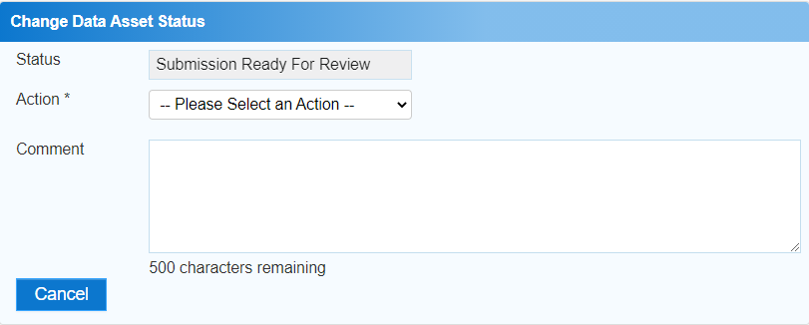

1. In the **Action** field, select the down arrow and select the appropriate action.

The available actions are:

* **Request Approval** – Select this action to send your nKPI submission to your CEO or their representative for approval.
* **Approve for Submission** – Select this action if you are the health service’s CEO, or nominated representative, and are approving your submission as well as reviewing it.
* **Request Interim Processing** – Select this action to send your submission to the AIHW for review prior to it going to your CEO or their representative for approval. This process is known as *Interim Processing*.
* **Revision Required** – Select this action to return the submission to your *Submission Uploader* for amendment.

1. In the **Comment** field, enter any comments about the action being performed on the submission.
2. One of the following buttons can now be selected when submitting your nKPI report, depending on the action you have selected:
   1. To send your nKPI submission to your CEO or their representative for approval, select the Request Approval. See the *Approve your nKPI Submission (Submission Approver)* QRG for the next step in the process.
   2. To approve your nKPI submission and send it directly to the AIHW for processing, select the Approve for Submission button. See the *Process an nKPI Submission* QRG for the next step in the process.
   3. To send your nKPI submission to the AIHW for review prior to sending it to your CEO or their representative for approval, select the Request Interim Processing button. See the *Interim Processing of an nKPI Submission* QRG for the next step in the process.

**Review your nKPI Submission (Submission Reviewer)**

* 1. To send your nKPI Submission back to your *Submission Uploader* for amendment, select the Revision Required button. See the *Amend your nKPI Submission (Submission Uploader)* QRG for the next step in the process.

Your nKPI submission has now been reviewed, and either sent on to your CEO or their delegate for approval or sent back to your *Submission Uploader* for revision if needed.