Once a health service Submission Uploader has drafted their TIS Performance Report in the Data Portal and submitted it for internal review, all users within the service with the Submission Reviewer role (including yourself) will receive an email, letting them know the report is ready for them to review.
Review a Health Service’s TIS Performance Report (NBPU)
At this point, you will need to work with the service’s internal Submission Reviewer to confirm who is going to review the report first. In some services the internal Reviewer will review the report and will then let you know that the report is ready for you to review as the NBPU representative.
To review a health service’s TIS Performance Report in the Data Portal as an NBPU reviewer:
- Open the Data Portal through Health Data Portal.
- Log in using the information provided in the Registering for and Logging in to the Health Data Portal QRG.
The Data Portal home screen will display with the Reporting Dashboard open.
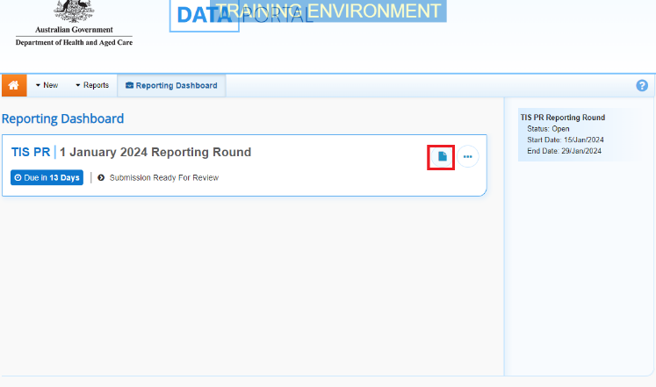
The health service’s TIS Performance Report will have the status of Submission Ready for Review.
- To open the TIS Performance Report, hover your mouse pointer to the right of the TIS PR Reporting Round text and select (as highlighted above).

The TIS Performance Report form will display.
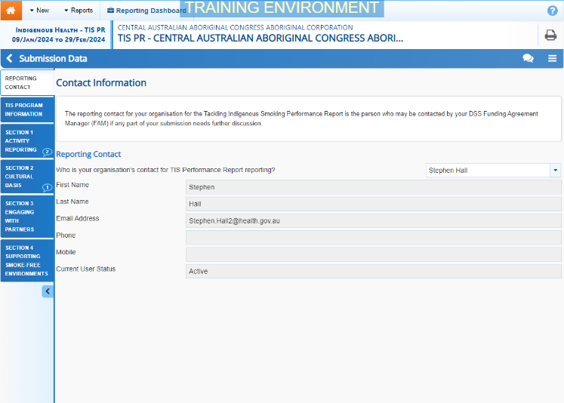
The TIS Performance Report form will be broken down into sections, with each section displaying as a tab on the left-hand side of the form.
If a section has a data validation flag that has been responded to by the health service’s Submission Uploader or an internal comment entered by the Submission Uploader, a will appear on the corresponding tab. You can review these comments as you go through the form.
If the TIS Performance Report has been sent to the DSS FAM for their review and has been returned to the service for amendment, you will see the DSS FAM’s comment and the health service’s response in the applicable section. These will display as a on the corresponding tab.
- You can now review the content of the health service’s TIS Performance Report, moving from section to section by either selecting the tab you wish to move to next, or by selecting at the bottom of each section.
- If you have a comment, suggestion, or question for the health service as you go through the form, you can add it by selecting on the blue Submission Data bar.
- In the Notifications Tray that displays, select .

The Notifications window will display.
Review a Health Service’s TIS Performance Report (NBPU)
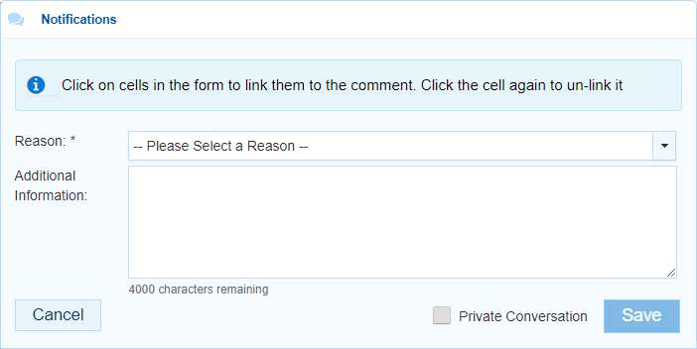
- To link your comment/question to a particular cell in the form, select the cell your comment/question relates to.
- In the Reason field, select and then select Other (specify) from the list that displays.
- In the Additional Information field, enter your comment or question for the health service regarding their TIS Performance Report.
- To ensure your comment can only be seen within the health service (not by the DSS FAM) select the Private Conversation check box.
- To save the question/comment, select .
Your question/comment for the health service has now been added to the form and a will display on the tab you added your comment/question to.
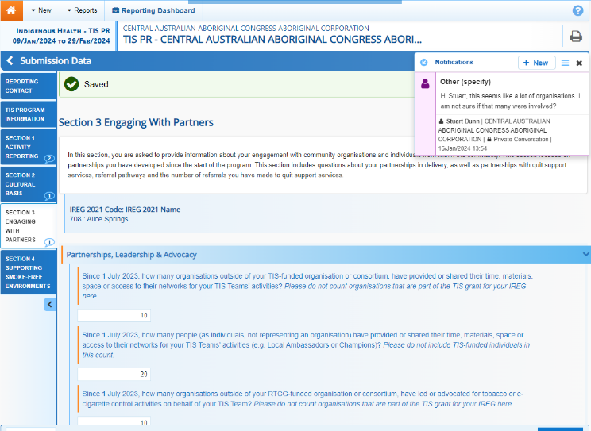
- Repeat steps 6 to 11 for any other comments or questions you have for the service regarding their TIS Performance Report.
- Once you have finished reviewing the health service’s TIS Performance Report, scroll to the bottom of the form and select .
The Data Portal home screen will again display with the Reporting Dashboard open.
Once you have finished reviewing the report, you need to send it back to the health service’s Submission Uploader so they can review and action your questions/comments as needed.
- To do this, select in your Reporting Dashboard.
The Change Data Asset Status dialog box will display.
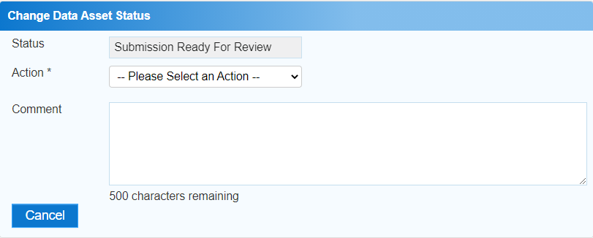
- In the Action field, select and select Revision Required.
- Select .
The health service’s TIS Performance Report has been returned to the health service’s Submission Uploader and its’ status has been set to Submission Revision Required.
The health service’s Submission Uploader will receive an email from the Data Portal notifying them you have returned the TIS Performance Report to them, and they can now go in and review and action your questions and comments as needed.

