**Interim Processing of an IAHP PHC Performance Report**

Initiate Interim Processing (Health Service)

To start interim processing of your IAHP PHC Performance Report in the Data Portal:

1. Open the Data Portal through [Health Data Portal](https://dataportal.health.gov.au/).
2. Log in using the information provided in the *Register for and Log in to the Health Data Portal* QRG.

The Data Portal home screen will display with the Reporting Dashboard open.

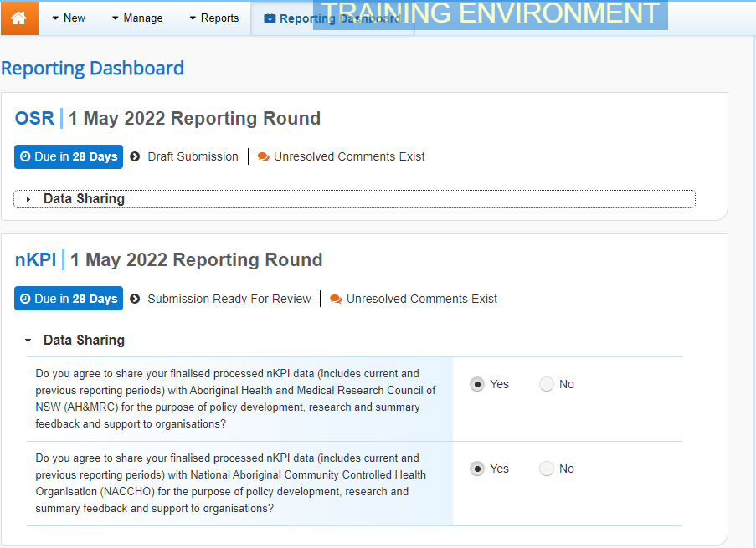

Note To be eligible for interim processing, your IAHP PHC Performance Report’s status will need to be at either *Draft Submission* or *Submission* *Ready for Review*, if you have the *Submission Reviewer* role.

1. Before progressing your IAHP PHC Performance Report through the interim submission workflow, answer either **Yes** or **No** to the data sharing consent questions that display under **Data Sharing** if the questions have not already been answered.
2. To save the changes, select Save.
3. To start interim processing, select the Submission Ready for Review link in the Reporting Dashboard and, in the Change Data Asset Status dialog box, in the **Action** field, select the down arrow and select **Request** **Interim Processing**.
4. In the **Comment** field, enter any comments you wish to add for your DSS FAM.
5. To send your IAHP PHC Performance Report to your DSS FAM for interim processing, select the Request Interim Processing button.

The status of your IAHP PHC Performance Report has now been set to *Interim Submitted* and your DSS FAM can review your report as needed to assess its suitability before it goes to your CEO, or their representative, for approval.

Review the Performance Report (DSS FAM)

To review the IAHP PHC Performance Report:

1. Ensure the Date Portal home screen is displayed.

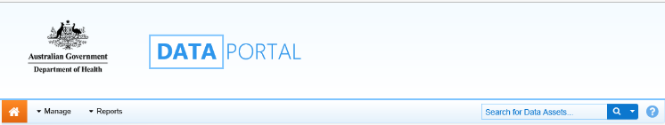

1. From the Data Portal home screen, search for the Performance Report to be reviewed.

For more information on how to search for a submission, see the *Get Started in the Health Data Portal* QRG.

Note The submission will have the status of *Interim Submitted*.

1. Select the IAHP PHC Performance Report to be reviewed.

The Data Asset Details screen will display.

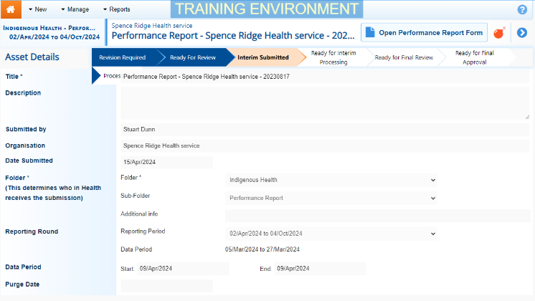

1. Review the details of the IAHP PHC Performance Report as needed.
2. To review the contents of the IAHP PHC Performance Report form, select the Open Performance Report form button at the top of the screen.
3. Once finished, select Close at the bottom of the IAHP PHC Performance Report form to exit the form and return to the Data Asset Details screen.
4. To action the report, select either the Change Status button or the workflow progress bar at the top of the screen and, in the Change Data Asset Status dialog box, in the **Action** field, select the down arrow and select *Ready for Interim Processing*.

Note If the health service has asked you to return the report as it has been submitted in error, select *Return to Uploader*.

1. In the **Comment** field, enter any comments about the action being performed on the Performance Report.
2. To prepare the Performance Report for processing, select the Ready for Interim Processing button.

Process the Performance Report (DSS FAM)

To complete interim processing on the IAHP PHC Performance Report in the Data Portal:

1. Ensure the Date Portal home screen is displayed.



1. From the Data Portal home screen, search for the applicable IAHP PHC Performance Report with the status of *Ready for Interim Processing*.

For more information on how to search for a submission, see the *Get Started in the Health Data Portal* QRG.

1. Select the IAHP PHC Performance Report to be processed.

The Data Asset Details screen will display.

1. Review the details of the submission as needed.
2. To review the contents of the form, select the Open Performance Report form button at the top of the screen.
3. Once finished, select Close at the bottom of the Performance Report form to exit the form and return to the Data Asset Details screen.
4. To action the report, select either the Change Status button or the workflow progress bar at the top of the screen and, in the Change Data Asset Status dialog box, in the **Action** field, select the down arrow and select *Request Review* to send the report back to the health service’s *Submission Reviewer*, who will review the submission and move it to the next stage of the process. This action will progress the report to the status of *Submission Ready for Final Review*.

**Interim Processing of an IAHP PHC Performance Report**

1. In the **Comment** field, enter any comments about the action being performed on the Performance Report.
2. To send the IAHP PHC Performance Report on to the health service’s *Submission Reviewer*, select the Request Review button.

Conduct a Final Review of the Submission (Submission Reviewer)

To conduct a final review of your IAHP PHC Performance Report in the Data Portal as a *Submission Reviewer*:

1. Ensure the Date Portal home screen is displayed, and the ReportingDashboard is open.

Note The submission will have the status of *Submission Ready for Final Review*.

1. To open the Data Asset Details screen for the submission, hover your mouse pointer to the right of the Activity Work Plan reporting round text in the ReportingDashboard, select Nore Details and then select **Open Data Asset**.
2. Review the details of the submission as needed.
3. To review the contents of the Performance Report form, select the Open Performance Report form button.
4. Once finished, select Close at the bottom of the Performance Report form to exit the form and return to the Data Portal home screen.
5. To action your submission from the **Reporting Dashboard**, select the Submission Ready for Final Review link and, in the Change Data Asset Status dialog box, in the **Action** field, select the down arrow and select **Request Approval**.

Note If changes need to be made to any of the information in the Performance Report, select *Revision Required* to send the submission back to the *Submission Uploader* for amendment.

1. To send your IAHP PHC Performance Report on to your CEO or their representative for approval, selectRequest Approval.

your Performance Report has now been sent to your CEO or their representative for final approval.

Approve your Performance Report (Submission Approver)

**Interim Processing of an IAHP PHC Performance Report**

To approve your IAHP PHC Performance Report that has been through interim processing in the Data Portal:

1. Ensure the Date Portal home screen is displayed.

Note The submission will have the status of *Submission Ready for Final Approval*.

1. To open the Data Asset Details screen for the submission, hover your mouse pointer to the right of the Activity Work Plan reporting round text in the ReportingDashboard, select Nore Details and then select **Open Data Asset**.
2. Review the details of your submission as needed.
3. To review the contents of your IAHP PHC Performance Report form, select the Open Performance Report form button.
4. Once finished, select Close at the bottom of the IAHP PHC Performance Report form to exit the form and return to the Data Portal home screen.
5. To action your submission from the Reporting Dashboard, select the Submission Ready for Final Approval link and, in the Change Data Asset Status dialog box, in the **Action** field, select the down arrow and select **Approve for Submission**.

Note If changes need to be made to any of the information in your IAHP PHC Performance Report, select *Revision Required* to send the submission back to the *Submission Uploader* for amendment.

1. In the **Comment** field, enter any comments about the action being performed on your Performance Report.
2. To approve your IAHP PHC Performance Report, select the Approve for Submission button.

Your IAHP PHC Performance Report has been progressed to the status of *Processed* and the submission process is now complete.