To review your HCP submission after it has been amended by your Submission Uploader at the request of Health and Aged Care:
- Open the Data Portal through Health Data Portal.
- Log in using the information provided in the Register for and Log in to the Health Data Portal QRG.
The Data Portal home screen will display with the Reporting Dashboard open.
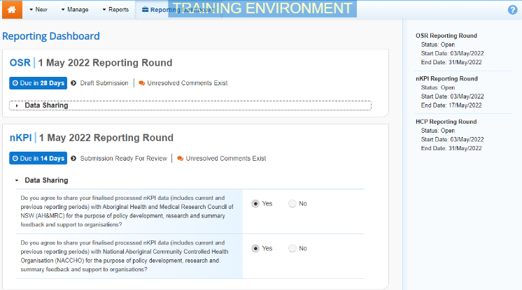
To be eligible for review, your submission’s status will need to be Submission Ready for Review.
- To open your HCP form, hover your mouse pointer to the right of the HCP reporting round text in the Reporting Dashboard and select .
The HCP form will display.
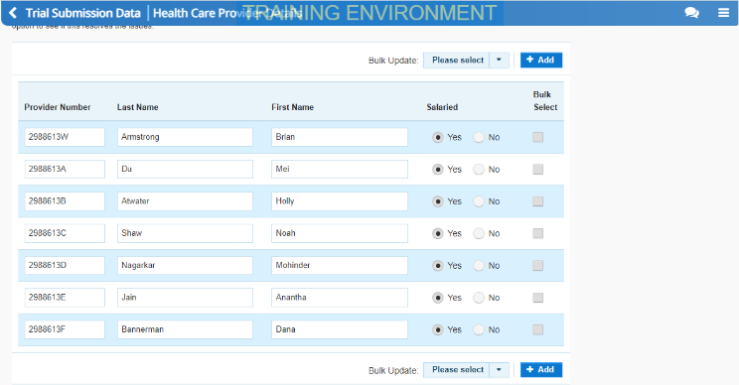
- Review the data in the HCP form, focussing on any comments left in the form by Health and Aged Care and/or your Submission Uploader.
- If needed, update any values in the required cells.
- To save your changes, select at the bottom of the form.
If you have made changes to any values and would like to add a comment explaining this, select at the top of the Notifications Tray, select a Reason, add your comment in the Additional Information field and then select .
- To exit your HCP form and return to the Data Portal home screen, scroll to the bottom of the form, and select .
The Data Portal home screen will again display with the Reporting Dashboard open.
- To progress your HCP submission through the submission workflow, select .
- In the Change Data Asset Status dialog box, in the Action field, select and select the required action.
The available actions are:
- Request Approval – Select this action to send your HCP submission to your CEO or their representative for approval.
- Approve for Submission – Select this action if you are the health service’s CEO, or nominated representative, and are approving the submission as well as reviewing it.
- Request Interim Processing – Select this action to send your HCP submission to Health and Aged Care for review prior to it going to your CEO or their representative for approval. This process is known as Interim Processing.
- Revision Required – Select this action to return your submission to the Submission Uploader for further amendment.
- In the Comment field, enter any comments regarding the action being performed on the submission.
- One of the following buttons can now be selected when submitting your HCP report, depending on the action you have selected:
  - To send your HCP submission to your CEO or their representative for approval again, select . See the Approve your HCP Submission based on Health Feedback (Submission Approver) QRG for the next step in the process.
  - To approve your HCP submission and send it directly to Health and Aged Care for processing, select . See the Process a HCP Submission QRG for the next step in the process.
  - To send your HCP submission to Health and Aged Care for initial review prior to sending it to your CEO or their representative for approval, select . See the Interim Processing of a HCP Submission QRG for the next step in the process.
  - To send your submission back to the Submission Uploader for amendment, select . See the Amend your HCP Submission based on Health Feedback (Submission Uploader) QRG for the next step in the process.
Your HCP submission has now been reviewed and either sent for re-approval or sent back to your Submission Uploader for further revision as required.

