Interim Processing of an nKPI Submission

Initiate Interim Processing (Health Service)
To start interim processing of your nKPI submission in the Data Portal:
- Open the Data Portal through Health Data Portal.
- Log in using the information provided in the Register for and Log in to the Health Data Portal QRG.
The Data Portal home screen will display with the Reporting Dashboard open.
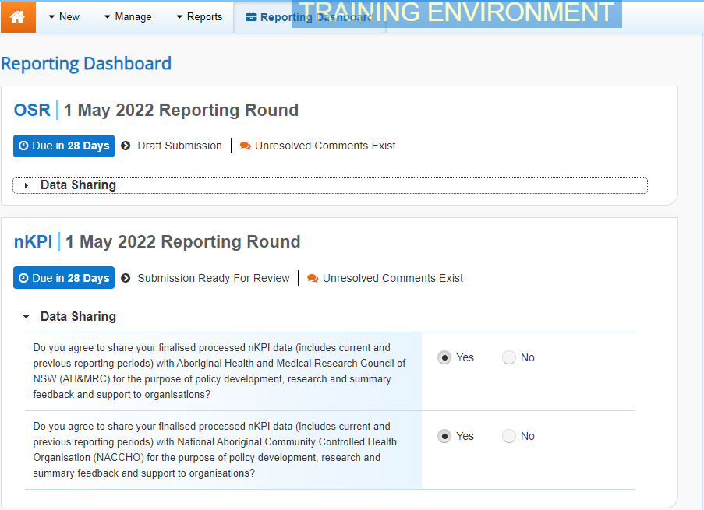
To be eligible for interim processing, your nKPI submission’s status will need to be at either Draft Submission or Submission Ready for Review, if you have the Submission Reviewer role.
- Before progressing the nKPI submission through the interim submission workflow, answer either Yes or No to the data sharing consent questions that display under Data Sharing if the questions have not already been answered.
- To save the changes, select .
- To start interim processing, select in the Reporting Dashboard and, in the Change Data Asset Status dialog box, in the Action field, select and select Request Interim Processing.
- In the Comment field, enter any comments you wish to add for the AIHW.
- To send the nKPI submission to the AIHW for interim processing, select.
The status of the nKPI submission has now been set to Interim Submitted and the AIHW can review the submission as needed to assess its suitability before it goes to your CEO, or their representative, for approval.
Review the Submission (AIHW)
To review the health service’s nKPI submission:
- Ensure the Date Portal home screen is displayed.
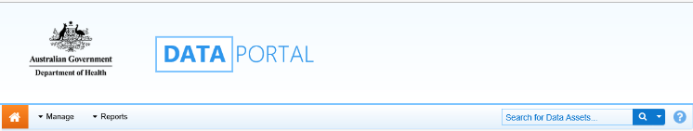
- From the Data Portal home screen, search for the nKPI submission to be reviewed.
For more information on how to search for a submission, see the Get Started in the Health Data Portal QRG.
The submission will have the status of Interim Submitted.
- Select the nKPI submission to be reviewed.
The Data Asset Details screen will display.
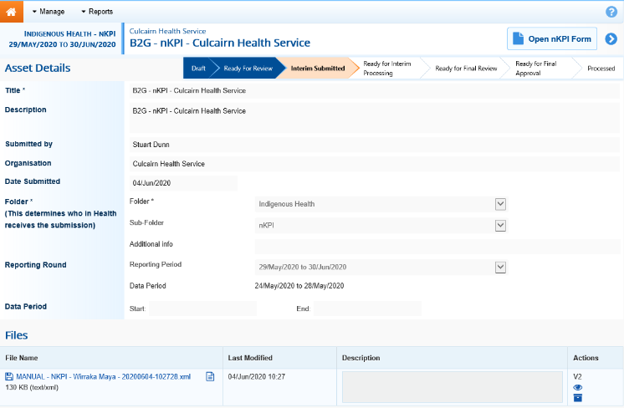
- Review the details of the submission as needed.
- To review the contents of the nKPI form, select at the top of the screen.
- Once finished, select at the bottom of the nKPI form to exit the form and return to the Data Asset Details screen.
- To action the submission, select either or the workflow progress bar at the top of the screen and, in the Change Data Asset Status dialog box, in the Action field, select and select Ready for Interim Processing.
If the health service has asked you to return the submission as it has been submitted in error, select Return to Uploader.
- In the Comment field, enter any comments about the action being performed on the submission.
- To prepare the submission for processing, select .
Process the Submission (AIHW)
To complete interim processing on the nKPI submission in the Data Portal:
- Ensure the Date Portal home screen is displayed.
- From the Data Portal home screen, search for the nKPI submission with the status of Ready for Interim Processing.
For more information on how to search for a submission, see the Get Started in the Health Data Portal QRG.
- Select the nKPI submission to be processed.
The Data Asset Details screen will display.
- Review the details of the submission as needed.
- To review the contents of the nKPI form, select at the top of the screen.
- Once finished, select at the bottom of the nKPI form to exit the form and return to the Data Asset Details screen.
- To action the submission, select either or the workflow progress bar at the top of the screen and, in the Change Data Asset Status dialog box, in the Action field, select and select Request Review to send the submission back to the health service’s Submission Reviewer, who will review the submission and move it to the next stage of the process. This action will progress the submission to the status of Submission Ready for Final Review.
Interim Processing of an nKPI Submission

- In the Comment field, enter any comments about the action being performed on the submission.
- To send the nKPI submission on to the health service’s Submission Reviewer, select .
Conduct a Final Review of the Submission (Health Service)
To conduct a final review of your nKPI submission in the Data Portal:
- Ensure the Date Portal home screen is displayed, and the Reporting Dashboard is open.
Your nKPI submission will have the status of Submission Ready for Final Review.
- To open the Data Asset Details screen for your submission, hover your mouse pointer to the right of the nKPI reporting round text in the Reporting Dashboard, select and then select Open Data Asset.
- Review the details of your submission as needed.
- To review the contents of your nKPI form, select .
- Once finished, select at the bottom of your nKPI form to exit the form and return to the Data Portal home screen.
- To action your nKPI submission from the Reporting Dashboard, select and, in the Change Data Asset Status dialog box, in the Action field, select and select Request Approval.
If changes need to be made to any of the data in your nKPI submission, select Revision Required to send the submission back to your Submission Uploader for amendment.
- To send the submission on to your CEO or their representative for approval, select.
The nKPI submission has now been sent to your CEO or their representative for final approval.
Approve the Submission (Health Service)
Interim Processing of an nKPI Submission

To approve the nKPI submission that has been through interim processing in the Data Portal:
- Ensure the Date Portal home screen is displayed.
The submission will have the status of Submission Ready for Final Approval.
- To open the Data Asset Details screen for your submission, hover your mouse pointer to the right of the nKPI reporting round text in the Reporting Dashboard, select and then select Open Data Asset.
- Review the details of your nKPI submission as needed.
- To review the contents of the nKPI form, select .
- Once finished, select at the bottom of the nKPI form to exit the form and return to the Data Portal home screen.
- To action your submission from the Reporting Dashboard, select and, in the Change Data Asset Status dialog box, in the Action field, select and select Approve for Submission.
If changes need to be made to any of the data in your submission, select Revision Required to send the submission back to your Submission Uploader for amendment.
- In the Comment field, enter any comments about the action being performed on your submission.
- To approve your submission, select.
Your nKPI submission has been progressed to the status of Processed and the submission process is now complete.

