When completing your nKPI report in the Data Portal, only those indicators you are funded for as a health service should appear in your form. For example, Maternal and Child Health services will only see indicators 01, 02, 03, 11 and 13 in their form. This means these health services won’t need to enter information for clinical services they don’t provide.
Complete nKPIs You Don’t Report on/Have Data For
There still may be times however, where you need to complete an indicator in the form that you either don’t report on or don’t have any data for.
To complete an indicator you don’t report on/have values for in the Data Portal:
- Ensure the Data Portal home screen is displayed, and the Reporting Dashboard is open.
- To commence creating your nKPI data asset for the current reporting round, select to the right of the nKPI data asset text in the Reporting Dashboard.
If your data asset has already been created/is in draft, select to open the form.
The nKPI form will display.
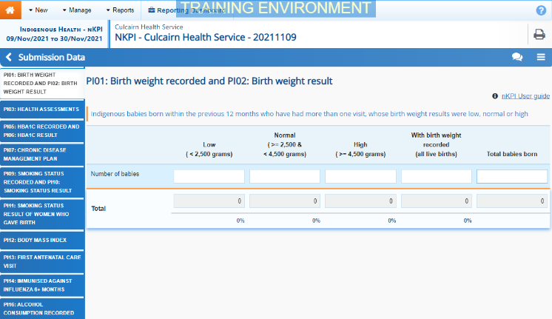
To complete an indicator you don’t report on/have values for, you will need to either leave the cells on the indicator blank or enter zeros. Which of these options you take depends on your situation.

If you are not funded to report on the indicator:
- If the indicator is blank, enter a value in any cell on the indicator to bring up and then remove the value.
If the indicator already has zeros in the cells, remove these using the Clear all cells option under the Options Menu () on the blue Submission Data bar towards the top of the form.
- To save the indicator as blank, select at the bottom of the form.
- In the Notifications Tray, next to the data validation flag that displays, select .
- In the Respond to comment dialog box, in the Reason field, select and select Zero results/Blanks - Not funded to provide this service, indicator not applicable.
- Enter any Additional Information if needed.
- To continue, select 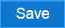.

If you are funded to report on only part of the indicator (PI03 only):
- Enter your data into the applicable cells of PI03 and leave the rest of the cells blank.
- Select at the bottom of the form.
- In the Notifications Tray, next to the data validation flag that displays, select .
- In the Respond to comment dialog box, in the Reason field, select and select Zero results/Blanks - Not funded to provide this service, indicator not applicable.
- In the Additional Information field, note that your service is only funded for part of the indicator.
- To continue, select .

If you are funded to report on the indicator but didn’t see any clients for the collection period:
Complete nKPIs You Don’t Have Data For
- Enter zeroes into the indicator’s cells by selecting on the blue Submission Data bar towards the top of the screen and selecting Populate empty cells with zeros.
- If the indicator has a Total Clients column (or similar), replace the zeros in this column with your total client values.
- If you wish to add an explanation of why the service wasn’t provided for the collection period, select at the top of the Notifications Tray and select Zero results/Blanks - Service provided, but no applicable clients seen in the period from the list.
- Enter any Additional Information if needed.
- To continue, select .

If you have provided the service but do not have the values for some reason:
- If the indicator is blank, enter a value in any cell on the indicator to bring up and then remove the value.
If the indicator already has zeros in the cells, remove these using the Clear all cells option under the Options Menu () on the blue Submission Data bar towards the top of the form.
- To save the indicator as blank, select at the bottom of the form.
- In the Notifications Tray, next to the data validation flag that displays, select .
- In the Respond to comment dialog box, in the Reason field, select and select Zero results/Blanks - Data could not be extracted.
- Enter any Additional Information if needed.
- To continue, select .

- To save any other changes to the indicator if needed, select .
- To exit the form and return to the Data Portal home screen, scroll to the bottom of the form and select 

