To amend your nKPI submission in the Data Portal as a *Submission* *Uploader*, once it has been returned to you by the AIHW:

**Amend your nKPI Submission based on AIHW feedback (Submission Uploader)**

1. Open the Data Portal through [Health Data Portal](https://dataportal.health.gov.au/).
2. Log in using the information provided in the *Register for and Log in to the Health Data Portal* QRG.

The Data Portal home screen will display with the Reporting Dashboard open.

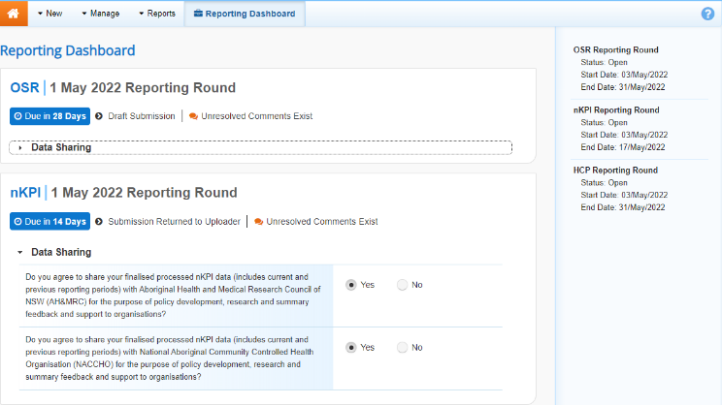

1. To open your nKPI form, hover your mouse pointer to the right of the nKPI reporting round text in the Reporting Dashboard and select Open Submission Form.

The nKPI form will display.

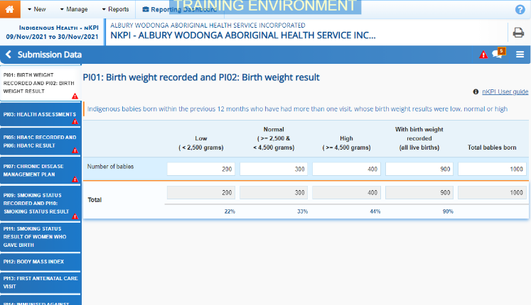

Any indicators containing AIHW comments that need responding to will display a data validation flag on the corresponding tab. The *Notifications Tray* will display as open for each of these indicators in the top right-hand corner of the form, so you can see the detail of the comments the AIHW has made.

1. For each indicator with data validation flags data validation flag, review the comment(s) made by the AIHW in the **Notifications Tray**.
2. If a value needs to be changed to address the comment made by the AIHW, update the value(s) in the required cell(s).

Note If you are unsure which value(s) needs to be updated, in the *Notifications Tray*, select the Eye button for the applicable data validation flag and the applicable cell(s) will be highlighted in red.

Note Any changes made to values in the form at this point will appear as an extra line with *Current* next to the updated field highlighted by an orange border. This allows all users viewing the nKPI form, including the AIHW, to identify the original value submitted by the health service and the value that was updated due to AIHW feedback.

1. To respond to a comment made by the AIHW, in the **Notifications Tray**, select the Respond button.
2. Enter your comment in the **Additional Information** field.
3. To save the comment, select the Save button.
4. Repeat the process for each AIHW comment in the form.
5. To exit your nKPI form and return to the Data Portal home screen, scroll to the bottom of the form, and select Close.

The Data Portal home screen will again display with the Reporting Dashboard open.

1. To progress your nKPI submission, select the Submission Returned to Uploader link.
2. In the Change Data Asset Status dialog box, select the the down arrow in the **Action** field and select the action needed.

The available actions are:

* **Request Review** – Select this action to send your nKPI submission to your *Submission Reviewer* for review again.
* **Request Approval** – Select this action to send your nKPI submission back to your CEO or their representative for approval.

Note If you can approve the nKPI submission yourself, you will also see the *Approve for Submission* option in the action list. This allows you to approve the submission and submit it directly to the AIHW for processing again.

1. In the **Comment** field, enter any comments about the action being performed on the submission.
2. One of the following buttons can now be selected when submitting your nKPI report, depending on the action you have selected:
   1. To send your nKPI submission to your *Submission Reviewer* for review again, select the Request Review button. See the *Review your nKPI Submission based on AIHW feedback (Submission Reviewer)* QRG for the next step in the process.
   2. To send your nKPI submission back to your CEO or their representative for approval, select the Request Approval. See the *Approve your nKPI Submission based on AIHW feedback (Submission Approver)* QRG for the next step in the process.

**Amend your nKPI Submission based on AIHW feedback (Submission Uploader)**

Your nKPI submission has now been amended and either sent back to your S*ubmission Reviewer* for further review or sent straight on to your CEO or their representative for approval.

An automated email will be sent to all users within your health service that have been assigned the applicable role in the Data Portal (*Submission* *Reviewer* or Submission *Approver*) notifying them the nKPI report has been submitted to them again for action.