This guide details the different sections of the Data Portal home screen and what they are used for.
Get Started in the Health Data Portal
The Data Portal home Screen
Upon logging into the Data Portal, you will arrive at the Data Portal home screen (for more information on how to log in, see the Register for and Log in to the Health Data Portal QRG).
The Data Portal home screen is divided into three sections:
- Header
- Search and Action
- Data Assets
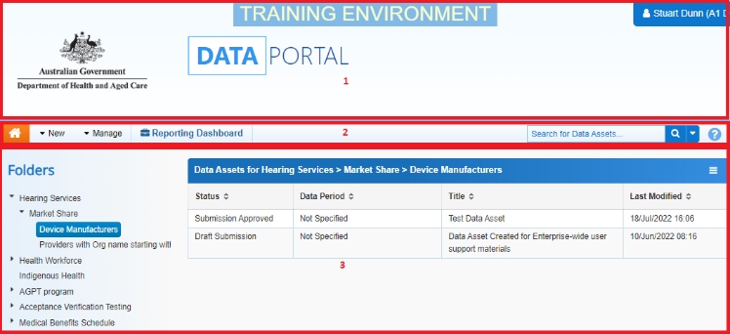
The Header Section (1)
The Header section appears on every screen within the Data Portal and is where you can access your user profile to either update your existing profile or request the creation of a new one.
- To manage your user profile, select next to your name in the top right-hand corner of the screen.
The following options are available:
- : Allows you to edit your user profile.
- : Allows you to request a new profile in another organisation, switch between profiles and set a different default profile.
- : Allows you to request a new profile in another organisation.
- : Logs you off from your current session of the Data Portal.
The Header section also contains the Department of Health’s crest, which will take you to the Department of Health’s website when you select it.
The Search and Action Section (2)
The Search and Action section is divided into two areas – Search and Action.
The Search area allows users to search for data assets in the Data Portal. Search results appear in the Data Assets section at the bottom of the screen.
To conduct a data asset search:
- Enter a keyword(s) for the data asset in the Search for Data Assets… field.
- To refine the search further, select next to the Search for Data Assets… field and select the check box relating to the appropriate Submission Status, Publication Status or State for the data asset(s) you are searching for.
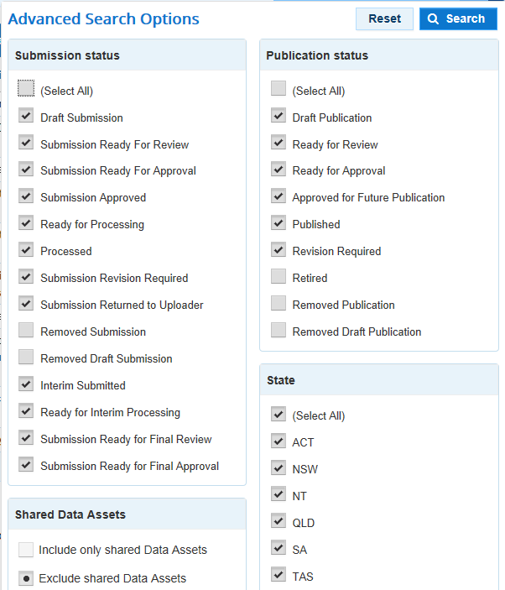
- The Shared Data Assets section in the Advanced Search Options dialog box allows you to refine your search according to whether a data asset is shared or not (a data asset can be shared exclusively with one user or with multiple users).
- To run the search, select .
A list of data assets with the selected parameters will display.
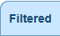 will now display to identify that the view has been filtered.
  - To clear the search results and display all data assets again, select in the Search for data assets… field.
  - To reset the check boxes under More Search Options, select .
Get Started in the Health Data Portal
The Action area of the Search and Action section contains a series of options that perform different Data Portal functions.
You will only see the options that relate to the functions you have access to. For example, if you don’t have the ability to create or update user records in the Data Portal, you will not see the Manage > Users option.
The following is a list of options available in the Data Portal and the functions they perform:
- The button allows users to navigate back to the home screen from any screen within the Data Portal.
- 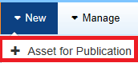: Allows the user to publish data assets for other users to view in the Data Portal. For Health Administrators and selected users.
- 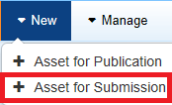: Allows the user to submit data assets in the Data Portal.
- 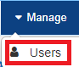: Allows the user to create new user profiles for themselves or another user or edit existing user profiles. For organisation User Administrators only.
- 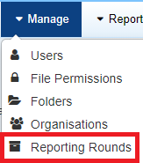: Allows the user to create new reporting rounds or edit the details of existing reporting rounds. For Department of Health Indigenous Health Administrators only.
- 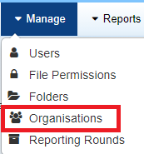: Allows the user to create new organisation records or edit the details of existing organisations. For Health Administrators only.
- 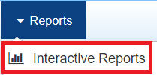: This option takes the user to their QLIK Interactive Reports, where they can view and filter reporting data in an interactive dashboard (e.g. the Health Service nKPI Report).
- 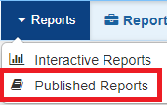: This option takes the user to their published reports that have been made available to them by the Department. They can then save, print and share these reports as needed.
The Data Assets Section (3)
The Data Assets section of the Data Portal home screen is divided into two areas – The Folders area and the Data Assets list area
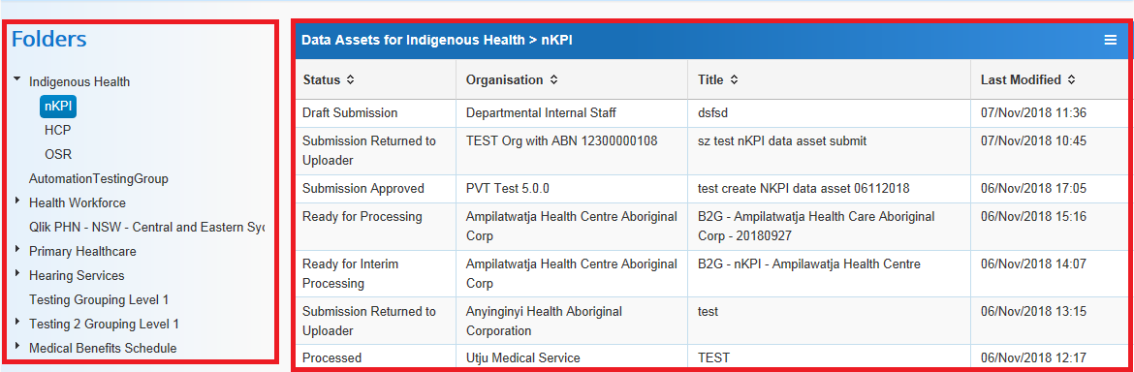
The Folders area displays all the folders you have access to along with the folder you currently have selected (highlighted in blue). The folder you have selected determines the data assets that display in the Data Assets list.
To browse folders:
- Select the folder’s name.
The data assets in the chosen folder will appear in the Data Assets list on the right-hand side of the screen.
If required, you can select next to a folder to open it up and examine its sub-folders.
  - To sort your folders by name, select and select Sort Folders by name. To undo the sort, select Sort Folders by last modified.
Get Started in the Health Data Portal
  - To hide your folders from view, select and select Hide Folders. To return your folders, select Show Folders.
The Data Assets list area displays the data assets that you are currently viewing.
There are several actions you can perform when viewing data assets:
  - To view the details of a data asset, select the data asset in the list. This will take you to the Data Assets Details screen.
  - To sort the displayed list of data assets in a particular order, select the required column heading. The list can be sorted according to Status, Organisation, Title or (Date) Last Modified.
  - If more than one page of data assets is available, select the desired page number, or the forward or back button at the bottom of the screen to view more data assets .

