To review your service’s IAHP PHC AWP submission in the Data Portal, as a *Submission* *Reviewer*:

**Review your IAHP PHC AWP (Submission Reviewer)**

1. Open the Data Portal through [Health Data Portal](https://dataportal.health.gov.au/).
2. Log in using the information provided in the *Registering for and Logging in to the Health Data Portal* QRG.

The Data Portal home screen will display with the Reporting Dashboard open.

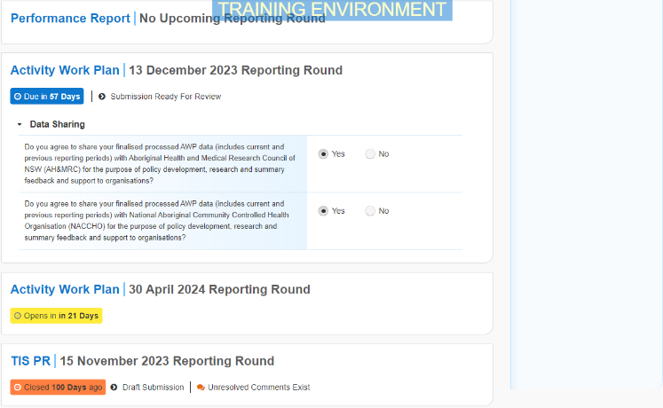

 To be eligible for review, your AWP’s status will need to be *Submission Ready for Review*.

1. To open your IAHP PHC AWP form, hover your mouse pointer to the right of the Activity Work Plan reporting round text in the Reporting Dashboard and select Open Submission Form.

 If you need to change the *Title* or *Description* of the AWP, you can do so in the Data Asset Details screen by selecting Nore Details next to Open Submission Form and then selecting *Open Data Asset.*

The IAHP PHC AWP form will display.

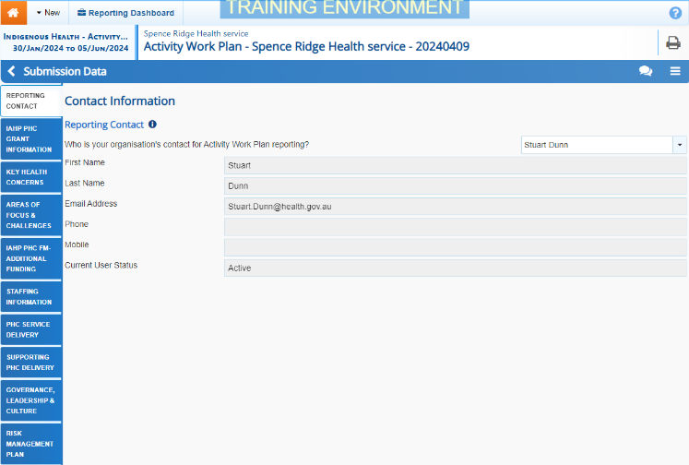

Any sections that still have completion flags to be addressed will display a data validation flag on the corresponding tab. If a section has a completion flag that has been responded to by your *Submission* *Uploader* or a new internal comment has been entered by your *Submission* *Uploader*, it will show a speech bubble on the corresponding tab.

1. Review the information in each section of the form and, if needed, update/add any information, saving as you go.
2. To add a comment about any changes you have made to the information or to ask the *Submission Uploader* to amend the data, hover your mouse pointer to the right of the applicable data validation flag title in the **Notifications Tray**, and select the Respond button next to the most recent comment.

 If the *Notifications Tray* doesn’t display, select Open Notification tray - some comments require action or Open Notification tray - some comments require action at the top of the form to open it so you can address the data validation issues/read the comments that display.

1. Select the down arrow in the **Reason** field that displays and select the reason you are adding a comment from the drop-down list.
2. Enter your comment in the **Additional Information** field.
3. To save the comment, select the Save button.
4. Repeat this process for any other values in the form that need to be changed.

The comment has been added and can be viewed by anyone accessing your submission.

Note If you wish to add an internal comment explaining the changes you have made, select Create New Comment at the top of the *Notifications Tray*, and add the details.

1. To exit your AWP form and return to the Data Portal home screen, scroll to the bottom of the form, and select Close.

The Data Portal home screen will again display with the Reporting Dashboard open.

1. Before progressing the report through the submission workflow, answer either **Yes** or **No** to the data sharing consent questions that display under **Data Sharing** if the questions have not already been answered.
2. To save the changes, select Save.
3. To progress your IAHP PHC AWP through the submission workflow, select the Submission Ready for Review link.

The Change Data Asset Status dialog box will display.

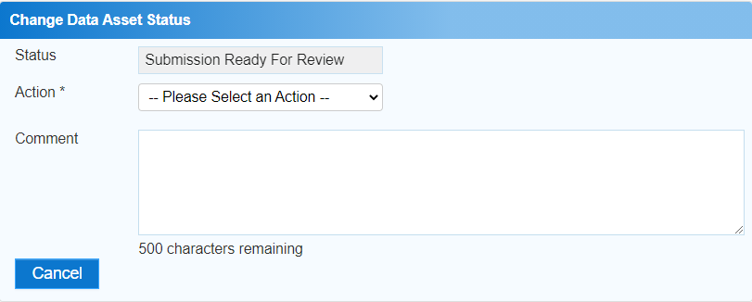

1. In the **Action** field, select the down arrow and select the appropriate action.

The available actions are:

* **Request Approval** – Select this action to send your AWP to your CEO or their representative for approval.
* **Approve for Submission** – Select this action if you are the health service’s CEO, or nominated representative, and are approving your AWP as well as reviewing it.
* **Request Interim Processing** – Select this action to send your AWP to your DSS FAM for review prior to it going to your CEO or their representative for approval. This process is known as *Interim Processing*.
* **Revision Required** – Select this action to return your AWP to the *Submission Uploader* for amendment.

1. In the **Comment** field, enter any comments about the action being performed on your AWP.
2. One of the following buttons can now be selected when submitting your AWP, depending on the action you have selected:
   1. To send your IAHP PHC AWP to your CEO or their representative for approval, select the Request Approval. See the *Approve your IAHP PHC AWP (Submission Approver)* QRG for the next step in the process.
   2. To approve your IAHP PHC AWP and send it directly to your DSS FAM for processing, select the Approve for Submission button. See the *Process an IAHP PHC AWP* QRG for the next step in the process.
   3. To send your IAHP PHC AWP to your DSS FAM for review prior to sending it to your CEO or their representative for approval, select the Request Interim Processing button. See the *Interim Processing of an IAHP PHC AWP* QRG for the next step in the process.

**Review your IAHP PHC AWP (Submission Reviewer)**

* 1. To send your IAHP PHC AWP back to the *Submission Uploader* for amendment, select the Revision Required button. See the *Amend your IAHP PHC AWP (Submission Uploader)* QRG for the next step in the process.

Your IAHP PHC AWP has now been reviewed and either sent on to your CEO or their delegate for approval or sent back to your *Submission Uploader* for revision if needed.