Overview
The QLIK Stakeholder nKPI & OSR Report contains 45 sheets that NACCHO, affiliate organisations and DSS Funding Agreement Managers (FAMs) can use to obtain a graphical view of health services’ aggregated nKPI data, back to December 2014. These are made up of a Health Service Snapshot sheet, an OSR – Summary sheet, an nKPI – Client summary sheet, an nKPI – Indicators over Time sheet, an nKPI – Recent Results sheet, an Executive Summary sheet, three nKPI Summary sheets covering the three indicator groupings, a Closing the Gap Target #2 sheet, a National Trajectories sheet, 23 individual indicator sheets, two Data Export sheets, the OSR – Masterlist sheet, OSR – Workforce Summary and Detail sheets, the OSR – Episodes of Care and Client Numbers sheet, the nKPI Definitions sheet and the Notes and Exclusions sheet.
When working in these sheets, you can compare data for selected health services for the current collection period to their data from previous periods or to the data for other health services in a particular comparison group, which you can create within the sheets. Comparison groups can be built using different elements such as remoteness, service size, state, and workforce characteristics.
Upon accessing the QLIK Stakeholder nKPI & OSR Report, the Stakeholder nKPI & OSR Report screen displays, containing individual “apps” for the different sheets contained within, as detailed above.
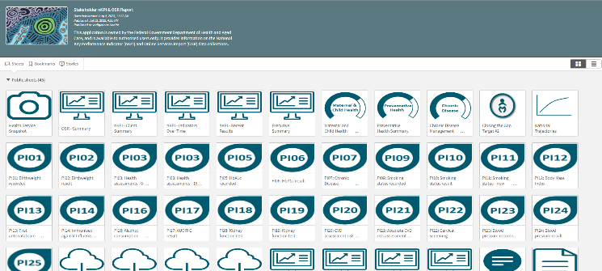

The Health Service Snapshot sheet
The Health Service Snapshot sheet shows different aspects of summary information for your selected health service. This summary information includes: a service summary, Indigenous population breakdown, health assessment information, workforce FTE information, and targets information for the selected service.
- To display results for a particular health service, select the filter field at the top of the sheet and select the health service you wish to view the snapshot for.
- To continue, select .
The Health Service Snapshot sheet will update to display the snapshot for the selected health service.
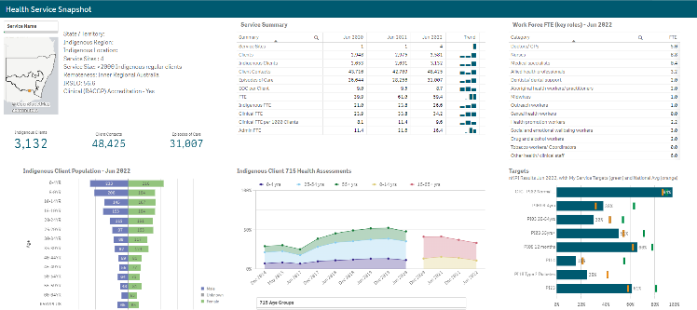
The following are the key elements of the Health Service Snapshot sheet:
- Top left section – contains a summary profile of the selected health service, including information about their indigenous location, IRSEO rating and Indigenous client numbers.
- Indigenous client population Jun 2023 graph– shows the breakdown of Indigenous clients (in raw numbers) for the selected health service, by age and gender.
- Service Summary table – contains key summary organisational information for the selected service, such as their client numbers, episodes of care, and FTE numbers. This information displays for the three most recently completed collection periods.
- Indigenous client 715 health assessments – shows the percentage of health assessments conducted by the selected health service, by age group and collection period. The data in the graph can be filtered by age group, gender and client and staff Indigenous status.
- Work Force FTE (key roles) – Jun 2023 table – shows the number of FTE, per position type, for the selected health service.
- Targets graph – shows the selected health service’s most recent results for the five indicators (across seven focus areas) the service has been asked to enter their self-determined targets for in the nKPI form. It also shows the service’s targets for each indicator for the most recently completed collection period, so you can see whether they have achieved their target, exceeded it, or fallen short. Lastly, the national average result for each focus area is shown, to give context to the health service’s results and targets.
The OSR – Summary sheet
The OSR – Summary sheet contains key information from the Online Services Report (OSR) which is submitted by health services each July.
The OSR – Summary sheet contains two sections:
- Summary over Time
- Summary by Service
The Summary over time section
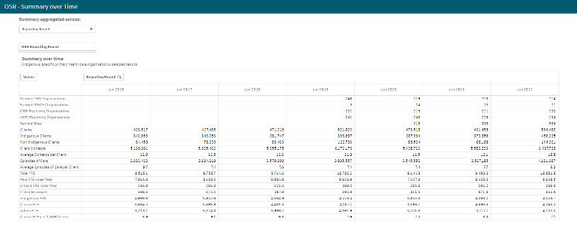
The Summary over time section of the sheet contains a table showing key OSR summary information for all health services nationally (such as client numbers, episodes of care, FTE numbers and some funding information) for all collection periods, back to June 2016, allowing you to easily compare the information across different years.
If required, you can compare the OSR summary information for services of different states, remoteness, and service size.
- To do this, first select above the table and select a particular year you wish to focus on.
- Once you have done this, you can then use at the top of the sheet and select the element you wish to compare the data for.
The table will then update to display information for the selected collection period, by the selected element.
The Summary by Service section
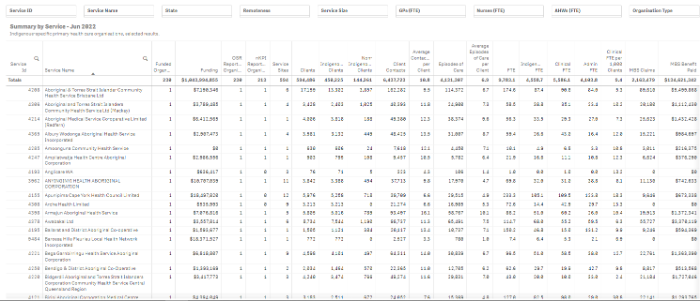
The Summary by Service section of the sheet contains a table displaying the same key summary information, but for individual health services.
If needed, you can then filter the information using the different filter fields above the table. For example, you may only want to display the OSR summary information for services from a particular state or with a particular remoteness category. You may also wish to display the information only for certain types of services or for services with a certain number of GPs. You can of course display the information for a particular service as well if needed.
You can export the selected information from either of the tables by right-clicking on the table and selecting Download as… > Data.

The nKPI – Client Summary sheet
The nKPI – Client Summary sheet contains key client information from the national Key Performance Indicator (nKPI) report, which is submitted by health services each January and July.
The nKPI – Client Summary sheet contains two sections:
- Summary by Reporting Round
- Summary by Service
The Summary by Reporting Round section
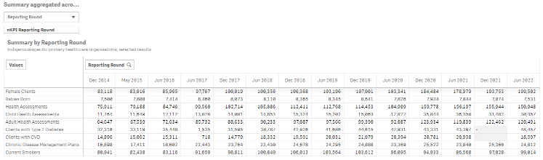
The Summary By Reporting Round section of the sheet contains a table showing key nKPI summary information for all health services nationally (such as the number of regular clients, clients with Type 2 Diabetes and the number of current smokers) for all collection periods, back to December 2014, allowing you to easily compare the information across different years.
If required, you can compare the nKPI client summary information for services from different states, remoteness, and service size.
- To do this, first select above the table and select a particular year you wish to focus on.
- Once you have done this, you can then use at the top of the sheet and select the element you wish to compare the data for.
The table will then update to display information for the selected collection period, by the selected element.

The Summary by Service section
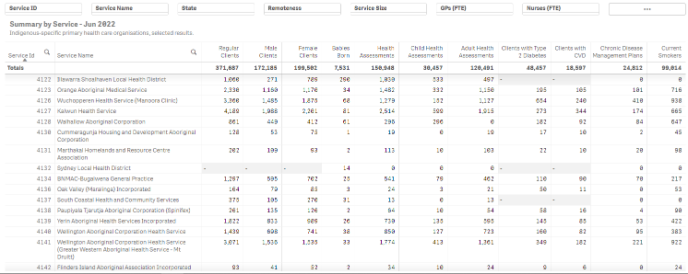
The Summary by Service section of the sheet contains a table displaying the same key summary information, but for individual health services.
If needed, you can then filter the information using the different filter fields above the table. For example, you may only want to display the client information for services from a particular state or remoteness. You may also wish to display the information only for certain types of services or for services with a certain number of GPs. You can of course display the information for a particular service as well if needed.
You can export the selected information from either of the tables by right-clicking on the table and selecting Download as… > Data.
The nKPI – Indicators Over Time sheet
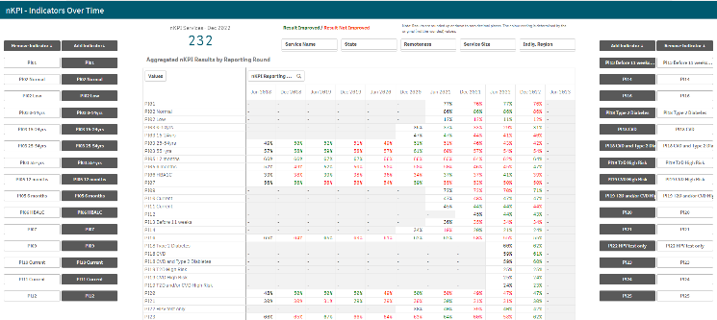
The nKPI – Indicators over Time sheet contains the Aggregated nKPI Results by Reporting Round table, which displays aggregated national results for all indicators/focus areas for all collection periods, back to June 2018. Where the results for an indicator/focus area are improving, the values will display in green. Where the results are getting worse over time, they will display in red.
Where there has been a change to an indicators specification, a – will display for that indicator prior to the specification change occurring.
- To remove an indicator’s/focus area’s results from the table, simply select the applicable button (e.g., ) in the Remove Indicator column.
The filter fields at the top of the sheet can be used to filter the results in the table as/if needed. For example, you may wish to only show the aggregated results for services from a particular state using .
To display the results for a particular health service, simply select the service using .
The nKPI – Recent Results sheet
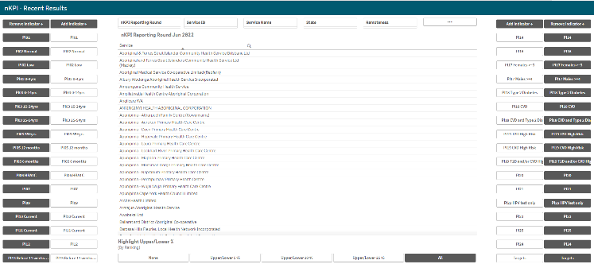
The nKPI – Recent Results sheet allows you to view results for multiple health services, across multiple indicators, on the one sheet. All health services currently required to report their nKPIs will display alphabetically on the sheet by default, in a table in the middle of the sheet.
- To view indicator results for the listed health services, select the applicable indicator button (e.g., ) from the Add Indicator column on either the left or right-hand side of the sheet.
The table will update to display the results for the selected indicators.
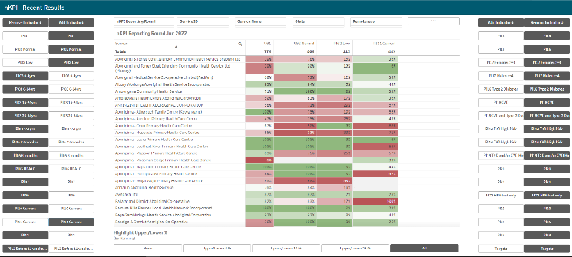
The filter fields at the top of the screen can be used to filter the results in the table as/if needed. For example, you may wish to only show the results for services from a particular state using .
In addition to health service results, you can also add health service targets to the table using .
The Highlight Upper/Lower % section
The Highlight Upper/Lower % section at the bottom of the sheet can be used to colour-code the results displaying in the table. For example, if is selected, the services whose results for a particular indicator are in the top 10% will be highlighted in green , while the results for the services in the bottom 10% for the indicator will be highlighted in red . The closer a service’s results are to the top, the darker green they will be, while the closer a service’s results are to the bottom, the darker red they will be.
The nKPI Result Distribution sheet
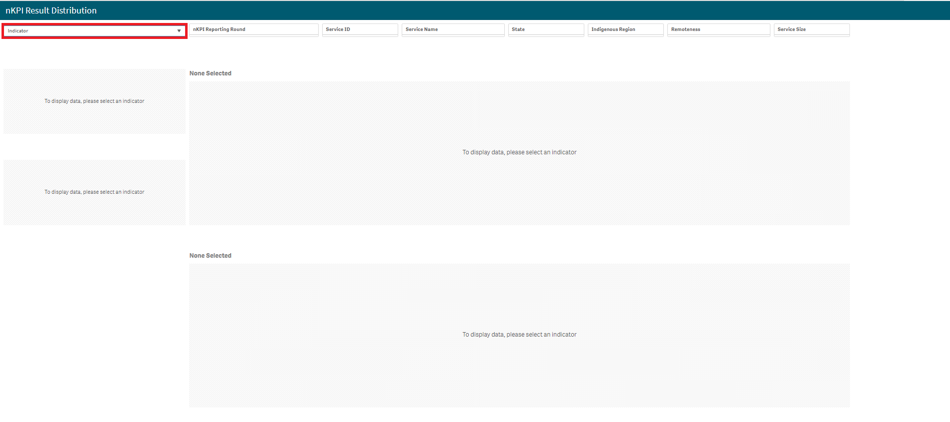
The nKPI Result Distribution sheet allows you to see the distribution of results for a selected indicator over percentile bands and over time. You can then filter the results if needed to see these distributions for a particular state, remoteness or service size or a combination of these.
- To display results for a particular indicator/focus area, select the filter field at the top of the sheet and select the indicator/focus area you wish to display the result distribution for.

The sheet will now update to show the result distribution information for the selected indicator/focus area.
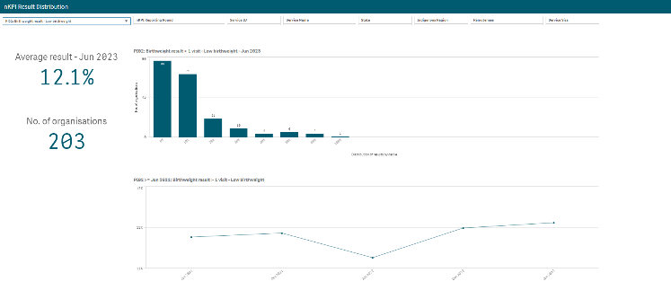
The nKPI Result Distribution sheet contains the following sections:
- Average result – June 2023 – displays the national average percentage for the selected indicator/focus area.
- No. of organisations – displays the number of organisations whose results are included in the distribution
- Top indicator/focus area graph – shows the number of health services whose results for the selected indicator/focus area fall within a particular percentile band.
- Bottom indicator/focus area graph – shows the national average results for the selected indicator/focus area, for each collection period, back to June 2021
If needed, you can filter the displayed results by state, remoteness etc using the filter fields at the top of the sheet.
The Executive Summary sheet
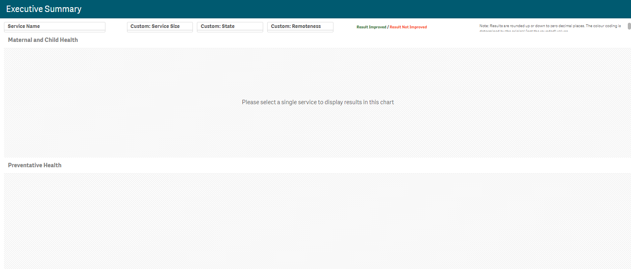
The Executive Summary sheet of the QLIK Stakeholder nKPI & OSR Report allows you to see your selected health service’s results for the three most recent collection periods for each indicator, by indicator grouping. It also shows their targets and how their results compare to the results of the pre-determined comparison groups sourced from the QLIK nKPI Summary sheets.
- To display results for a particular health service, select the filter field at the top of the sheet and select the health service you wish to view the summary data for.
- To continue, select .
The Executive Summary sheet will now update to display summary nKPI information for the selected health service.
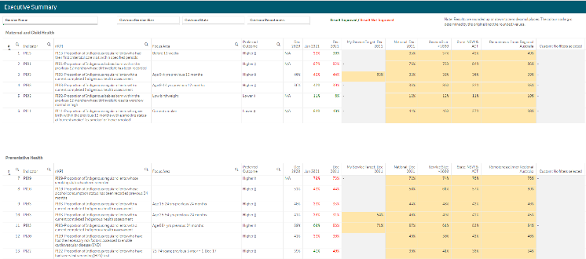
The following are the key elements of the Executive Summary sheet:
- Custom filter fields – display at the top of the sheet and allow you to build your own customised comparison group, for which results will then display in the Comparison group table.
- Indicator and nKPI columns – describe each of the indicators included in the table for the applicable grouping.
- The Focus Area column - where applicable, displays the focus area for the indicator (for example Low birthweight for PI02 or Current smoker for PI10).
- The Preferred outcome column – informs you whether the desired result for the indicator is for a higher or lower result
- Collection period columns – shows your selected health service’s results for the last three collection periods for each of the indicators in the specified grouping. If a result is better than the corresponding result for the previous collection period it will appear in green. If a result is worse than the corresponding result for the previous collection period it will appear in red.
- The My Service Target column – shows your selected health service’s self-determined target for the most recent collection period for each of the applicable indicators.
- The comparison group table – shows the results for the most recently completed collection period for the comparison groups shown in the nKPI summary sheets and the customised comparison group, that can be set using the custom filter fields at the top of the sheet.
The nKPI Summary sheets
The Stakeholder nKPI & OSR Report contains three nKPI Summary sheets:
- Maternal and Child Health (shown in this guide)
- Preventative Health
- Chronic Disease Management
- To open one of the nKPI Summary sheets, select the top half of the app for the required sheet on the Stakeholder nKPI & OSR Report screen.
The selected nKPI Summary sheet will display.
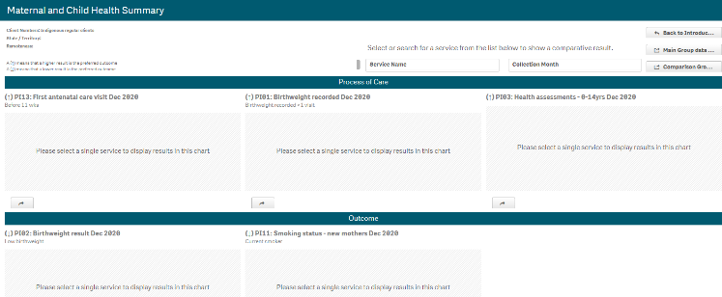
- To display results for a particular health service, select the filter field at the top of the sheet and select the health service you wish to view the summary data for.
- To continue, select .
NACCHO and state sector support organisations will only be able to select from those health services who have agreed to share their processed data with them.
The sheet will now update to display summary data for the selected indicator grouping.
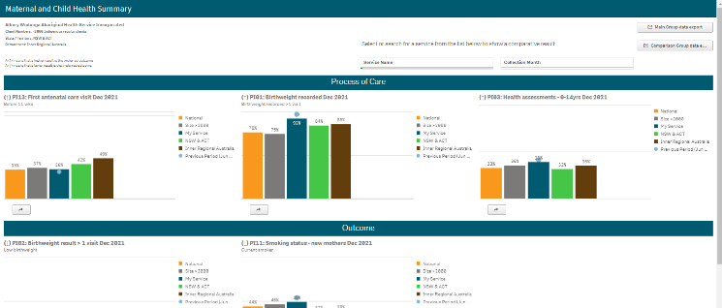
The top half of each of the summary sheets shows how the selected health service’s data for the applicable Process of Care indicators, for the current (dark blue bar) and immediately previous collection periods (light blue dot) compares to the national average (orange bar) and the results for services of the same size (grey), state (green) and remoteness (brown).
The bottom half of the sheet contains the same information as the top half of the sheet, but for the Outcome indicators.
Other nKPI Summary Sheet Functions/Buttons
- An arrow displays next to the title of each indicator in the sheet and will point up if a high result is the preferred outcome for the indicator or down if a low result is preferred.
- This button displays beneath each indicator graph and, when selected, opens the individual sheet for the selected indicator.
- Select this button to display (in table form) nKPI data for the selected health service(s) for every data collection period, back to December 2014. From here, you can export the data to Excel as needed by right clicking on the table, selecting Download as… > Data and then selecting the link to download the file.
For more information, see the Data Export – Main Group sheet section below.
- Select this button to display (in table form) the national data set for every indicator, for every data collection period, back to December 2014. From here you can export the data to Excel as needed by right clicking on the table, selecting Download as… > Data and then selecting the link to download the file.
For more information, see the Data Export – Comparison Group sheet section below.
The Preventative Health and Chronic Disease Management Summary sheets are in the same format and contain the same parameters as the Maternal and Child Health Summary sheet, so they are not specifically covered in this guide.
The Closing the Gap Target #2 sheet
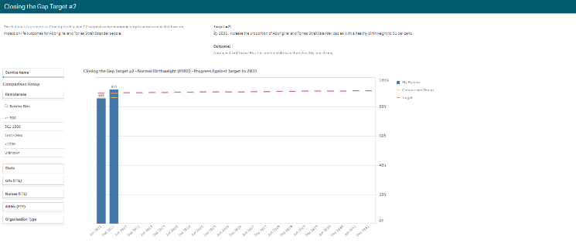
- To display the results for a particular health service, select the filter field on the left-hand side of the sheet. and select the required health service.
- To continue, select .
The Closing the Gap Target #2 sheet shows how the selected health service’s national PI02 healthy birthweight results (the blue bars) compare to the Closing the Gap Target #2 (represented by ) which is to increase the proportion of Aboriginal and Torres Islander babies with a healthy birthweight to 91% by 2031.
The comparison group (displaying as ) that displays in the graph defaults to be the national average but can be changed if needed by creating your own customised comparison group using the Comparison Group section on the left-hand side of the sheet.
In addition to the graph, the data contained within this sheet will also display as a data table on the right-hand side of the sheet. The data in this table can be exported to Excel as needed by right-clicking on the table and selecting Download as… > Data.

The National Trajectories sheet
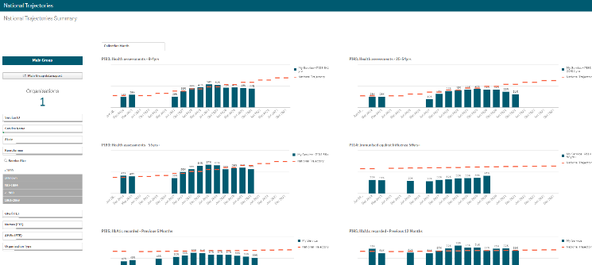
The National Trajectories sheet displays the national nKPI results (represented by the blue bars) along with the corresponding national trajectories (represented by ) back to December 2014, for the five indicators that have had national trajectories set for them by the AIHW. There are eight graphs on the sheet across the five applicable indicators, due to some of the indicators containing multiple result bands.
Main Group Section
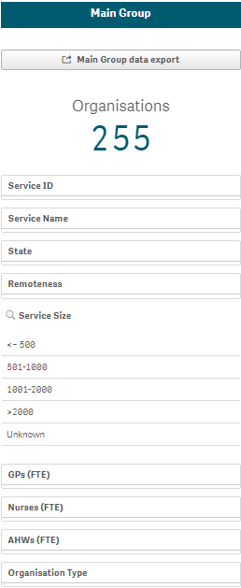
The Main Group section of the National Trajectories sheet displays on the left-hand side of the sheet and can be used to filter the bar graphs for each of the applicable indicators to display results for health services, states, remoteness categories etc, rather than the default national results.
- To do this, select the applicable filter field(s) 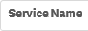 in the Main Group section (e.g., Service Name, as you may wish to see the results against the set trajectories for a particular service).
- Select the applicable option from the list that displays, and then select .
- Repeat the process for any other filters to be added.
When this is done, the selected filter(s) will be applied to each of the graphs and the results (represented by the blue bars) will update accordingly.
To remove your selection(s), simply select against the selection in the grey Selection Bar at the top of the screen 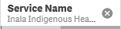.
The button detailed above for the nKPI Summary sheets, is also available in the National Trajectories sheet.
Individual Indicator sheets
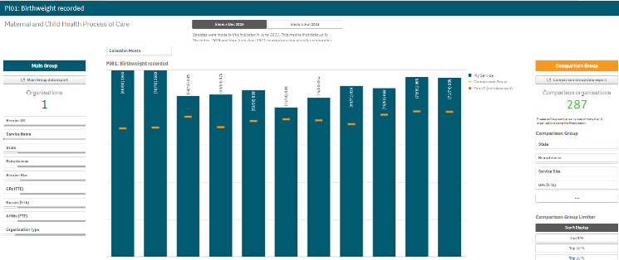
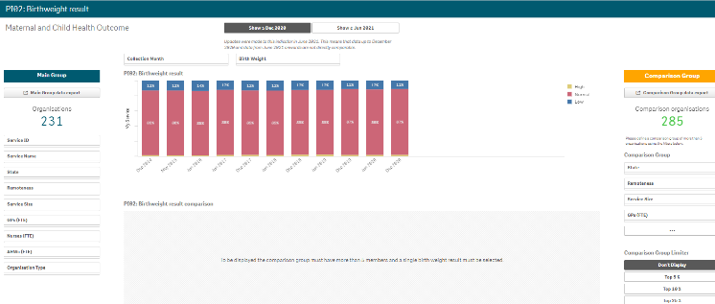
In addition to the summary sheets for the three indicator groupings, the QLIK Stakeholder nKPI & OSR Report also contains individual sheets for each of the indicators.
The screenshots shown above are of PI01: Birthweight recorded and PI02: Birthweight result as they represent the two different individual nKPI sheets (single dimension indicator sheets and sheets for indicators with multiple result bands). The features detailed below are common to both sheet types.

Layout view/Main Screen Window
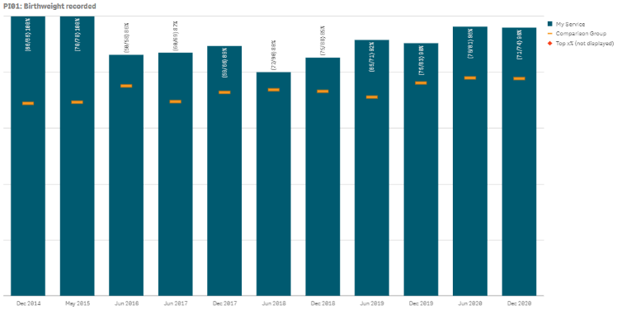
The main section of an individual indicator sheet shows, by default, the results for the selected health service for the selected indicator, back to December 2014, using a bar graph.
The line on each bar of the graph represents the results of any selected comparison group for each collection period. If you have not yet created a comparison group, this will represent the national averages for all health services.
For the five indicators for which the AIHW has set national trajectories, a line will appear on the graph from June 2021 onwards, showing the health service’s self-determined targets for the indicator.
Any comments entered in the nKPI form by either the health service or the AIHW regarding the service’s data will be visible through the Submission Comments tab.
Main Group Section
The Main Group section of the individual indicator sheets within the QLIK Stakeholder nKPI & OSR Report displays on the left-hand side of each of the sheets and can be used to filter the bar graph to display results for health services, states, remoteness categories etc, rather than the default national averages.
- To filter the national averages initially displayed in the graph, select the applicable filter field in the Main Group section (e.g., Service Name, as you wish to compare the results for a particular service to those of the rest of their state).
For NACCHO and sector support organisations, you will only be able to select from those applicable health services who have agreed to share their processed data with you.
- Select the applicable option from the list that displays and then select .
The selected filter will be applied to the graph and the results will update accordingly.
- Repeat the process for all other filters to be added.
To remove any of your selections, simply select against the selection in the grey Selection Bar at the top of the screen .
Comparison Group Section
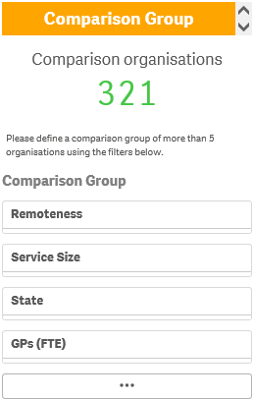
The Comparison Group section displays on the right-hand side of all individual nKPI sheets and is used to build a comparison group of health services sharing similar characteristics (such as state, remoteness category etc). When a comparison group is created, the graph will be redrawn and the on the graph will now represent the results of the selected comparison group rather than the default national averages.
- To create your comparison group, select the applicable option 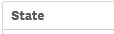 in the Comparison Group section (e.g., State as you wish to compare the state results to those of a particular health service within that state).
- Select the applicable option from the list that displays, and then select .
- Repeat the process for any other characteristics to be added to your comparison group.
Your comparison group has now been created and the comparison group results shown in the graph (represented by ) will update accordingly.
To remove your selections, simply select against each selection in the grey Selection Bar at the top of the screen 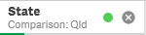.
Comparison Group Limiter Section
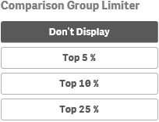
In addition to comparing results for the selected health service(s) for the current/latest collection period to other health services with similar characteristics, you can also compare the selected health service results for the selected indicator to the Top 5, 10 and 25 percent of health services in any comparison group you have created in the Comparison Group section of the sheet.
To do this, simply select the applicable button in the Comparison Group Limiter section in the bottom right-hand corner of the sheet. Once selected, the average results for the selected grouping of higher performing organisations will display as in the graph, while the averages for the entire comparison group will continue to be represented by the .
The and buttons detailed above for the nKPI Summary sheets, are also available in each of the individual indicator sheets.
nKPI Targets
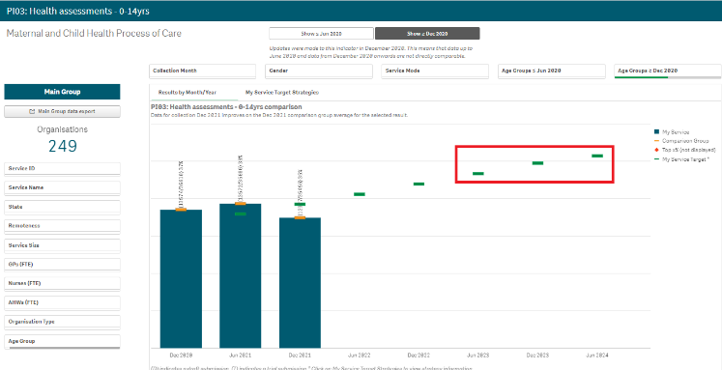
Once a health service has entered their self-determined targets for PI03, 05, 14, 18 and 23 into their nKPI form, these targets will then display as green lines () on the graphs within the applicable individual indicator sheets (as highlighted above) in the QLIK Stakeholder nKPI & OSR Report. The target lines will allow you to see, for each collection period, whether the selected health service has reached or exceeded the targets for the selected indicator or are yet to do so.
While the health service targets for some of the indicators will display as soon as you select the applicable sheet, some selections will need to be made to get the targets to display for others. Bookmarks have been created in QLIK for these indicators to make it easier for you to display the targets
To display the targets for each applicable indicator in QLIK:
- PI03 (0-4 years) – Open the PI03 0-14 yrs sheet, select and then right click on “My Service Targets-PI03-0-4YRS-In Person” and select Apply selections. The targets will display.
- PI03 (25-54 years) - Open the PI03 15-65yrs+ sheet, select and then right click on “My Service Targets-PI03-25-54YRS-In Person” and select Apply selections. The targets will display.
- PI03 (55YRS+) - Open the PI03 15-65yrs+ sheet, select and then right click on “My Service Targets-PI03-55yrs+-In Person” and select Apply selections. The targets will display.
- PI05 – Open the PI05: HbA1c recorded sheet, select and then right click on “My Service Targets-PI05-Previous 12 months” and select Apply selections. The targets will display.
- PI14 – Open the PI14: Immunised against influenza sheet and the targets will display. The targets will display.
- PI18 – Open the PI18: Kidney function test – Type 2 Diabetes sheet and the targets will display. The targets will display.
- PI23 – Open the PI23: Blood pressure recorded sheet and the targets will display. The targets will display.
If you have entered accompanying strategy text for the applicable indicator in the nKPI Targets tab of your nKPI form, this text can be seen by selecting the My Service Target Strategies tab in the applicable individual indicator sheet.
The Data export – Main Group sheet
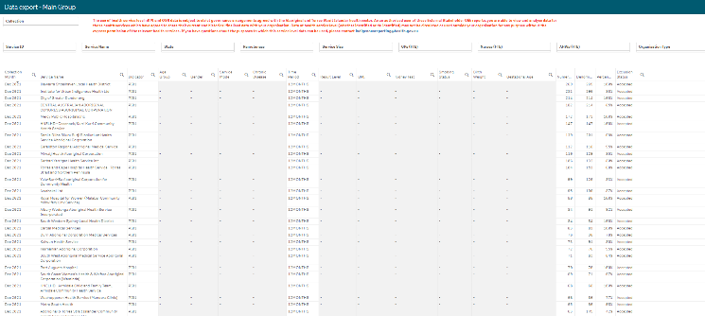
The Data Export – Main Group sheet displays (in table form) nKPI data for the selected Health Service(s) for every collection period, back to December 2014.
If you haven’t selected a particular health service on one of the other sheets, then data for all health services will display here.
- To select a particular health service to export data for, select .
- Select the applicable service from the list that displays, and then select .
If you wish to, you can the further filter the data by selecting at the top of any column in the table and making the required selection. For example, you may only require the service’s data for a particular collection period or for a subset of indicators.
- To export the data to Excel right click anywhere on the table, select Download as… > Data and then select the link to download the file.
The selected data has now been downloaded into a Microsoft Excel spreadsheet for use as needed.
The Data export – Comparison Group sheet
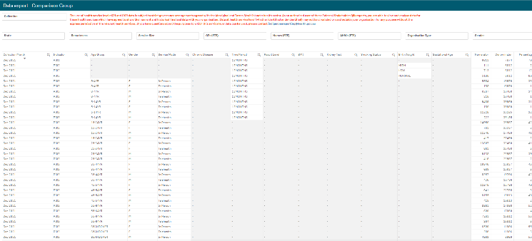
The Data Export – Comparison Group sheet displays (in table form) the national nKPI data set for every collection period, back to December 2014.
- To filter the data that displays in the table, select the applicable filter field(s) above the table as required. For example, you may wish to export data only for services in Queensland without GPs.
- Select the applicable option from the list that displays, and then select .
If you wish to, you can the further filter the data by selecting at the top of any column in the table and making the required selection. For example, you may only require data for the latest collection period or for a subset of indicators.
- To export the data to Excel, right click anywhere on the table, select Download as… > Data and then select the link to download the file.
The selected data has now been downloaded into a Microsoft Excel spreadsheet for use as needed.

The Export of Current Reporting Round sheet
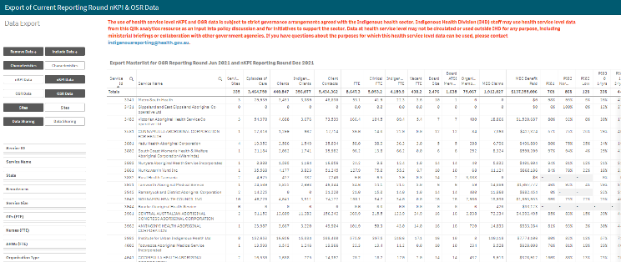
The Export of Current Reporting Round sheet displays key OSR and nKPI data in the one table, so it can be easily exported together into Excel as/if needed.
By default, the table displays key OSR data (such as Episodes of care, client numbers and client contacts) and results for each of the applicable nKPIs. Extra information, such as organisation characteristics, service sites and data sharing consent responses, can be add to the table if needed.
- To add further information to the table, select the applicable button (such as ) from Include Data column on the left-hand side of the sheet.
The table will now be updated to include the selected information.
- To export the data in the table to Excel, right-click on the table and select Download as… and then select Data.
- In the window that displays, select .
- In the Export complete window, select the link.
The data has now been exported to and Excel spreadsheet for saving and/or sharing as needed.
The OSR – Data Export sheet
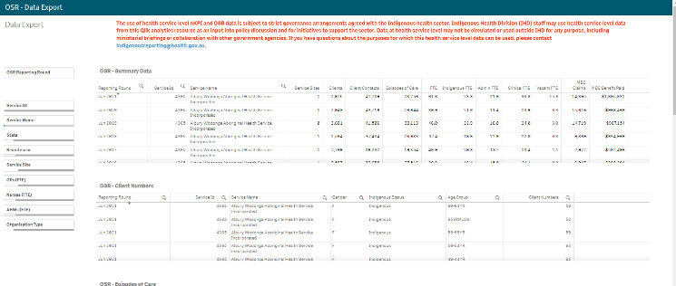
The OSR – Data Export sheet allows you to export summary OSR data for your selected service(s) or cohort, to a Microsoft Excel spreadsheet. This sheet contains several different tables, covering different elements of OSR data.
- Select in the Organisations section of the sheet and select the health service you wish to view the OSR data for.
- To continue, select .
You can use the other filter fields in the Organisations section of the sheet if needed to display the data set for a particular cohort of health services. For example, all NSW/ACT services with a remoteness category of “Major Cities”.
Once you have applied the required filters to the data set, you can then export the data to Excel as needed.
- To do this, right-click on the applicable data export table and select Export > Export data.
- In the window that displays, select the Click here to download your data file link.
- In the Download bar that displays at the bottom of the sheet, select the arrow, and then select Open.
The Microsoft Excel spreadsheet containing the selected data set will now display and can be edited, saved, and shared as needed.
The Organisation Masterlist sheet
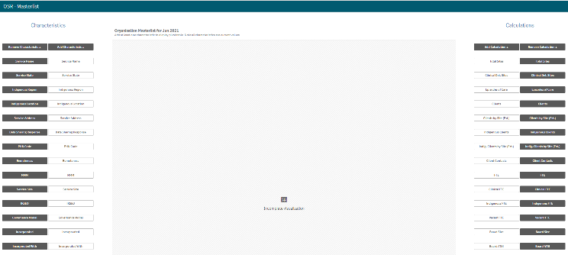
The Organisation Masterlist sheet allows you to overlay different organisational characteristics to display combinations of data for reporting health services, using the Characteristics section on the left-hand side of the sheet and the Calculations section on the right-hand side of the sheet.
The Characteristics section is where you select the characteristic you wish to add to the master list.
The Calculations section produces values for the selected characteristic.
The following is an example of how a FNHD user could use the organisation master list:
- Select under Add Characteristic in the Characteristics section on the left-hand side of the sheet.
- Select under Add Calculation in the Calculations section on the right-hand side of the sheet.
- Select under Add Calculation in the Calculations section on the right-hand side of the sheet.
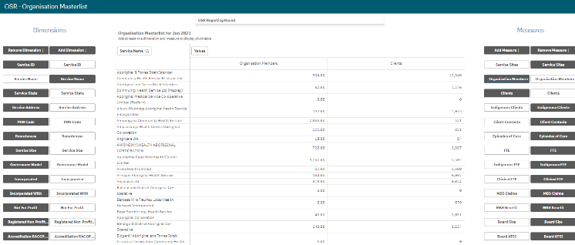
The Organisation Masterlist sheet is now updated to display the list of health services on the left-hand side of the table, with their client and member numbers displaying on the right-hand side.
If required, you can export the data out of QLIK and into an Excel spreadsheet by right-clicking anywhere on the table and selecting Download as… > Data.
If required, you can limit the data being displayed in the master list to a particular collection period, using the filter field at the top of the sheet.

The OSR – Workforce Summary – Paid FTE sheet
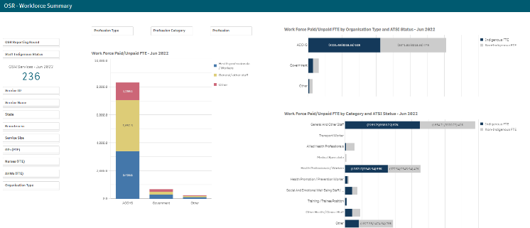
The OSR – Workforce Summary – Paid FTE sheet displays, by default, national summary workforce information, showing the breakdown of FTE for position types by organisation type, category and ATSI status.
The Organisations section on the left-hand side of the sheet can be used as needed to filter the workforce summary data by characteristics such as state, remoteness or service size as required.
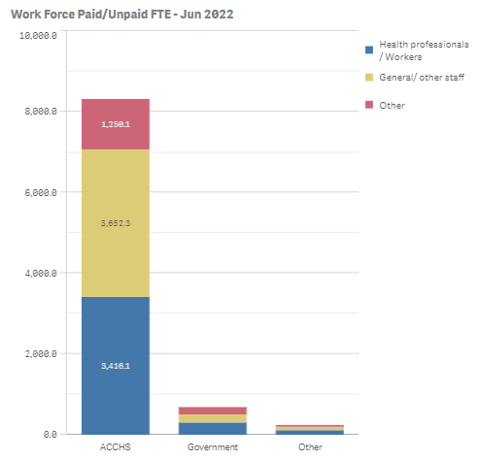
The Work Force Paid FTE – Jun 2023 graph shows a breakdown of position types, by organisation type (displayed on the vertical axis). If needed, you can use the filter fields at the top of the graph to filter the information shown by Profession, Profession Type or Profession Category.
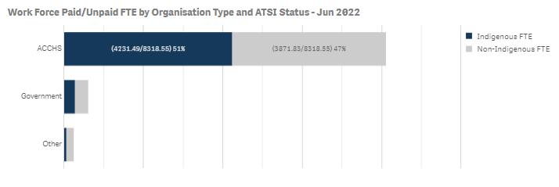
The Work Force Paid FTE BY Organisation Type/Category and ATSI Status graphs show the breakdown of Indigenous and non-Indigenous FTE by organisation type/category for whatever characteristics have been selected in the Organisations section.
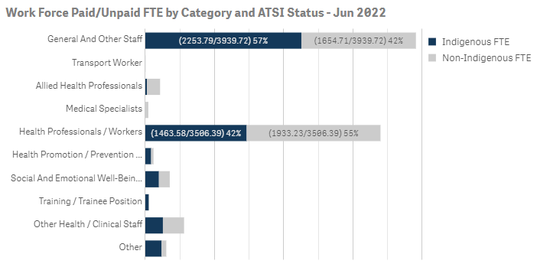

The OSR – Workforce Detail sheet
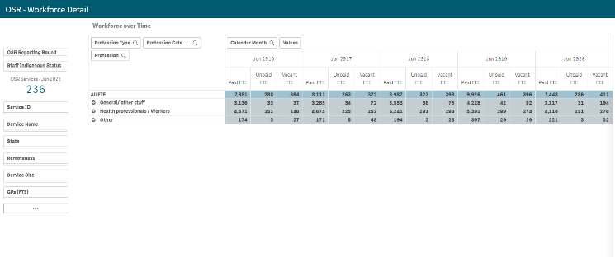
The OSR – Workforce Detail sheet displays more detailed workforce information for the selected health services.
- Select in the Organisations section if needed and select the health service you wish to view the workforce data for.
- To continue, select .
The Workforce over Time table displays the Paid, Unpaid and Vacant FTE values for the selected service, by position grouping first and then by individual position (e.g., CEO, Pharmacist, Cardiologist).
To expand the information in the table, simply right-click in the first column in the table and select Expand / collapse > Expand all. You will now be able to see the FTE for all position types and positions.

The OSR – Episodes of Care and Client Numbers sheet
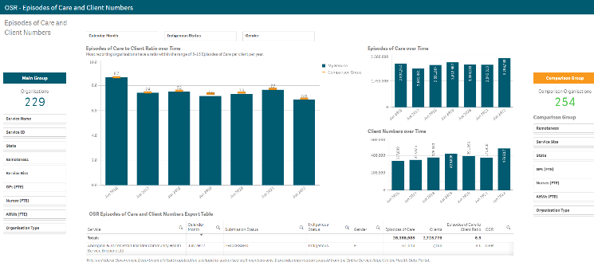
The OSR – Episodes of Care and Client Numbers sheet allows you to analyse the trends in the selected service’s episodes of care and client numbers data over time. You can compare their OSR data to that of other services, either by creating your own comparison groups or using pre-existing groups.
- To select the health service you wish to analyse OSR data for, select 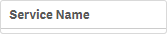 in the Main Group section on the left-hand side of the screen and select the required service.
- To continue, select .
Episodes of Care to Client Ratios Over Time
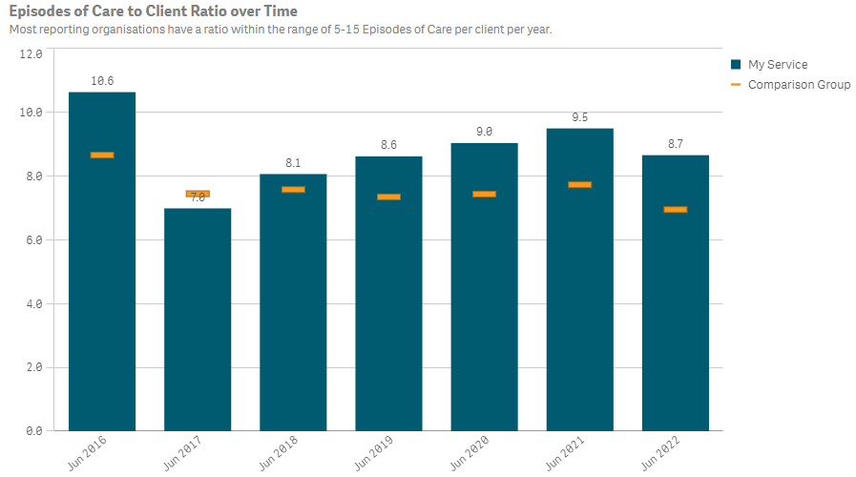
This graph shows your selected service’s episodes of care to client numbers ratio for each year back to 2016 This ratio is simply the service’s episodes of care numbers divided by the client numbers for each year. As the text in the graph states, most services have a ratio of between five and 15 episodes of care per client each year.
The graph also contains the results of the selected comparison group (the national average if no comparison group has been selected) identified by the .
You can create your desired comparison group using the Comparison Group section on the right-hand side of the screen.
Episodes of Care Over Time
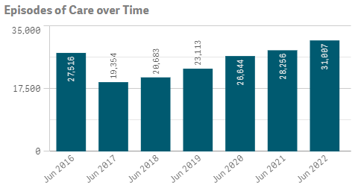
The Episodes of Care over Time graph shows your selected service’s episodes of care values over time, from 2016 to the most recent OSR collection.
Client Numbers Over Time
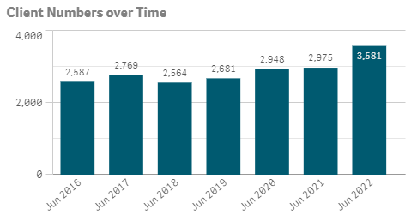
The Client Numbers over Time graph shows your selected service’s client numbers over time, from 2016 to the most recent OSR collection.
OSR Episodes of Care and Client Numbers Export Table
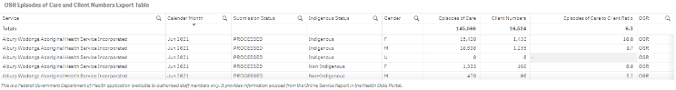
The OSR Episodes of Care and Client Numbers Export Table presents all your selected service’s OSR episodes of care and client numbers data in a table that can be easily exported to Microsoft Excel.
Before exporting the data, you can use to filter the data by any of the columns containing a (for example, Calendar Month, Gender, and Indigenous Status).
When you are ready to export the selected data to Excel, simply right click on the table and select Download as… > Data. An Excel spreadsheet containing the data will be downloaded so you can save and use it as needed.
The OSR Comments sheet
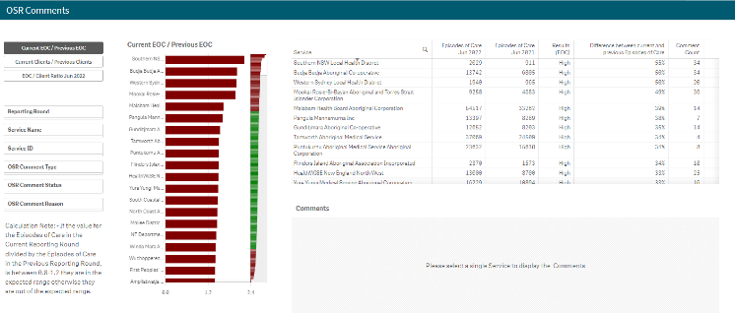
The OSR Comments sheet is used by FNHD to identify discrepancies between health services’ episodes of care and client number data from year to year. It can also be used to identify any Episodes of Care (EoC) to client ratios for the most recent collection period that are outside of the expected range. Once the discrepancies are identified the Comments table in the sheet can then be used to identify why the discrepancies are occurring.
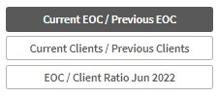
This section allows you to decide which OSR information you wish to compare, to identify discrepancies for.
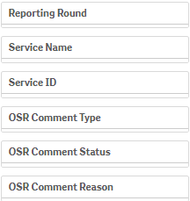
The Filter section of the sheet allows you to filter the information displaying on the right-hand side of the sheet by characteristics such as reporting round, health service and OSR comment characteristics.
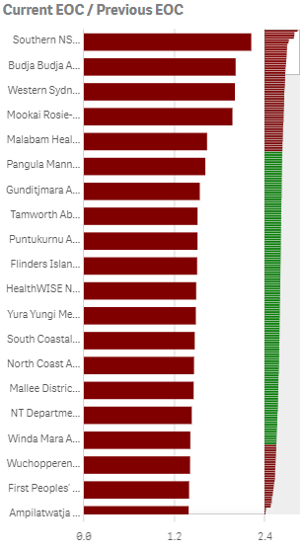
The graph lists the health services with the highest calculated ratio at the top of the graph, to the services with the lowest ratios at the bottom.
Those ratios that are outside of the desired range and should be investigated in more detail, are shown in red.
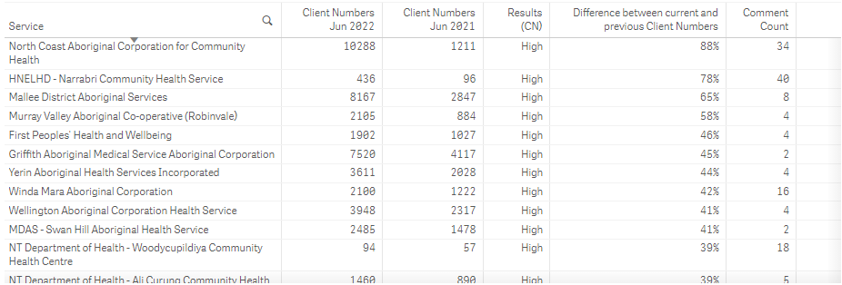
The table lists all reporting health services, along with the applicable numbers, based on the selection you have made on the left-hand side of the sheet.
- To investigate a service in more detail by displaying the comments attached to their values, select the service, and then select that displays.
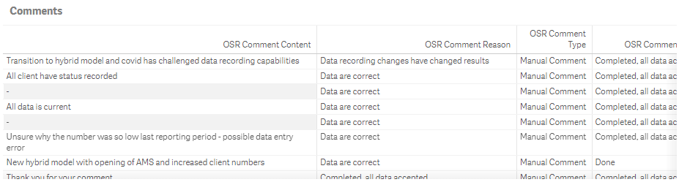
Once a health service is selected, the Comments table will display the details of all comments entered by the service in the most recent OSR submission, related to the applicable values. These comments may provide you with an insight as to why the selected values (year to year client numbers for example) sit outside of the expected/desired range for that service. This information will then assist you make an informed policy decision regarding this service and its funding.
The nKPI Definitions sheet
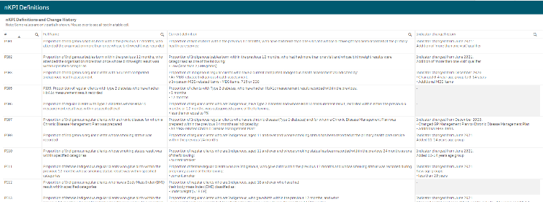
The nKPI Definitions sheet can be accessed from any individual indicator sheet within the QLIK Stakeholder nKPI & OSR Report by selecting the button, or by selecting the app on the home screen.
This sheet contains the number, name, and detailed current definition for each of the indicators contained within the Stakeholder nKPI & OSR Report. In addition, there is a column in the table that explains changes that have been made to any of the indicators, to assist you in interpreting each of the individual indicator sheets in the report.
Only a limited amount of text can be shown in the nKPI Definitions and Change History table. If the text in a section of the table is incomplete, simply hover your mouse pointer over the text and the rest of the text will display in a hover text box.

