When a data asset has been submitted for review by the Submission Uploader, it can be reviewed in the Data Portal by anyone within the organisation with the Submission Reviewer role.
Review a Data Asset Submission
To review a data asset in the Data Portal:
- Open the Data Portal through Health Data Portal.
- Log in using the information provided in the Registering for and Logging in to the Health Data Portal QRG.
The Data Portal home screen will display.
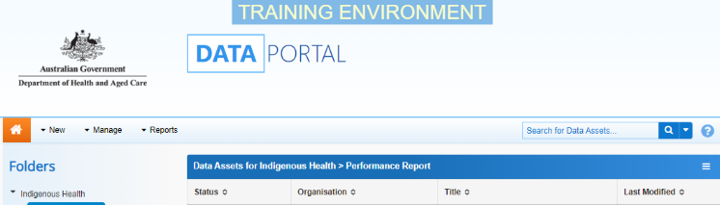
- From the Data Portal home screen, search for the data asset to be reviewed.
For more information on how to search for a data asset, see the Get Started in the Health Data Portal QRG.
To be eligible for review, the data asset’s status will need to be Submission Ready for Review.
- In the Data Assets section, select the data asset.
The Data Asset Details screen will display.
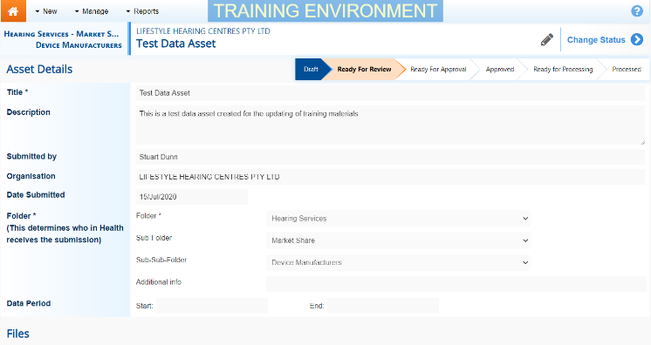
- To update any details in the data asset, select at the top of the screen.
The Data Asset Details screen will update so active (white) fields on the screen can be edited if needed (including answering any data submission questions if needed).
- Make any required changes to the active fields on the Data Asset Details screen.
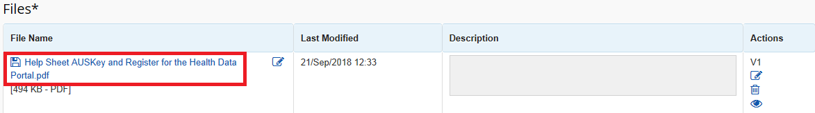
- There are several actions that can be performed on the attached file, in the Files section, if needed.
Button | Description
 | Select this button under File Name to download and view the file. A pop up will appear in the bottom left-hand corner of the screen and you can open the file from here and save it as required.
 | Select this button under File Name to replace the file with another file if it has been uploaded incorrectly.
 | Select this button under Actions to view the file’s previous versions.
 | Select this button under Actions to activate the Description field so a description of the file can be added if needed.
 | Select this button under Actions to remove the file from the data asset.
 | Select this button under Actions to view the file’s download history.
Select this button under Actions to add an updated version of the file if needed.
This will add a second file, rather than replace the existing one.
- To save your changes to the data asset details, select .
- Once the data asset has been reviewed and updated as needed, select either or the workflow progress bar at the top of the screen and, in the Change Data Asset Status dialog box, in the Action field, select and select the required action.
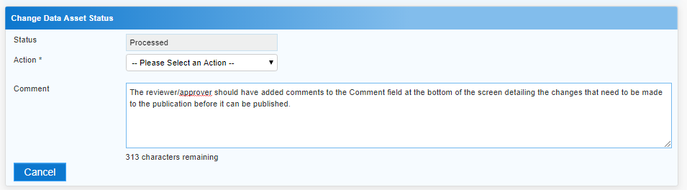
The available actions are:
- Request Approval – Select to send the data asset on to the appropriate person within the organisation for approval.
- Request Interim Processing – Select to send the data asset to the external Data Receiver for review prior to it going to your CEO or their representative for approval. This process is known as Interim Processing.
Review a Data Asset Submission
- Revision Required – Select to return the data asset to the Submission Uploader for amendment.
If you have the ability to approve data asset submissions, you will see the Approve for Submission option in the action list. This allows you to approve the data asset and submit it directly to an external data receiver for processing.
- In the Comment field add any comments regarding the asset.
- One of the following options can now be selected:
  - To send the data asset for approval, select . See the Approve a Data Asset Submission QRG for the next step in the process.
  - To send the data asset to an external Data Receiver for initial review prior to sending it to your CEO or their representative for approval, select 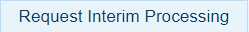. See the Interim Processing of a Data Asset Submission QRG for the next step in the process.
  - To send the data asset back to the uploader for amendment, select . See the Amend a Data Asset Submission QRG for the next step in the process.
To save the data asset as a draft select .
The data asset has now been submitted to the next stage of the data asset submission process.

