Interim Processing of an OSR Submission

Initiate Interim Processing (Health Service)
To start interim processing of an OSR submission in the Data Portal:
- Open the Data Portal through Health Data Portal.
- Log in using the information provided in the Register for and Log in to the Health Data Portal QRG.
The Data Portal home screen will display with the Reporting Dashboard open.
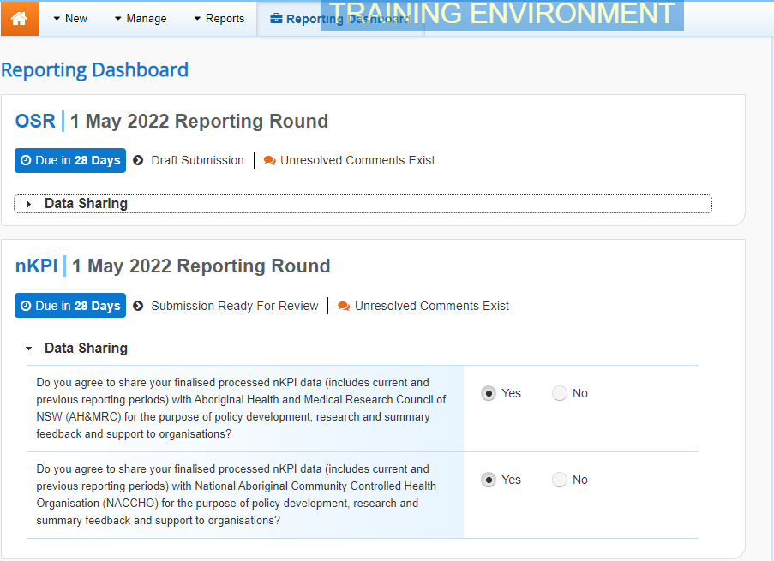
To be eligible for interim processing, the OSR submission’s status can be at either Draft Submission or Submission Ready for Review, if the user has the Submission Reviewer role.
- Before progressing your submission through the interim submission workflow, answer either Yes or No to the data sharing consent questions that display under Data Sharing if the questions have not already been answered.
- To save the changes, select .
- To start interim processing, select in the Reporting Dashboard and, in the Change Data Asset Status dialog box, in the Action field, select and select Request Interim Processing.
- In the Comment field, enter any comments you wish to add for the AIHW.
- To send your OSR submission to the AIHW for interim processing, select.
The status of your OSR submission has been set to Interim Submitted and the AIHW can now review the submission as needed to assess its suitability before it goes to your CEO, or their representative, for approval.
Review the Submission (AIHW)
To review a health service’s OSR submission:
- Ensure the Date Portal home screen is displayed.
- From the Data Portal home screen, search for the submission to be reviewed.
For more information on how to search for a submission, see the Get Started in the Health Data Portal QRG.
The submission will have the status of Interim Submitted.
- Select the submission to be reviewed.
The Data Asset Details screen will display.
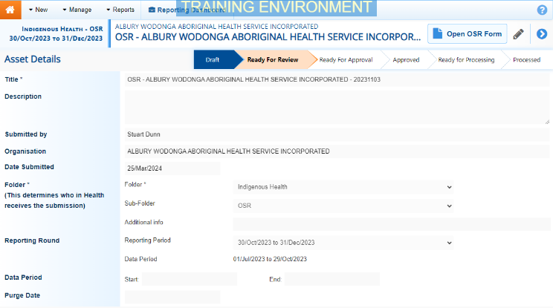
- Review the details of the submission as needed.
- To review the contents of the attached form, select at the top of the screen.
- Once finished, select at the bottom of the OSR form to exit the form and return to the Data Asset Details screen.
- To action the submission, select either or the workflow progress bar at the top of the screen and, in the Change Data Asset Status dialog box, in the Action field, select and select Ready for Interim Processing.
If the health service has asked you to return the submission, as it has been submitted in error, select Return to Uploader.
- In the Comment field, enter any comments about the action being performed on the submission.
- To prepare the OSR submission for processing, select .
Process the Submission (AIHW)
To complete interim processing on the OSR submission in the Data Portal:
- Ensure the Date Portal home screen is displayed.
- From the Data Portal home screen, search for the submission with the status of Ready for Interim Processing.
For more information on how to search for a submission, see the Get Started in the Health Data Portal QRG.
- Select the OSR submission to be processed.
The Data Asset Details screen will display.
- Review the details of the submission as needed.
- To review the contents of the attached form, select at the top of the screen.
- Once finished, select at the bottom of the OSR form to exit the form and return to the Data Asset Details screen.
- To action the submission, select either or the workflow progress bar at the top of the screen and, in the Change Data Asset Status dialog box, in the Action field, select and select Request Review to send the submission back to the health service’s Submission Reviewer, who will review the submission and move it to the next stage of the process. This action will progress the submission to the status of Submission Ready for Final Review.
Interim Processing of an OSR Submission

- In the Comment field, enter any comments about the action being performed on the submission.
- To send the submission on to the health service’s Submission Reviewer, select.
Conduct a Final Review of your Submission (Health Service)
To conduct a final review of your OSR submission in the Data Portal:
- Ensure the Date Portal home screen is displayed, and the Reporting Dashboard is open.
The submission will have the status of Submission Ready for Final Review.
- To open the Data Asset Details screen, hover your mouse pointer to the right of the OSR reporting round text in the Reporting Dashboard, select and then select Open Data Asset.
- Review the details of your submission as needed.
- To review the contents of the attached form, select .
- Once finished, select at the bottom of the OSR form to exit the form and return to the Data Portal home screen.
- To action the submission from the Reporting Dashboard, select and, in the Change Data Asset Status dialog box, in the Action field, select and select Request Approval.
If changes need to be made to any of the data in your submission, select Revision Required to send it back to your Submission Uploader for amendment.
- To send your OSR submission on to the CEO or their representative for approval, select .
Your OSR submission has now been sent to the CEO or their representative within the health service for final approval.
Approve your Submission (Health Service)
Interim Processing of an OSR Submission

To approve your OSR submission that has been through interim processing in the Data Portal:
- Ensure the Date Portal home screen is displayed.
The submission will have the status of Submission Ready for Final Approval.
- To open the Data Asset Details screen for your OSR submission, hover your mouse pointer to the right of the reporting round text in the Reporting Dashboard, select and then select Open Data Asset.
- Review the details of your OSR submission as needed.
- To review the contents of the attached form, select .
- Once finished, select at the bottom of the OSR form to exit the form and return to the Data Portal home screen.
- To action the submission from the Reporting Dashboard, select and, in the Change Data Asset Status dialog box, in the Action field, select and select Approve for Submission.
If changes need to be made to any of the data in your submission, select Revision Required to send it back to the Submission Uploader for amendment.
- In the Comment field, enter any comments about the action being performed on your submission.
- To approve your OSR submission, select.
Your OSR submission has been progressed to the status of Processed and the submission process is now complete.

