Update User Profiles
Manage User Records (User Administrator)
If you are a User Administrator for your organisation, you will be able to make changes to user profiles in the Data Portal for users within your organisation. The main application of this will be to add roles and folders to profiles for newly registered users to ensure they can use the Data Portal to work with data assets as required. Another use of this function, however, may be to revoke a user’s profile if they have left the organisation or no longer need to access the Data Portal.
If you are the User Administrator for a Parent organisation, you will also be able to update user profiles for users within any of the Child organisations that sit underneath the Parent.
To update a user profile in the Data Portal:
- Open the Data Portal through Health Data Portal.
- Log in using the information provided in the Initial Access to the Health Data Portal QRG.
The Data Portal home screen will display.
- From the Data Portal home screen, select and then select Users from the list that displays.
The Manage Users screen will display, showing a list of all users with active and pending user profiles within your organisation.
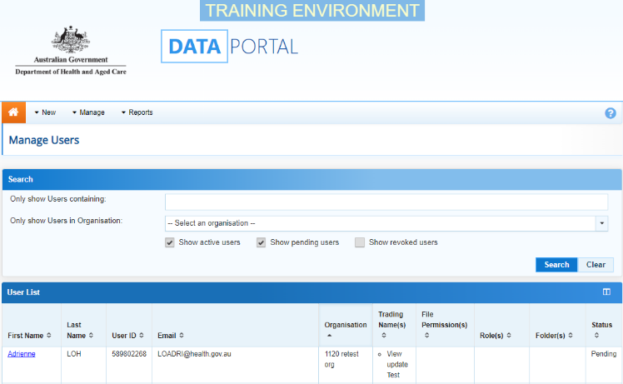
- If needed, to search for the user whose profile you wish to update, enter the user’s name in the Only show Users containing field.
If your organisation is part of a Parent/Child organisational structure, you will see the Only show Users in Organisation field as well (as shown above).
- If this is the case and the user whose record you are looking for resides in another organisation within your structure, select in the Only show Users in Organisation field and select the user’s organisation from the list.
Alternatively, you can select in the header of the required column (for example Last Name) to find the required user’s record.
- Once you have entered the required search criteria, select .
A list of matching users will display.
- To display the details for the selected user, select the first name link for the user.
The User Details screen will display.
- To open the user’s profile for editing, select at the top of the screen.
The User Details screen will update so the user’s profile can be edited.
- If the user has entered their email address incorrectly as part of their registration for the Data Portal, you can update the user’s address in the Email field.
- In the Roles section, select or deselect the relevant check box to add or remove a role to/from the user’s profile.
You can’t assign the Data Receiver role to a user within your organisation. This role can only be assigned to external users responsible for processing your data.
- In the File Permissions section, select .
- In the File Permissions dialog box, select the file permissions to be added to the user’s profile from the Available section and select .
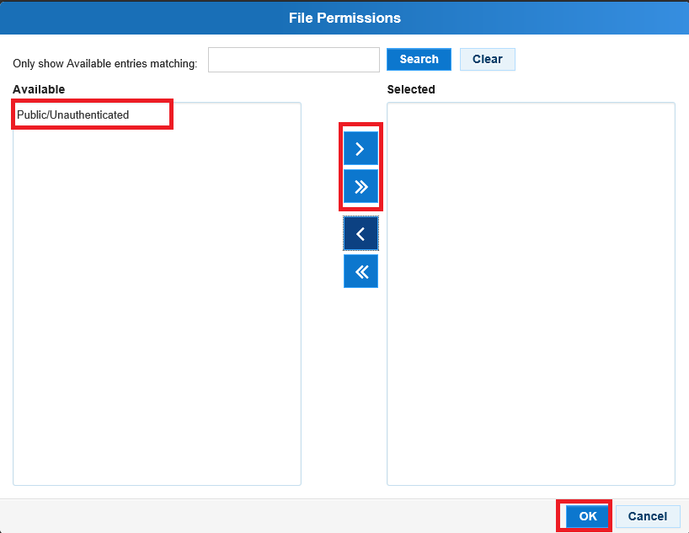
Manage User Records (User Administrator)
File permissions determine the published data assets a user will be able to see in the Data Portal.
- To continue, select .
- In the Folders section, select .
- In the Available section of the Folders dialog box, select the check boxes for the folders to be added to the user’s profile and select .
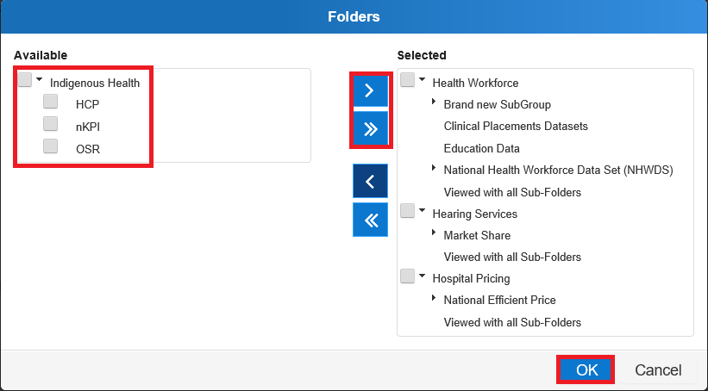
Where relevant, it is important to select both the top-level folder and at least one sub-level folder underneath for the user to be able to perform the required functions.
Folders determine the data assets the user will be able to view and/or edit as the data assets go through the submission workflow process.
- To continue, select .
- If you need to revoke the user’s profile, select in the User Status cell and select Revoked.
- Select in the Reason cell and select the applicable reason for the user’s profile being revoked.
- To save the changes to the user’s profile, select .
- In the Save Changes dialog box, select .
The changes made will be applied to the user’s profile.
Update Your Own User Profile
As a User Administrator, you can update your own user profile in addition to being able to update profiles for other users in your organisation. For example, you may need to add a role to your profile (Submission Uploader, Submission Reviewer etc) so you can be involved in the data asset submission workflow.
To update your user profile in the Data Portal:
- Ensure the Data Portal home screen is displayed.
- Select next to your name in the top right-hand corner of the screen and select Manage My User Profile from the list that displays.
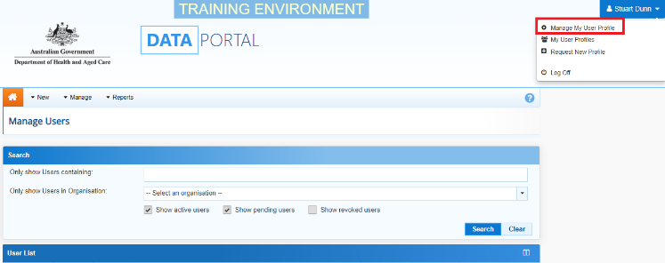
The User Details screen will display.
- To open your profile for editing, select at the top of the screen.
The User Details screen will update so your profile can be updated.
- If needed, you can update your email address in the Email field.
- In the Roles section, select or deselect the relevant check box to add or remove a role to/from your user profile.
- In the File Permissions section, select .
- In the File Permissions dialog box, select the file permissions to be added to your profile from the Available section and select .
- To continue, select .
Manage User Records (User Administrator)
- In the Folders section, select .
- In the Folders dialog box, select the check boxes for the folders to be added to your user profile and select .
- To continue, select .
- To save the changes, select .
- In the Save Changes dialog box, select .
The changes will be applied to your user profile.
Process Alternate User Profile Requests
When a user requests an alternate user profile in the Data Portal, the User Administrator for the applicable organisation will receive an email informing them a request has been submitted. The administrator can then action the request as required.
To process an alternate user profile request in the Data Portal:
- Ensure the Data Portal home screen is displayed.
- From the Data Portal home screen, select and then select Users from the list that displays.

The Manage Users screen will display.
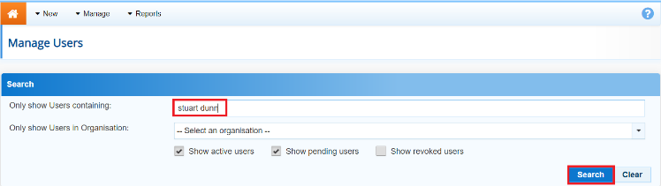
- Enter the user’s name in the Only show Users containing field.
- To continue, select .
A list of the selected user’s profiles will now display in the User List section, including the new profile that has been requested. This profile will have the status of Pending.
- For the user profile you are actioning, select the link in the First Name column.
The User Details screen will display.
- To update the user’s profile, select at the top of the screen.
The User Details screen will update so the user’s profile can be edited.
- In the Roles section, select the applicable check box(es) for the role(s) to be added to the new user profile.
- In the File Permissions section, select .
- In the File Permissions dialog box, select the file permissions to be added to the user’s role from the Available section and select .
- To continue, select .
- In the Folders section, select .
- In the Available section of the Folders dialog box, select the check boxes for the folders to be added to the user’s profile and select .
- To continue, select .
- In the User Status section, select in the User Status field and select the appropriate action from the drop-down list that displays.
  - To accept the user profile request, select Active.
  - To reject the user profile request, select Revoked.
If you select Revoked, the Reason field will display asking you to confirm why the profile has been revoked. Select the applicable reason from the list.
Manage User Records (User Administrator)
- To save the changes to the profile, select .
- In the Save Changes dialog box, select .
The List of Users screen will display with a note informing you the changes you have made to the user’s profile may not be visible in the Data Portal for up to five minutes.
Once the changes have updated, the user’s alternate profile status will change to either Active or Revoked, depending on the action taken.

