Attach a Supporting Document to your TIS Performance Report
Submit a Data Asset
As part of the submission of your Tackling Indigenous Smoking (TIS) Performance Report to your DSS Funding Agreement Manager (FAM) through the Health Data Portal, you will have some additional, supporting documentation that you will need to include as part of your submission (such as your expenditure information, which is required as part of your Funding Agreement). You can easily attach this documentation to your TIS Performance Report in the Data Portal.
If you have graphs or tables that you wish to add to your TIS Performance Report, these will need to be attached as supporting documents as the TIS Performance Report form does not currently support them.
To attach a document to your TIS Performance Report:
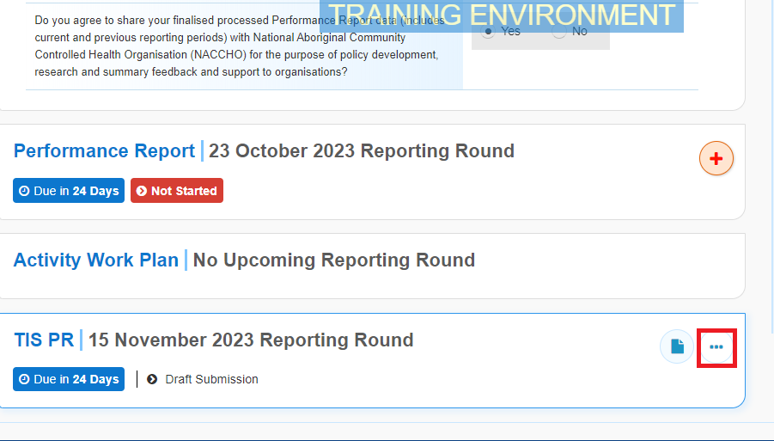
- On the Data Portal home screen. hover your mouse pointer to the right of the TIS PR reporting round text, select and then select Open Data Asset.
The Data Asset Details screen will display.
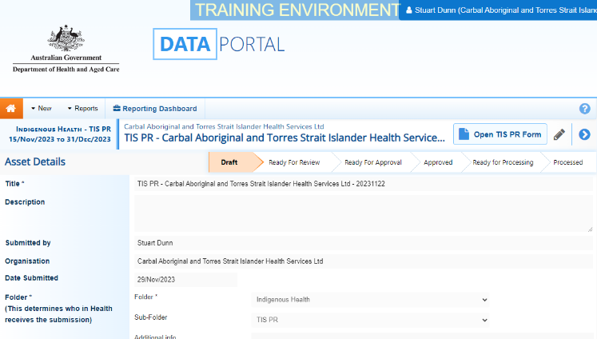
- Put the screen into edit mode by selecting in the top right-hand corner of the screen.
- To upload your supporting document(s), scroll to the bottom of the screen and select .
The Upload Files dialog box will display.
- Select .
The Windows dialog box will display.
- Locate the document you wish to upload to the report.
- Select the file and then select .
The Data Assets Details screen will display, and the selected document will now appear in the Files section of the Data Asset Details screen.
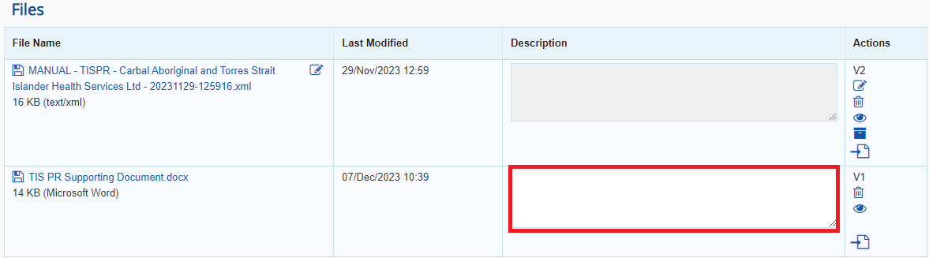
- If needed, you can enter some information into the Description field explaining to your DSS FAM which section(s) of your TIS Performance Report the attached document refers to.
If you have uploaded the incorrect document and need to remove it, simply select from the Actions column of the Files section.
- Repeat steps 3 to 7 for any other documents you need to attach.
- To save the upload of your document(s), select at the bottom of the screen.
- To return to the Data Portal home screen, select .
Once you have attached your supporting documentation to your TIS Performance Report, you should inform your DSS FAM that you have done so, so they know to look out for this documentation when reviewing your TIS Performance Report in the Data Portal.

