Submit your IAHP PHC Activity Work Plan (AWP)
To submit your IAHP PHC AWP through the Data Portal, as a Submission Uploader:
- Open the Data Portal through Health Data Portal.
- Log in using the information provided in the Register for and Log in to the Health Data Portal QRG.
The Data Portal home screen will display with the Reporting Dashboard open.
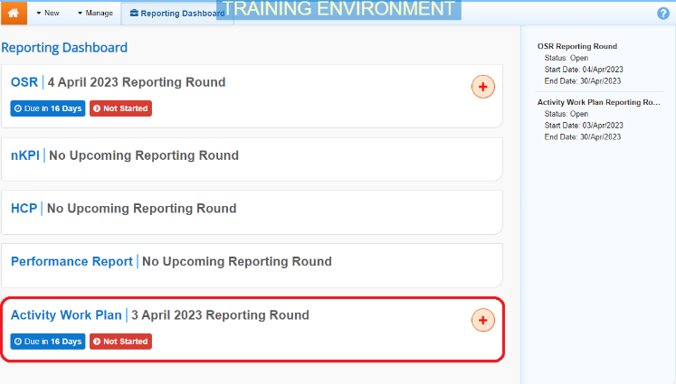
- To commence the creation of your IAHP PHC AWP, select to the right of the Activity Work Plan reporting round text in the Reporting Dashboard (as highlighted above in red).
The IAHP PHC AWP form will display with the Reporting Contact – Contact Information section displaying by default.
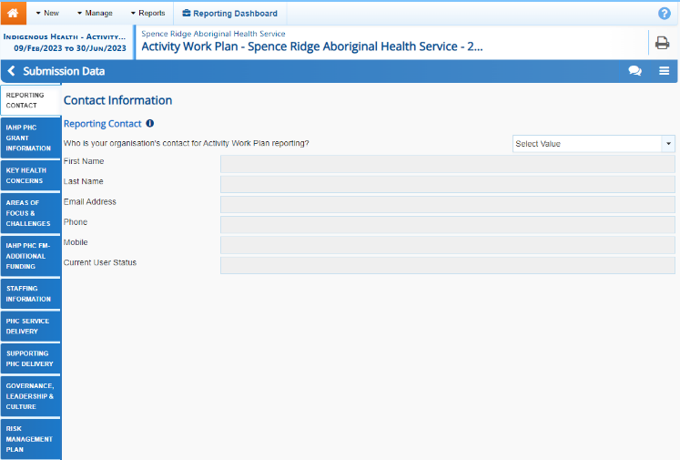
- You now need to complete each of the sections of your IAHP PHC AWP before sending it to your DSS Funding Agreement Manager (FAM) for approval.

The following are the sections of the IAHP PHC AWP that need to be completed:
- Reporting Contact – Select the person within your service who will be the primary contact for your IAHP PHC AWP.
- IAHP PHC Grant Information – Your service’s grant information will display here and can be reviewed as needed.
- Key Health Concerns – Select your key health needs and enter information regarding how you are going to address each need.
- Areas of Focus & Challenges – Select your key areas of focus and challenges and how they will be addressed.
- IAHP PHC FM Additional Funding – If your service receives additional funding, detail how you plan on allocating that funding.
- Staffing information – Upload your organisational chart or staffing profile as appropriate.
- PHC Service Delivery – Select your service’s objectives and detail how you will achieve these objectives and by when.
- Supporting PHC Delivery - Select your service’s objectives and detail how you will achieve these objectives and by when.
- Governance, Leadership & Culture - Select your service’s objectives and detail how you will achieve these objectives and by when.
- Risk Management Plan – If your Risk Management Plan is published online, enter the details of the website it can be found on. If you have a Risk Management Plan, you can upload it here. Otherwise, detail the risks your service is facing, the impact each risk will have if it happens and how you will prevent or manage the risks.

Some tips for completing your IAHP PHC AWP in the Data Portal are:
- Enter information for each section of the form by selecting the applicable tab on the left-hand side of the form.
- The IAHP PHC Grant Information tab will pre-populate with your grant information from your IAHP PHC Performance Report. If any of this information needs to be changed, select and ask for the information to be updated.
- You can add comments for your colleagues on any section of the form by selecting at the top of the Notifications Tray, adding in the comment or question for your colleagues and then selecting Save.
- Documents can be uploaded to the Key Health Concerns, Staffing Information and Risk Management Plan sections of your IAHP PHC AWP using the applicable upload buttons as needed.
- The help text at the top of the Primary Health Care Service Delivery and Risk Management Plan tabs can be collapsed and expanded using .

- Once the required information has been entered for the first section, select at the bottom of the form.
The simple completeness data validations will now run on the cells you have completed in the first section of the form, and if any of the cells have been left blank, a data validation flag will appear in the Notifications Tray.
- If a data validation flag has been generated, you will need enter the required information in the applicable cell(s).
If you are unsure which cell has been left blank, in the Notifications Tray, hover your mouse pointer to the right of the data validation flag title, select and the applicable cell(s) will be highlighted in red.

To open the Notifications Tray if it doesn’t display, select in the blue Submission Data bar at the top of the form.
- To save the amendment and run data validation again, select at the bottom of the form.
The data validation flag relating to the cell you have just completed should now have disappeared from the Notifications Tray.
- Repeat the above steps for each section of the form as required.
- Once you have finished entering your information into the different sections of the form and have saved the information, select at the bottom of the form.
The Data Portal home screen will again display with the Reporting Dashboard open.
- Before progressing your IAHP PHC AWP through the submission workflow, answer either Yes or No to the data sharing consent questions that display under Data Sharing and then select .
- To progress your AWP through the submission workflow, select .
The Change Data Asset Status dialog box will display.
Submit your IAHP PHC Activity Work Plan (AWP)
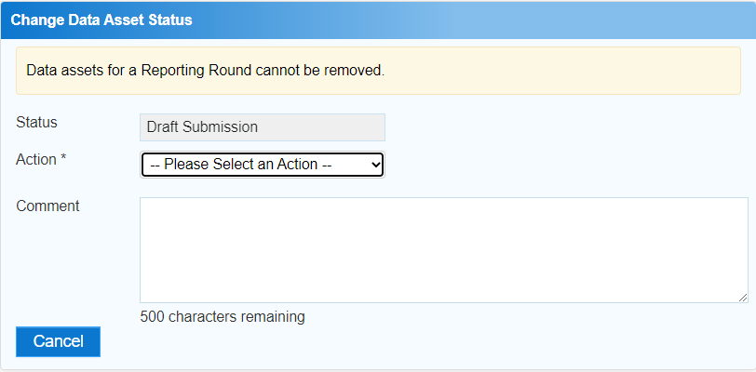
- In the Action field, select and select the appropriate action.

The available actions are:
- Request Review – Select this action to send your AWP to your Submission Reviewer review prior to it being submitted for approval.
Submit your IAHP PHC Activity Work Plan (AWP)
- Request Approval – Select this action to send your AWP to your CEO or their representative for internal approval.
- Request Interim Processing – If you are a Submission Reviewer as well as a Submission Uploader, you can select this action to send your AWP to your DSS FAM for review prior to it going to your CEO or their representative for approval. This process is known as Interim Processing.
If you can approve the AWP yourself, you will also see the Approve for Submission option in the Action list. This allows you to approve the AWP and submit it directly to your DSS FAM for processing.
- In the Comment field, enter any comments regarding the action being performed on the AWP.
- One of the following buttons can now be selected when submitting your IAHP PHC AWP, depending on the action you have selected:
  - To send your AWP for internal review, select . See the Review your IAHP PHC AWP (Submission Reviewer) QRG for the next step in the process.
  - To submit your AWP directly for approval to your CEO or their representative, select . See the Approve your IAHP PHC AWP (Submission Approver) QRG for the next step in the process.
Your IAHP PHC AWP has now been created and submitted to either your Submission Reviewer for review or your CEO or their representative for approval.
An automated email will be sent to all users within your health service that have been assigned the applicable role in the Data Portal (Submission Reviewer or Submission Approver) notifying them your AWP has been submitted to them for action.
For a more detailed description of how to submit your IAHP PHC AWP through the Data Portal, see Submit your IAHP PHC Activity Work Plan (AWP) in the IAHP PHC Activity Work Plan in the Health Data Portal user guide on the User Support page of the Data Portal.

