If you are a Health User Administrator, you will be able to activate profiles in the Data Portal for Health staff members as the need arises for them to use the Data Portal. This is done by assigning the user’s profile roles, file permissions and folders to ensure they can use the Data Portal to work with data assets as required.
Set up a New Health User in the Data Portal
To activate a new user profile in the Data Portal:
- Open the Data Portal through Health Data Portal.
The Data Portal home screen will display.
- From the Data Portal home screen, select and then select Users from the list that displays.
The Manage Users screen will display.
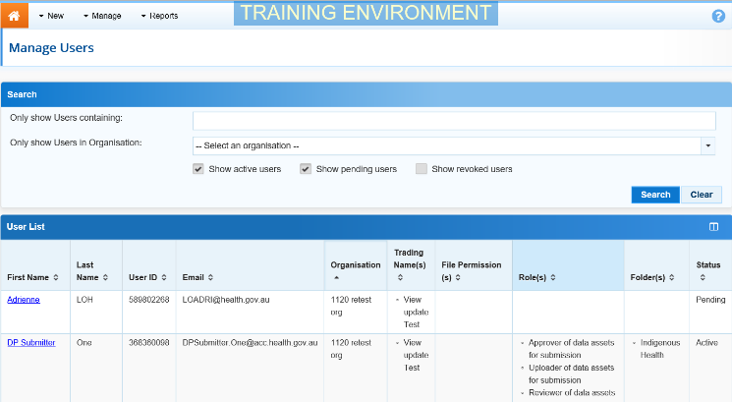
- In the User ID field at the bottom of the screen, enter the user’s Health user ID.
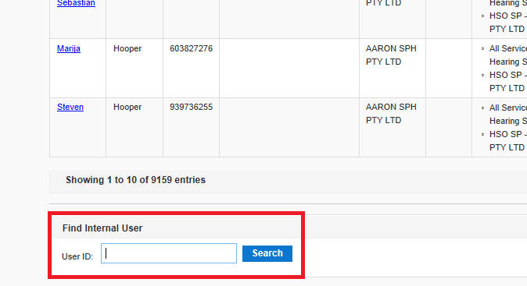
- To search for the user’s record, select .
If a message displays informing you the user’s user ID doesn’t exist in the Data Portal, this means an MSSP request will need to be created to create this user in the Data Portal. Once the user is created in the Data Portal, you will then be able to set them up.

The User Details screen will display.
- To open the user’s profile for editing, select at the top of the screen.
The User Details screen will update so the user’s profile can be edited.
- In the Roles section, select the relevant check box(es) to add roles to the user’s profile.
- In the File Permissions section, select .
- In the File Permissions dialog box, select the file permissions to be added to the user’s profile from the Available section and select .
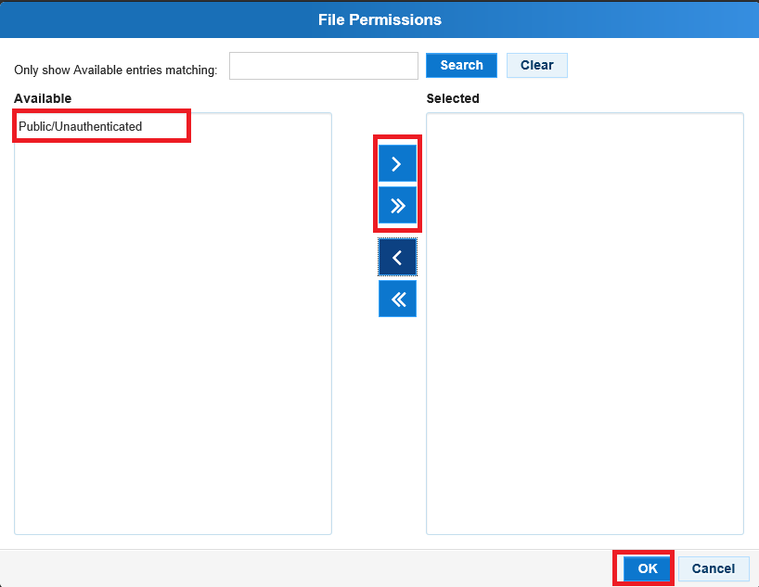
File permissions determine the published data assets a user will be able to see in the Data Portal.
- To continue, select .
- In the Folders section, select .
- In the Available section of the Folders dialog box, select the check boxes for the folders to be added to the user’s profile and select .
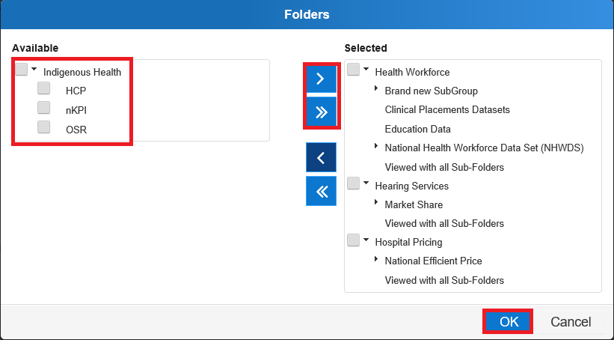
Folders determine the data assets the user will be able to view and/or edit as the data assets go through the submission workflow process.
Set up a New Health User in the Data Portal
- To continue, select .
- To save the changes to the user’s profile, select .
- In the Save Changes dialog box, select .
The changes made will be applied to the user’s profile and the user can now log in to the Data Portal and perform their required tasks.

