When your DSS FAM returns your TIS Performance Report to you for amendment, you will receive an email notification informing you your TIS Performance Report is ready for you to review and update as required.
To amend your TIS Performance Report in the Data Portal:
Amend your TIS Performance Report based on DSS FAM Feedback
- Open the Data Portal through Health Data Portal.
- Log in using the information provided in the Register for and Log in to the Health Data Portal QRG.
The Data Portal home screen will display with your Reporting Dashboard open.
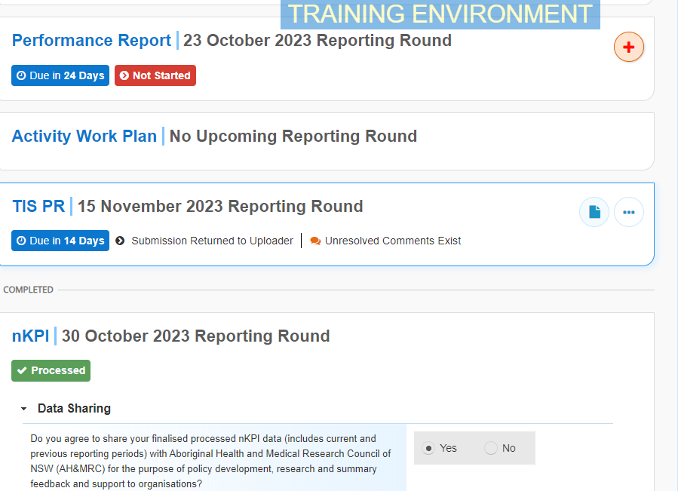
- To open your TIS Performance Report, hover your mouse pointer to the right of the TIS PR reporting round text in the Reporting Dashboard and select .
Your TIS Performance Report will open.
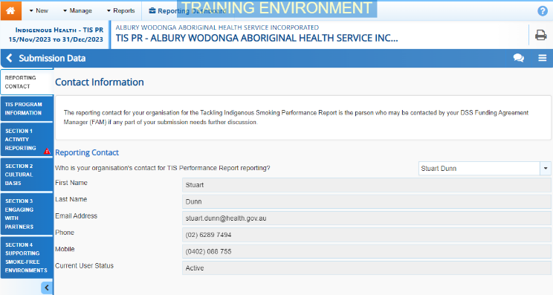
Any sections of your report containing DSS FAM comments will contain a on the corresponding tab. The Notifications Tray will display as open for each of these sections in the top right-hand corner of the form, so you can see the detail of the comments the FAM has made.
- For each section of your form with data validation flags, review the comment made by your FAM in the applicable Notifications Tray.
- If text needs to be updated to address the comment made by your FAM, make the changes in the applicable cell(s) as needed.
When you add text to a cell in your form at this stage of the process, it will look the same as the previous text you have entered, so please add some detail regarding the changes you have made in the response you have to make to the FAM’s comment.
Once you have made the required text changes, you will need to respond to the comment your FAM left.
- To do this, select next to the applicable FAM comment in the Notifications Tray.
- In the Respond to Comment window, select in the Reason field and select Other (specify).
- In the Additional Information field, enter text explaining the amendments you have made.
- To save your response, select .
Your response has now been added to the DSS FAM comment and the on the section should now have been replaced by .
- Repeat steps 4 to 9 for any other comments your DSS FAM has left in the form.
- To exit your TIS Performance Report form and return to the Data Portal home screen, scroll to the bottom of the form, and select .
The Data Portal home screen will again display with the Reporting Dashboard open.
- To commence the process of sending your updated TIS Performance Report back to your FAM, select .
- In the Change Data Asset Status dialog box, select the in the Action field and select the action required.
The available actions are:
- Request Review – Select this action to send your report to your Submission Reviewer for review again (including NBPU if needed).
- Request Approval – Select this action to send your report back to your CEO or their representative for approval.
If you can approve your TIS Performance Report yourself, you will also see the Approve for Submission option in the action list. This allows you to approve the TIS Performance Report and submit it directly to your FAM for processing again.
- In the Comment field, enter any comments regarding the action being performed on your report.
- One of the following buttons can now be selected when submitting your TIS Performance Report, depending on the action you have selected:
  - To send your report to the Submission Reviewer for review again, select . See the Review your TIS Performance Report based on DSS FAM Feedback (Submission Reviewer) QRG for the next step in the process.
  - To send your report back to your CEO or their representative for approval, select .See the Approve your TIS Performance Report based on DSS FAM Feedback (Submission Approved) QRG for the next step in the process.
Amend your TIS Performance Report based on DSS FAM Feedback
Your TIS Performance Report has now been amended and either sent back to your Submission Reviewer for further review (and/or NBPU as needed) or sent straight on to your CEO or their representative for approval.
An automated email will be sent to all users within your health service that have been assigned the applicable role in the Data Portal (Submission Reviewer or Submission Approver) notifying them your TIS Performance Report has been submitted to them again for action.

