To approve your service’s HCP submission as a Submission Approver, after it has been amended by your Submission Uploader/Reviewer as requested by Health and Aged Care:
Approve your HCP Submission based on Health Feedback (Submission Approver)
- Open the Data Portal through Health Data Portal.
- Log in using the information provided in the Register for and Log in to the Health Data Portal QRG.
The Data Portal home screen will display with the Reporting Dashboard open.
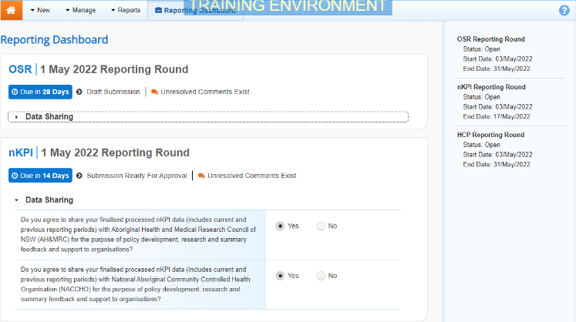
To be eligible for approval, your service’s HCP submission’s status will need to be Submission Ready for Approval.
- To open your HCP form, hover your mouse pointer to the right of the HCP reporting round text in the Reporting Dashboard and select .
The HCP form will display.
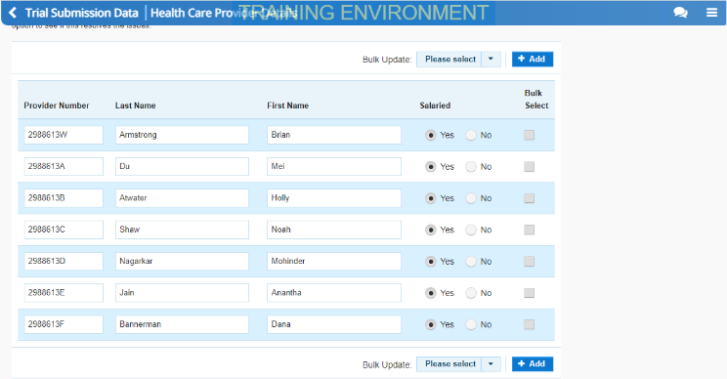
- Review the data in your HCP form as required, reading any comments that have been left for you in the Notifications Tray, if applicable.
If the Notifications Tray doesn’t display, select in the top right-hand corner of the form to open it.
- If the comment is just for your information or you’re happy it has been addressed as needed through the data that has been added in the section, select at the top of the comment in the Notifications Tray.
- In the Notifications window that displays, select .
The comment has now been removed from the nKPI form.
- Repeat steps 4 to 6 as needed for each comment that has been left in the form by your Submission Uploader/Reviewer.
If you need to respond to one of the comments that has been left, select in the comment in the Notifications Tray. In the window that displays, select a Reason, and enter your response in the Additional Information field and select . Your response has now been added and can be addressed by your Submission Uploader as needed once you send the nKPI submission back to them for amendment.
- To exit your HCP form and return to the Data Portal home screen, scroll to the bottom of the form, and select .
The Data Portal home screen will again display with the Reporting Dashboard open.
- To progress the HCP submission through the submission workflow, select .
- In the Change Data Asset Status dialog box, in the Action field, select and select Approve for Submission.
If you responded to one of the comments in the form and need to send your HCP report back to your Submission Uploader so they can address your response, select Revision Required and then select .
- In the Comment field, enter any comments about the action being performed on your HCP submission.
- To approve your HCP submission and send it for processing by Health, select . See the Process a HCP Submission QRG for the next step in the process.
Your HCP submission has now been approved and sent to Health again for processing.

