To update and submit your *direct load* Health Care Provider (HCP) submission in the Health Data Portal, as a *Submission Uploader*:

1. Open the Health Data Portal through [Health Data Portal](https://dataportal.health.gov.au/).
2. Log in using the information provided in the *Register for and Log in to the Health Data Portal* QRG.

The Data Portal home screen will display with the Reporting Dashboard open.

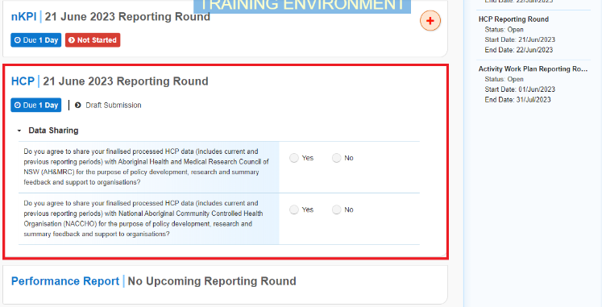

Your HCP submission that has been created as part of the Direct Load transfer from your Clinical Information System (CIS) will display here (*as highlighted above in red*).

 Your submission’s status will be *Draft Submission*.

1. To open your HCP form, hover your mouse pointer to the right of the HCP reporting round text in the ReportingDashboard and select Open Submission Form.

 If you need to change the *Title* or *Description* of the submission, you can do this in the Data Asset Details screen first to by selecting Nore Details next to Open Submission Form and then selecting *Open Data Asset*.

Your HCP Form will display.

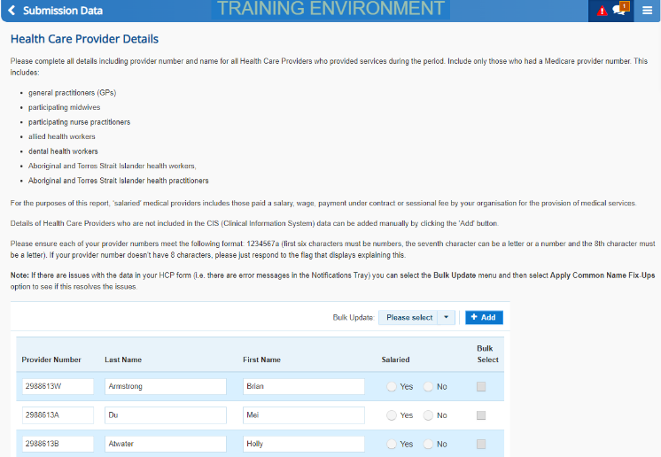

Your HCP form contains the Health Care Provider names and numbers for your health service that have been transferred from your Clinical Information System (CIS).

An “All fields are required” data validation flag will display in the *Notifications Tray* on the right-hand side of the form, as information regarding whether or not your providers are salaried is not contained within your CIS and, therefore, not transferred to the HCP form in the Data Portal as part of the direct load process.

1. To complete the **Salaried** section of the form, select the down arrow on the **Bulk update:** button (either at the top or bottom of the form) and select the applicable option from the second half of the list that displays. The options are **Mark empty Salaried as Yes**, **Mark empty Salaried as No**, **Mark all Salaried as Yes** and **Mark all Salaried as No**.

 You can also complete the *Salaried* section of the form either by simply selecting *Yes* or *No* for each listed provider.

1. To save your changes, select Save at the bottom of the form.

The “All fields are required” data validation flag should now be removed from the *Notifications Tray*.

Other data validation flags may also display in your HCP form *Notifications Tray* for the following reasons:

* One or more of your provider numbers do not meet the required numbering format.
* The *Last Name* cell is empty for one or more of your providers.
* One of the name cells for one or more of your providers contains a salutation (e.g. Dr, Prof).

1. If any other data validation flags do display in the *Notifications Tray*, read the message to determine what action needs to be taken.
2. You can then either make the required change in the applicable cell(s) or, for any validation flags relating to provider names, select Please select and then select **Apply Common Name Fix Ups** from the list that displays.
3. Select Yes in the window that displays.
4. Select Save at the bottom of the form.

Any validation flags associated with the provider names will now be resolved.

**If values need to be amended:**

* 1. Update the incorrect value(s) in the required cell(s) to address the data validation issue(s).

Note If you are unsure which value(s) needs to be updated, hover your mouse pointer to the right of the applicable data validation flag title in the *Notifications Tray*, select the Eye button and the applicable cell(s) will be highlighted in red.

* 1. To save the amendment and run data validation again, select Save at the bottom of the form.

The data validation flag relating to the value you have just amended should now have disappeared from the *Notifications Tray*.

 If you wish to add a comment for your colleagues explaining the changes you have made to the values, select Create New Comment at the top of the *Notifications Tray* and add the details.

**If explanatory comments need to be added:**

1. In the **Notifications Tray**, hover your mouse pointer to the right of the applicable data validation flag title and select the Respond button.
2. Select the Down Arrow in the **Reason** field that displays and select the reason you are adding a comment from the drop-down list.
3. Enter your comment in the **Additional Informatio**n field.
4. To save the comment, select the Save button.

 If an additional Health Care Provider needs to be added to your HCP form, select the Add button either at the top or bottom of the form and add the provider’s details.

 If provider information needs to be removed from the form (perhaps providers from a different clinic have been included in the report) select the applicable *Bulk select* check boxes at the end of the rows and then select the down arrow on the **Bulk update:** button (either at the top or bottom of the form) and select *Delete all selected* from the list that displays.

1. Once all validation issues in your HCP form have been addressed, to exit the form and return to the Data Portal home screen, scroll to the bottom of the form, and select Close.

The Data Portal home screen will again display with the Reporting Dashboard open.

1. Before progressing your HCP submission through the submission workflow, answer either **Yes** or **No** to the data sharing consent questions that display under **Data Sharing**.
2. To save the changes, select Save.
3. To progress your HCP submission through the workflow, select the Draft Submission link.

The Change Data Asset Status dialog box will display, informing you that your draft submission cannot be removed.

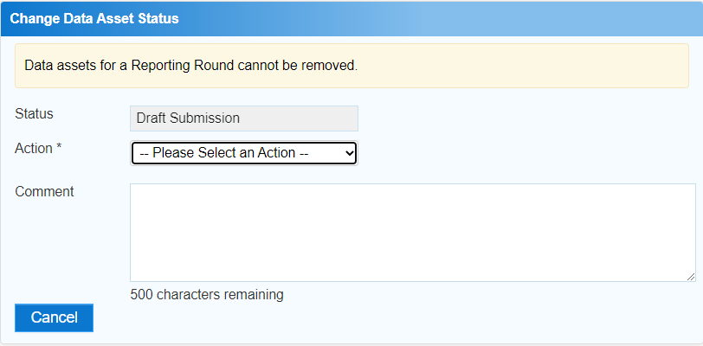

1. In the **Action** field, select the down arrow and select the appropriate action.

The available actions are:

* **Request Review** – Select this action to send your HCP submission to your *Submission Reviewer* for review prior to it being submitted for approval.
* **Request Approval** – Select this action to send your HCP submission directly to your CEO or their representative for approval.
* **Request Interim Processing –** If you are a *Submission* *Reviewer* as well as a *Submission* *Uploader*, you can select this action to send your submission to the AIHW for review prior to it going to your CEO or their representative for approval. This process is known as *Interim Processing*.

 If you can approve HCP submissions yourself, you will see the *Approve for Submission* option in the list. This allows you to immediately approve the submission and submit it directly to the Department of Health and Aged Care for processing.

1. One of the following options can now be selected when submitting your HCP report, depending on the action you have selected in the **Action** field:
   1. To send your submission for internal review, select Request Review. See the *Review your HCP Submission (Submission Reviewer)* QRG for the next step in the process.
   2. To submit your HCP report directly for approval to your CEO or their representative, select Request Approval. See the *Approve your HCP Submission (Submission Approver)* QRG for the next step in the process.

Your *direct load* HCP submission has now been updated and sent to your *Submission Reviewer* for review or your CEO or their representative for approval.

An automated email will be sent to all staff within your health service that have been assigned the applicable role in the Data Portal (*Submission Reviewer* or *Submission Approver*) notifying them your HCP report has been submitted to them for action.

 For a more detailed description of how to submit your HCP report through the Data Portal, see *Submit your HCP Report (Direct Load)* in the *HCP Reporting in the Health Data Portal* user guide on the *User Support* page of the Data Portal.

Refresh your HCP Submission

If there have been updates to your data for the current reporting round in your CIS (or perhaps an error in the CIS has been fixed) then you can transfer the data across to the Health Data Portal again and the values in your existing HCP submission in the Data Portal for the matching/current reporting round will be updated to reflect the new values.

Your updated submission can then be progressed through the submission workflow as normal.

 For this to be possible, your submission in the Data Portal needs to be “with” the *Submission Uploader*. That is, it needs to be at one of the following statuses: *Draft Submission*, *Submission Revision Required* or *Submission Returned to Uploader*.

 If you need to complete the Direct Load process again to update your HCP data in the Data Portal, **DO NOT** try to remove your existing HCP submission, just follow the process above.