To update and submit your *direct load* Online Services Report (OSR) in the Health Data Portal, as a *Submission Uploader*:

1. Open the Health Data Portal through [Health Data Portal](https://dataportal.health.gov.au/).
2. Log in using the information provided in the *Register for and Log in to the Health Data Portal* QRG.

The Data Portal home screen will display with the *Reporting Dashboard* open.

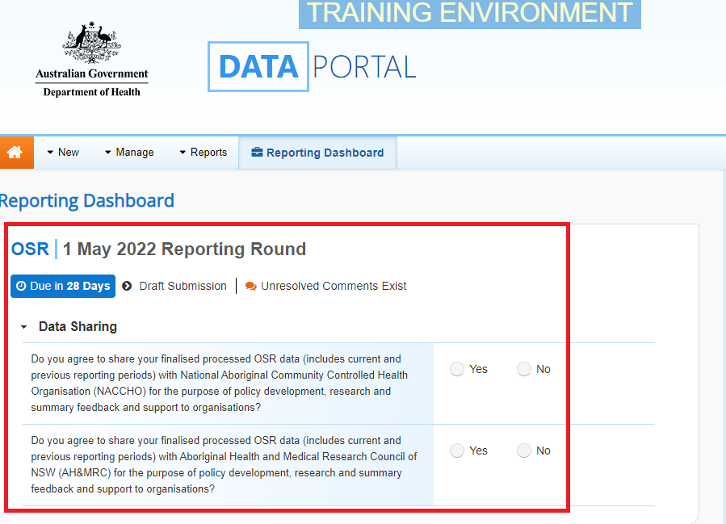

Your OSR submission that has been created as part of the Direct Load transfer from your Clinical Information System (CIS) will display here (*as highlighted in red above).*

 Your OSR submission’s status will be *Draft Submission*.

1. To open your OSR form, hover your mouse pointer to the right of the OSR reporting round text in the Reporting Dashboard and select Open Submission Form.

 If you need to change the *Title* or *Description* of the submission or switch it to be a *Trial Submission*, you can do this in the Data Asset Details screen by selecting Nore Details next to Open Submission Form and then selecting *Open Data Asset.*

The OSR Form will display.

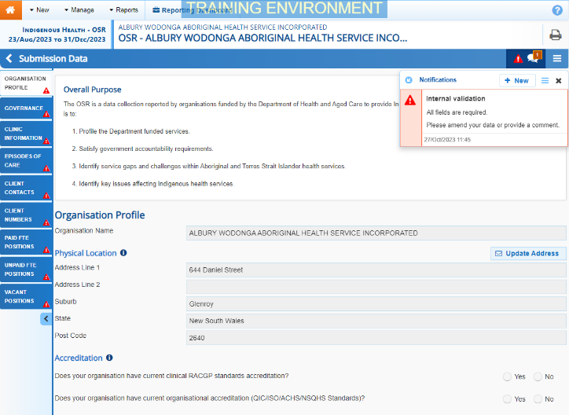

Each section of your OSR form is displayed on a separate tab on the left-hand side of the form. Most of the tabs will display a validation flag icon, as each of these sections contain cells that need to be completed.

1. You can now start completing/updating your OSR form (starting with the O*rganisation Profile* section) as required.

The OSR form contains the following sections that need to be completed:

* **Organisation Profile** – here you need to answer questions regarding your health service’s accreditation, smoke-free workplace, and incorporation status. You can also nominate your health service’s main contact for your OSR report.
* **Governance** – here you need to answer questions about your governing committee/Board if you have one, and you are able to answer the questions.
* **Clinic Information** – for each of your service delivery sites enter information such as the site’s opening hours, the catchment areas it services, the functions the site performs and how many clients attended the site during the collection period (estimating this the best you can).
* **Episodes of Care –** these values will come across from your CIS as part of the Direct Load. Check these values and then confirm whether or not they are estimates.
* **Client Contacts** - these values will come across from your CIS as part of the Direct Load so you should just need to check these to ensure they are correct.
* **Client Numbers -** these values will come across from your CIS as part of the Direct Load. Check these values and then confirm whether or not they are estimates.
* **Paid FTE Positions** – if needed, you can manually enter the FTE details for all the paid positions your service has had over the last 12 months. You can also upload these values using your workforce profile spreadsheet. To do this, see the Work with the *Workforce Profile Spreadsheet in your OSR Submission*.
* **Unpaid FTE Positions** – if needed, you can manually enter the FTE details for all the unpaid positions your service has had over the last 12 months. You can also upload these values using your workforce profile spreadsheet. To do this, see the Work with the *Workforce Profile Spreadsheet in your OSR Submission*.
* **Vacant Positions** – enter the details of any positions that were vacant within your service on **30 June**.

1. Once you have answered the required questions and/or entered the required information into a section of your OSR form, select Save at the bottom of the form.
2. If the section still contains a validation flag icon on the corresponding tab, read the accompanying data validation message in the *Notifications Tray* on the right hand-side of the section to see what the issue is.

 If the *Notifications Tray* doesn’t display, select Open Notification tray - some comments require action or Open Notification tray - some comments require action at the top of the form to open it.

**If a value needs to be amended:**

* 1. Update the incorrect value(s) in the required cell(s) to address the data validation flag(s).

 If you are unsure which value(s) needs to be amended, hover your mouse pointer to the right of the applicable data validation flag title in the *Notifications Tray*, select the Eye button and the applicable cell(s) will be highlighted in red.

* 1. To save the amendment and run data validation again, select Save at the bottom of the form.

The data validation flag relating to the value(s) you have just amended should now have disappeared from the *Notifications Tray*.

 If you wish to add a comment for your colleagues explaining the changes you have made to the values, select Create New Comment at the top of the *Notifications Tray* and add the details.

**If you believe the value is correct:**

1. In the **Notifications Tray**, hover your mouse pointer to the right of the data validation flag title and select the Respond button.
2. Select the Down Arrow in the **Reason** field that displays and select the reason you are adding a comment from the drop-down list.
3. Enter your comment regarding the value in the **Additional Informatio**n field.
4. To save the comment, select the Save button.
5. Repeat this process for any other value(s) in the section that need to be explained.

 The data validation flag on the tab on the left-hand side of the form will change to a speech bubble if all data validation flags for the section have been responded to. This shows that you have responded as required to the data validation flags for the section and can submit the data asset to the AIHW if there are no flags to be actioned on any other sections.

The comment(s) has been added and can be viewed by anyone accessing the submission in the Data Portal.

1. Repeat the process for all sections of your OSR form as required.
2. Once all sections of your OSR form have been completed, to exit the form and be returned to the Data Portal home screen, scroll to the bottom of the form, and select Close.

The Data Portal home screen will again display with the Reporting Dashboard open.

1. Before progressing your OSR submission through the submission workflow, answer either **Yes** or **No** to the two data sharing consent questions that display under **Data Sharing**.
2. To save the changes, select Save.
3. To progress your OSR submission through the workflow, select the Draft Submission link.

The Change Data Asset Status dialog box will display, informing you that your draft submission cannot be removed.

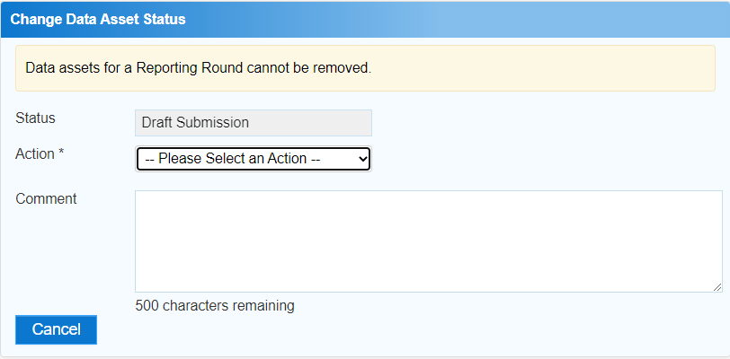

1. In the **Action** field, select the down arrow and select the appropriate action.

The available actions are:

* **Request Review** – Select this action to send your OSR submission to your *Submission Reviewer* for review prior to it being submitted for approval.
* **Request Approval** – Select this action to send your OSR submission directly to your CEO or their representative for approval.
* **Request Interim Processing –** If you are a *Submission* *Reviewer* as well as a *Submission* *Uploader*, you can select this action to send your OSR submission to the AIHW for review prior to it going to your CEO or their representative for approval. This process is known as *Interim Processing*.

 If you can approve OSR submissions yourself, you will see the *Approve for Submission option* in the list. This allows you to immediately approve the report and submit it directly to the AIHW for processing.

1. In the **Comment** field, enter any comments regarding the action being performed on your OSR submission.
2. One of the following options can now be selected when submitting your OSR report, depending on the action you have selected in the **Action** field:
   1. To send your OSR submission for internal review, select Request Review. See the *Review your OSR Submission (Submission Reviewer)* QRG for the next step in the process.
   2. To submit your OSR report submission directly for approval to your CEO or their representative, select Request Approval. See the *Approve your OSR Submission (Submission Approver)* QRG for the next step in the process.

Your *direct load* OSR submission has now been updated and sent to either your *Submission Reviewer* for review or your CEO or their representative for approval.

An automated email will be sent to all users within your health service that have been assigned the applicable role in the Data Portal (*Submission Reviewer* or *Submission Approver*) notifying them your submission has been submitted to them for action.

 For a more detailed description of how to submit your OSR direct load report in the Data Portal, see *Submit your OSR Report (Direct Load)* in the *OSR Reporting in the Health Data Portal* user guide on the *User Support* section of the Data Portal.

Refresh your Direct Load submission

If there have been updates to your OSR data for the current reporting round in your CIS (or an error in the CIS has been fixed) then you can transfer the data across to the Health Data Portal again and the values in your existing OSR submission for the current reporting round will be updated to reflect the new values.

Your updated submission can then be progressed through the submission workflow as normal.

 For this to be possible, your OSR submission in the Data Portal needs to be “with” the *Submission Uploader*. That is, it needs to be at one of the following statuses: *Draft Submission*, *Submission Revision Required* or *Submission Returned to Uploader*.

 If you need to complete the Direct Load process again to update your data in the Data Portal, **DO NOT** try to remove the submission, just follow the process above.