To amend your IAHP PHC Performance Report in the Data Portal at the request of your *Submission Reviewer* or *Approver*:

**Amend your IAHP PHC Performance Report (Submission Uploader)**

1. Open the Data Portal through [Health Data Portal](https://dataportal.health.gov.au/).
2. Log in using the information provided in the *Registering for and Logging in to the Health Data Portal* QRG.

The Data Portal home screen will display with the Reporting Dashboard open.

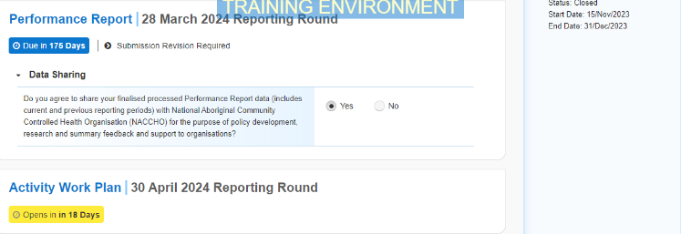

1. To open your IAHP PHC Performance Report form, hover your mouse pointer to the right of the Performance Report reporting roundtext in the ReportingDashboard and select Open Submission Form.

 When your Performance Report is sent back to you for amendment, it will generally have the status of *Submission Revision Required*.

Your IAHP PHC Performance Report form will display.

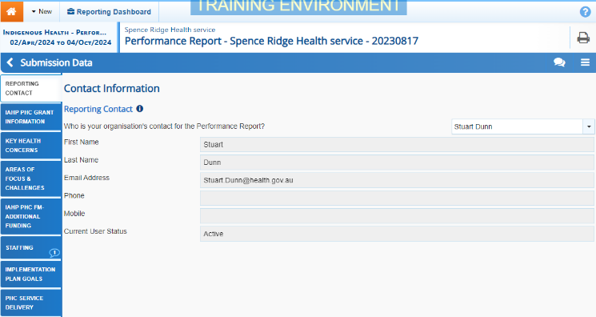

If your *Submission Reviewer* or *Approver* have asked you to make amendments to your Performance Report, they would’ve added comments to the section(s) of the form that needs updating, providing you with guidance on what needs to be done. Any sections of the form that have had comments added will display a speech bubble on the corresponding tab.

1. Open the first section of your Performance Report form containing a speech bubble, and read the comment(s) that has been added by either your *Submission Reviewer* or *Submission* Approver asking you to make changes to the information in the section.
2. Then, as required, update the information in the required cell(s) based on the *Submission* *Reviewer*/*Approver’s* comments.

Once you have made the required amendments, or you haven’t made the amendments and need to explain why, you should respond to the comment made by the *Submission Reviewer/Approver*.

1. To do this in the *Notifications Tray*, hover your mouse pointer to the right of the comment title, and select the Respond button.

 If the *Notifications Tray* doesn’t display, select Open Notification tray - some comments require action or Open Notification tray - some comments require action at the top of the form to open it.

1. Select the drop down arrow in the **Reason** field that displays and select the reason you are adding a response from the drop-down list.
2. Enter your response in the **Additional Information** field.
3. To save the comment, select the Save button.
4. Repeat steps **4** to **9** for any other sections in the form you have been asked to make amendments to.

 If you wish to add an internal comment for your colleagues explaining the changes you have made to the values, select Create New Comment at the top of the *Notifications Tray* and add the details.

1. To exit your IAHP PHC Performance Report form and return to the Data Portal home screen, scroll to the bottom of the form, and select Close.

The Data Portal home screen will again display with the Reporting Dashboard open.

1. Before progressing your Performance Report through the submission workflow, answer either **Yes** or **No** to the data sharing consent questions that display under **Data Sharing** if the questions have not already been answered.
2. To save the changes, select Save.
3. To progress your Performance Report through the submission workflow, select the Submission Revision Required link.

The Change Data Asset Status dialog box will display, informing you that your draft submission cannot be removed.

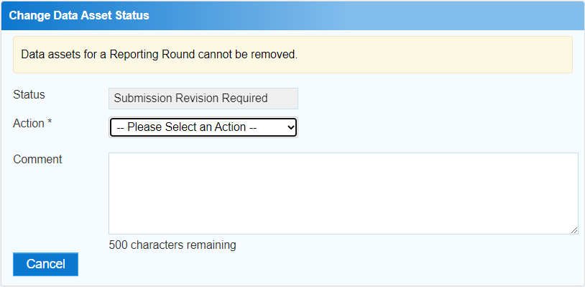

**Amend your IAHP PHC Performance Report (Submission Uploader)**

1. In the **Action** field, select the down arrow and select the appropriate action.

The available actions are:

* **Request Review** – Select this action to send your Performance Report to your *Submission Reviewer* for review again.
* **Request Approval** – Select this action to send your Performance Report directly to your CEO or their representative for approval.

Note If you can approve your IAHP PHC Performance Report yourself, you will also see the *Approve for Submission* option in the action list. This allows you to approve the report and submit it directly to your DSS FAM for processing.

1. In the **Comment** field, enter any comments about the action being performed on your Performance Report.
2. One of the following options can now be selected when submitting your Performance Report, depending on the action you have selected:
   1. To send your Performance Report to your CEO or their representative for approval, select the Request Approval. See the *Approve your IAHP PHC* *Performance Report* *(Submission Approver)* QRG for the next step in the process.
   2. To send your Performance Report to your *Submission Reviewer* for review again, select the Request Review button. See the *Review your IAHP PHC Performance Report (Submission Reviewer)* QRG for the next step in the process.

Your IAHP PHC Performance Report has now been amended and either sent back to your *Submission Reviewer* for review or sent straight on to your CEO or their representative for approval.

An automated email will be sent to all users within your health service that have the applicable role in the Data Portal (*Submission* *Reviewer* or *Submission* *Approver*) letting them know your Performance Report had been submitted to them for action.