To submit your TIS Performance Report through the Data Portal as a Submission Uploader:
- Open the Data Portal through Health Data Portal.
- Log in using the information provided in the Register for and Log in to the Health Data Portal QRG.
The Data Portal home screen will display with the Reporting Dashboard open.
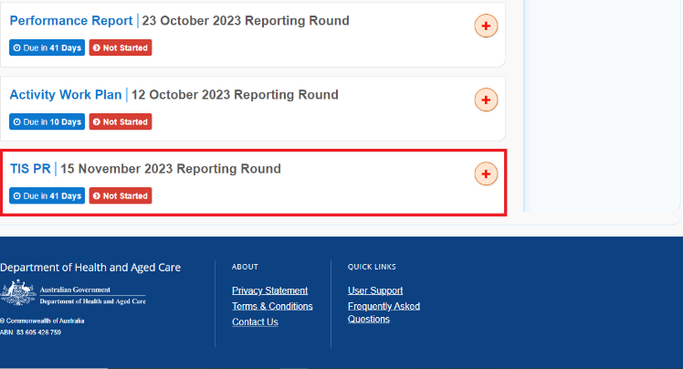
- To commence the creation of your TIS Performance Report, select to the right of the TIS PR reporting round text in the Reporting Dashboard (as highlighted above in red).
The TIS Performance Report form will display.
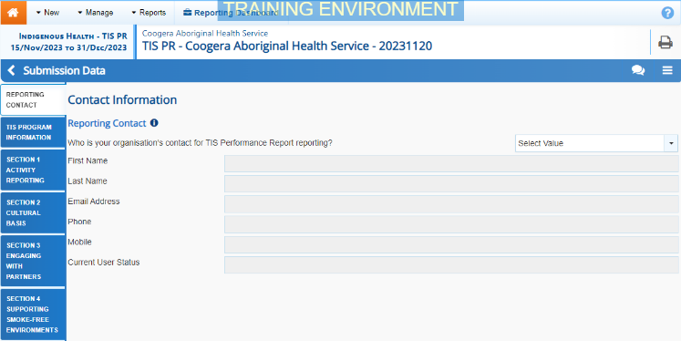
- You can now start entering your TIS Performance Report information into the first section (Reporting Contact – Contact Information) of the form as needed.
The following are the sections of the TIS Performance Report that need to be completed:
- Reporting Contact – Select the person within your service who will be the primary contact for your TIS Performance Report.
- TIS Program Information – Enter some general information regarding your TIS program.
- Section 1 Activity Reporting – Enter the detail for each of your activities, including the type, design, and delivery of the activity, as well as the partnerships and monitoring and evaluation outcomes involved in each activity. Use to add each of your activities.
- Section 2 Cultural Basis – Enter information regarding the number of TIS funded positions in your program.
- Section 3 Engaging with Partners – Enter information relating to Partnerships, Leadership & Advocacy, as well as QUIT Support Partnerships.
- Section 4 Supporting Smoke-free Environments – Enter information regarding smoke-free organisations, public spaces and homes that are part of your program.

Some tips for completing your TIS Performance Report in the Data Portal are:
- Enter data for each section of the form by selecting the applicable tab on the left-hand side of the form.
- You can enter 15000 characters (around 800 words) in each text box in the form so you should be able to fit all the information you need.
- When working in the Section 1 Activity Reporting tab, you will only be able to work on one section at a time (this is to ensure the information saves more efficiently). The section that is currently editable will be marked with a button. Once you save the information in that section by selecting , all sections of the tab will become editable again, until you start working on the next section.
- As part of your funding agreement, you are required to submit expenditure information with your TIS Performance Report. You can upload this as an attachment to your TIS Performance Report through the Portal. To do this, see the Attach a Supporting Document to your TIS Performance Report QRG.
- You can add comments for your colleagues on any section of the form by selecting at the top of the Notifications Tray, adding in the comment or question for your colleagues and then selecting Save.
- If a cell is not relevant to your TIS Performance Report, you can leave it blank. If the cell is optional, you will be able to continue completing the report; if the cell is mandatory, a data validation flag will display that you will need to address.

- Once the required information has been entered for the first section, select at the bottom of the form.
The simple completeness data validations will now run on the cells you have completed in the first section of the form, and if any mandatory cells have been left blank, a data validation flag will appear in the Notifications Tray.
- If a data validation flag has been generated, you can either respond to the message in the Notifications Tray explaining why the cell has been left blank or you can complete the empty cell.
To open the Notifications Tray if it doesn’t display, select in the blue Submission Data bar at the top of the form.
- Repeat the above steps for each section of the form as required.
- Once you have finished entering your data into the different sections of the form and have saved the data, select at the bottom of the form.
The Data Portal home screen will again display with the Reporting Dashboard open.
If needed, you can attach supporting documentation to your TIS Performance Report (such as your expenditure information) before sending it on for review. For more information, see the Attach a Supporting Document to your TIS Performance Report QRG.
- To progress your TIS Performance Report through the submission workflow, select .
The Change Data Asset Status dialog box will display.
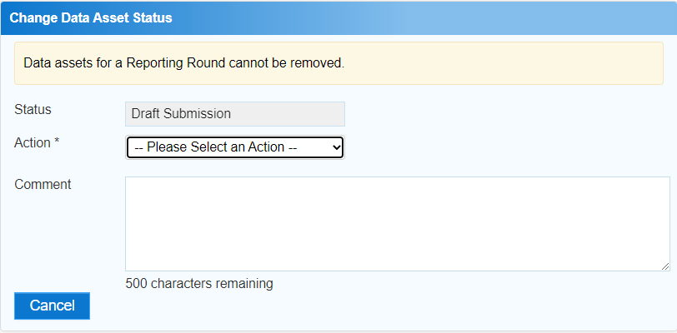
- In the Action field, select and select the appropriate action.
The available actions are:
- Request Review – Select this action to send your report to someone within your health service or NBPU for review prior to it being submitted for approval.
- Request Approval – Select this action to send your report to your CEO or their representative for internal approval.
- Request Interim Processing – If you are a Submission Reviewer as well as a Submission Uploader, you can select this action to send your report to your DSS FAM for review prior to it going to your CEO or their representative for approval. This process is known as Interim Processing.
If you can approve your TIS Performance Report yourself, you will also see the Approve for Submission option in the Action list. This allows you to approve your report and submit it directly to your DSS FAM for processing.
- In the Comment field, enter any comments regarding the action being performed on your report.
- One of the following buttons can now be selected when submitting your report, depending on the action you have selected:
  - To send your report for internal review, select . See the Review your TIS Performance Report (Submission Reviewer) QRG for the next step in the process.
  - To submit your report directly for approval to your CEO or their representative, select . See the Approve your TIS Performance Report (Submission Approved) QRG for the next step in the process.

Your TIS AWP report has now been created and submitted to either the NBPU or your Submission Reviewer for review or your CEO or their representative for approval.
An automated email will be sent to all users within your health service (including the NBPU representative working within your service) that have been assigned the applicable role in the Data Portal (Submission Reviewer or Submission Approver) notifying them your report has been submitted to them for action.
For a more detailed description of how to submit your TIS Performance Report in the Data Portal, see Submit your TIS Performance Report in the TIS Performance Reporting in the Health Data Portal user guide on the User Support page of the Data Portal.

