**Work with Comments in your HCP Form**

Respond to a Data Validation Flag

To respond to a data validation flag in your HCP form:

1. Ensure the Data Portal home screen is displayed, and the ReportingDashboardis open.

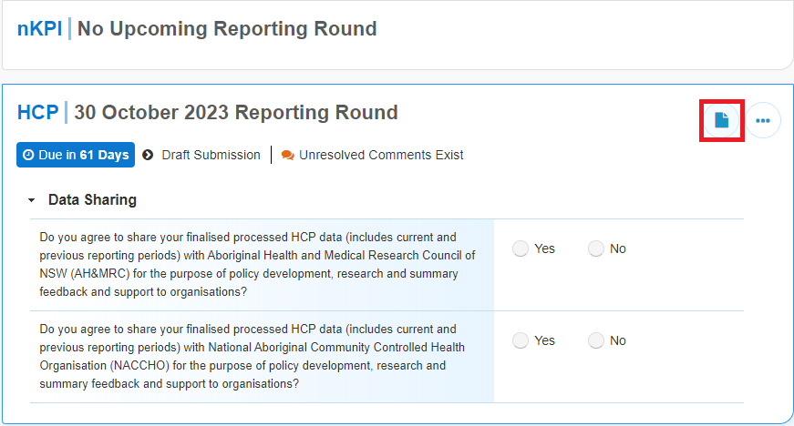

1. From the **Reporting Dashboard**, hover your mouse pointer to the right of the HCP reporting round text and select the Open Submission Form button (*highlighted above in red*).

The HCP form will display.

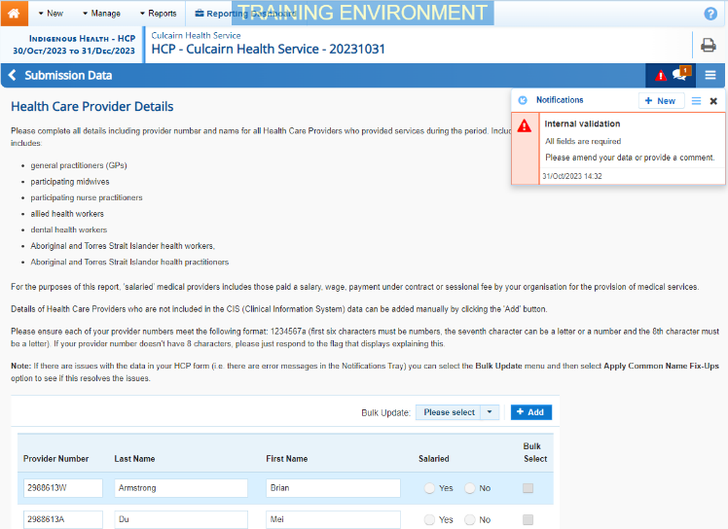

The *Notifications Tray* will display on the right-hand side of the form and any applicable data validation flags (along with any responses made against the flags) will display.

 To open the *Notifications Tray* if it doesn’t display, select Open Notifications tray - Some comments require season in the blue *Submission Data* bar at the top of the form.

1. To provide your explanation as to why you aren’t updating the value in question, in the Notifications Tray, hover your mouse pointer to the right of the applicable data validation flag title and select the Respond button.
2. Select the Down Arrow in the **Reason** field that displays and select the reason you are adding a response from the drop-down list.
3. Enter your response in the **Additional Information** field.
4. To save the response, select the Save button.

In the *Notifications Tray*, your response has been added directly under the data validation flag you are responding to and can be viewed by anyone accessing the submission in the Data Portal.

1. Repeat this process for any other data validation flags you wish to respond to.
2. To exit the form and return to the Data Portal home screen, scroll to the bottom of the form, and select Close.

The responses you have made to the data validation flags can now be seen by anyone else within your health service who needs to work with the submission, plus the Department of Health and Aged Care once the submission is approved and submitted to them for processing.

Add a New Comment

To add a new comment to your HCP form in the Data Portal:

1. Ensure the Data Portal home screen is displayed, and the ReportingDashboard is open.



1. To open your HCP form, hover your mouse pointer to the right of the HCP reporting round text and select the Open Submission Form button (*highlighted above in red*).

The HCP form will display.



You can now add a new comment (for example, explaining to the Department of Health and Aged Care a value change you have made to address a data validation issue, or providing some additional information to other users within your health service) to the required section of the form.

1. To add a new explanatory comment to the form, select Create New Comment at the top of the Notifications Tray.
2. Select the Down Arrow in the **Reason** field that displays and select the reason you are adding a comment from the drop-down list.
3. Enter your comment in the **Additional Information** field.
4. To mark your comment as private so no one outside the health service can see it, select the **Private Conversation** check box.
5. To save the comment, select the Save button.

The new comment has now been added to the *Notifications Tray* for the section, separate to any data validation flag and associated responses that may display.

1. To exit your HCP form and return to the Data Portal home screen, scroll to the bottom of the form, and select Close.

Link a Comment to Particular Cells

To add a new comment to your HCP form and then link the comment to certain cells:

1. Ensure the Data Portal home screen is displayed, and the ReportingDashboardis open.

**Work with Comments in your HCP Form**

1. To open your HCP form, hover your mouse pointer to the right of the HCP reporting round text and select the Open Submission Form button.

The HCP form will display.



1. To add a new explanatory comment to the selected section, select Create New Comment at the top of the Notifications Tray.

The Add Comment dialog box will display, showing the message “Click on cells above to link them to the comment. Click the cell again to unlink it”.

1. Scroll back up to the data cells for the indicator and select the cell or cells the new comment relates to.

 The selected cell(s) will be highlighted with a red border. To unlink the cell(s) simply select it again.

1. Select the Down Arrow in the **Reason** field that displays and select the reason you are adding a comment from the drop-down list.
2. Enter your comment in the **Additional Information** field.
3. To mark your comment as private so no one outside the health service can see it, select the **Private Conversation** check box.
4. To save the comment, select the Save button.

The comment has been saved and the selected cell(s) has been linked to the comment to give it context.

Any user who opens the form and accesses your comment can see the cell(s) that relates to your comment by selecting the Eye button next to your comment in the *Notifications Tray*.

Mark Comments as Complete

To mark comments as complete in your HCP form:

1. Ensure the Data Portal home screen is displayed, and the ReportingDashboard is open.
2. To open your HCP form, hover your mouse pointer to the right of the HCP reporting round text and select the Open Submission Form button.

The HCP form will display.



If you are a health service user looking to remove an internal comment or conversation from view prior to the submission being submitted to the Department of Health and Aged Care for processing, you will need to mark the comment/conversation as complete.

Similarly, if you are a Department of Health and Aged Care user looking to process a submission and the form still contains a data validation flag and its associated responses, you will need to mark these as complete before you can process the submission.

1. To mark a comment/data validation flag conversation as complete, in the Notifications Tray, select the Mark as Complete button next to the applicable comment/data validation flag.

 To open the *Notifications Tray* if it doesn’t display, select Open Notifications tray - Some comments require season at the top of the screen.

The comment and the conversation it is part of will now disappear.

 To retrieve the comment that has been marked as complete, select Notification Options at the top of the *Notifications Tray*and then select*Show completed comments*. To return the comment permanently to view, select the Mark as not complete button. The comment will now redisplay and can be responded to as needed.

**Work with Comments in the HCP Form**

1. To exit your HCP form and return to the Data Portal home screen, scroll to the bottom of the form, and select Close.