To review your IAHP PHC AWP as a *Submission* *Reviewer*, after it has been amended by your *Submission Uploader* at the request of your DSS FAM:

**Review your IAHP PHC AWP based on DSS FAM Feedback (Submission Reviewer)**

**Review an nKPI Submission as Part of Exception Reporting (Health Service)**

1. Open the Data Portal through [Health Data Portal](https://dataportal.health.gov.au/).
2. Log in using the information provided in the *Register for and Log in to the Health Data Portal* QRG.

The Data Portal home screen will display with the Reporting Dashboard open.

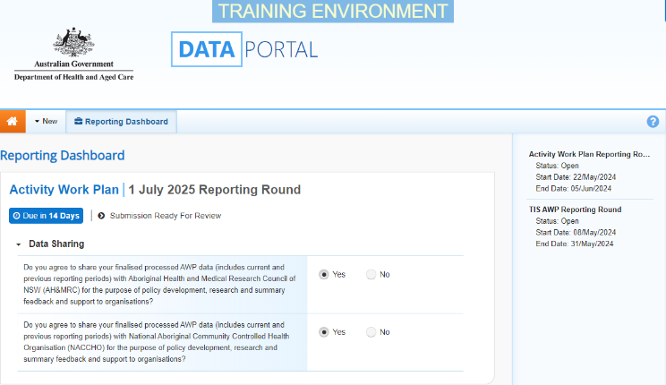

 To be eligible for review, the AWP’s status will need to be *Submission Ready for Review*.

1. To open your IAHP PHC AWP form, hover your mouse pointer to the right of the Activity Work Plan reporting round text in the Reporting Dashboard and select Open Submission Form.

Your IAHP PHC AWP form will display.

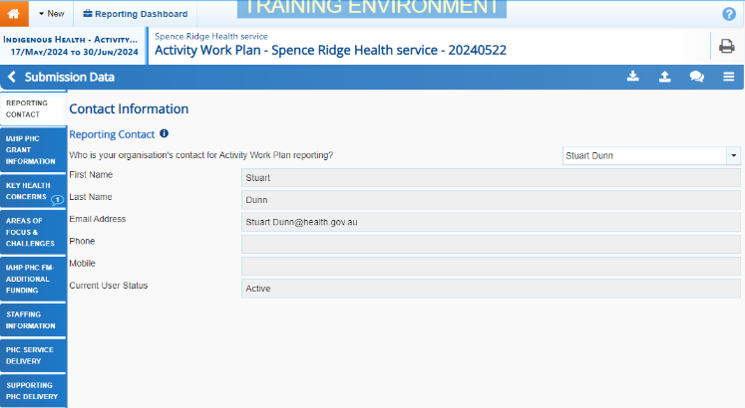

1. Review the data in the different sections of the form as required.
2. Update information in the cells if you feel any of the information entered by the *Submission Uploader* needs to be changed or added to.
3. If your DSS FAM or *Submission* *Uploader* has left a comment for you in the form that you need to respond to, in the Notifications Tray, select the Respond button.

 To open the *Notifications Tray* if it doesn’t display by default, select Open Notifications tray - Some comments require season in the blue *Submission Data* bar at the top of the form.

1. Select the down arrow in the **Reason** field that displays and select the reason you are adding a comment from the drop-down list.
2. Enter your comment in the **Additional Information** field.
3. To save the comment, select the Save button.

The comment(s) has been added and can be viewed by anyone accessing your AWP in the Data Portal.

 If you would like to leave your own comment for others accessing/reviewing the AWP form, select Create new comment in the *Notifications Tray* and add your comment, linking it to a particular cell and making it a private comment if needed. Once you are done, select the Save button.

1. To exit your IAHP PHC AWP form and return to the Data Portal home screen, scroll to the bottom of the form, and select Close.

The Data Portal home screen will again display with the Reporting Dashboard open.

1. To progress your IAHP PHC AWP through the submission workflow, select the Submission Ready for Review link.
2. In the Change Data Asset Status dialog box, in the **Action** field, select the down arrow and select the required action.

The available actions are:

* **Request Approval** – Select this action to send your AWP to your CEO or their representative for approval again.
* **Approve for Submission** – Select this action if you are the CEO, or nominated representative, and are approving the AWP as well as reviewing it.
* **Request Interim Processing** – Select this action to send your AWP to your DSS FAM for review prior to it going to your CEO or their representative for approval. This process is known as *Interim Processing*.
* **Revision Required** – Select this action to return your AWP to the *Submission Uploader* for further amendment.

1. In the **Comment** field, enter any comments regarding the action being performed on your submission.
2. One of the following buttons can now be selected when submitting your AWP, depending on the action you have selected:
   1. To send your AWP to your CEO or their representative for approval again, select the Request Approval. See the *Approve your IAHP PHC AWP based on DSS Feedback (Submission Approver)* QRG for the next step in the process.
   2. To approve your AWP and send it directly to your DSS FAM for processing again, select the Approve for Submission button. See the *Process an IAHP PHC AWP* QRG for the next step in the process.

**Review your IAHP PHC AWP based on DSS FAM Feedback (Submission Reviewer)**

* 1. To send your AWP to your DSS FAM for initial review prior to sending it to your CEO or their representative for approval, select the Request Interim Processing button. See the *Interim Processing of an IAHP PHC AWP* QRG for the next step in the process.
  2. To send your AWP back to your *Submission Uploader* for amendment again, select the Revision Required button. See the *Amend your IAHP PHC AWP based on DSS Feedback (Submission Uploader)* QRG for the next step in the process.

Your IAHP PHC AWP has now been reviewed and either sent to your *Submission Approver* for re-approval or sent back to your *Submission Uploader* for further revision as required.