

First Nations Health Reporting:
nKPI - Communicare Data Limitations

Introduction
The National Key Performance Indicators (nKPI) is a suite of process of care and health outcome indicators focussing on maternal and child health, preventive health, and chronic disease management for First Nations people. Accurate reporting is essential to support continuous quality improvement in primary health care delivery.
Differences in how clinical information systems (CIS) capture and report data (whether due to system capability, reporting limitations, or both) can affect the accuracy and completeness of these indicators. Understanding these system-specific limitations and how they translate into CIS reports, as well as knowing where to record data within the CIS, is critical for ensuring your activities are comprehensively reported and results interpreted correctly.
This article outlines some key CIS limitations that may impact health service’s data and some practical tips to help manage data.
Communicare limitations and data quality tips
Qualifiers
In Communicare, qualifiers are used to capture detailed clinical data, such as blood pressure readings, HbA1c levels, ACRs, and eGFRs. These qualifiers are linked to clinical items and are critical for accurate reporting. However, since some qualifiers can be locally defined, Communicare relies on system codes and export codes to formally identify these items for reporting purposes.
System codes are usually three-character codes used to identify clinical items within Communicare. They help the system recognise what kind of data is being recorded and are also used in reports.
It’s important to note that local items should not be assigned a system code unless they have been verified as suitable. Incorrectly assigning system codes can impact the accuracy of reporting.
Export codes are used solely for reporting and can be up to eight characters long.
TIPS:
- You can review which system or export codes are used for a particular indicator by checking the indicator’s details in the Communicare Knowledge Centre (refer to the User Guide article for access instructions).
- Think of system and export codes like ICPC codes, they help Communicare classify and report on clinical data accurately. You can view these by running: Reports > Reference Tables > System Codes and Rule Codes.
Telephone visits
Communicare doesn't distinguish between clinical and non-clinical encounters for telephone visits. As a result, all telephone encounters are counted as eligible visit types for assessing Regular Client status in the nKPI report. This may lead to inflated Regular Client figures, particularly if non-clinical staff are recording their client interactions as telephone encounters.
The Specifications allow for, and accept, this limitation in scenarios where a CIS can’t distinguish between clinical and non-clinical telephone visits.
NOTE: Telehealth visits are categorised separately.
TIP: Knowing this limitation helps you better understand which data are included in the calculation of Regular Client status.
Smoking status – PI09, PI10, PI11
In PI09, PI10 and PI11, the Specifications for nKPI and Online Service Reports (OSR) (the Specifications) state that smoking status should be recorded within specific time periods or events. However, this requirement has not been strictly enforced in recent years due to system limitations in several CIS. Some systems have not historically enabled the smoking status assessment date to be updated unless the status of smoking was changed. Because of this, the Department of Health, Disability and Ageing accepted that CIS reports could count the most recently recorded smoking status, based on the assumption that clinicians would update it if it was known that the status had changed.
Communicare currently includes all clients with a recorded smoking status, no matter when it was recorded. The last recorded smoking status is used. While this approach aligns with historical reporting practices, it may lead to an overcount of clients who appear to have had a smoking status assessment within the required timeframe.
TIP: Communicare does enable a new smoking status assessment to be recorded without changing the existing status. Clinical staff are encouraged to do this to confirm data are current in case indicator requirements for smoking status change. These screenshots show where to record a new assessment in Communicare and where each assessment can be viewed.
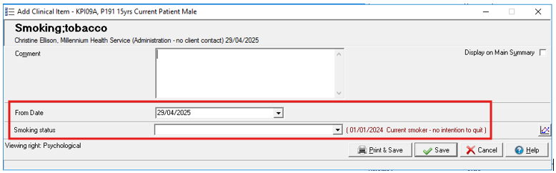
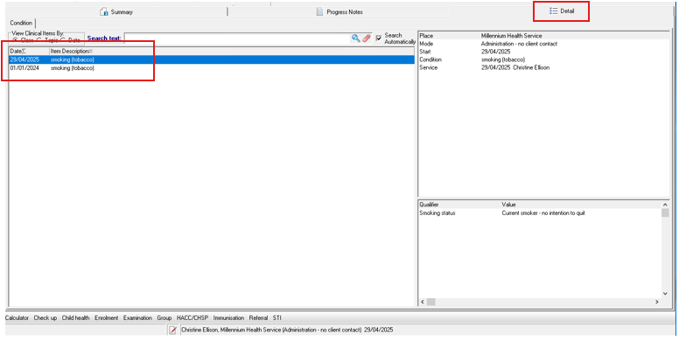
Communicare settings enable ‘flagging’ of qualifier currency. Setting the currency of the smoking status qualifier to two years will prompt the smoking status date to appear in red text when the currency falls outside the two-year window (as illustrated in the first image above).
TIP: Set the smoking status qualifier currency to two years to prompt addition of a new assessment.
Baby birthweight – PI13
Communicare uses an internal algorithm to calculate gestational age (GA) when it is not recorded at the first antenatal visit. This ensures the system can still include clients in PI13 reporting even if some data points are missing. The algorithm works in the following order:
- First, it checks the earliest antenatal visit to see if GA is explicitly recorded.
- If no gestation is recorded, Communicare uses the date of delivery and gestation at birth and calculates backwards to the antenatal visit date.
- If there is no gestation value in either the first antenatal visit or the pregnancy ending, Communicare uses the LMP (last menstrual period) date and calculates forward to estimate the gestation at the time of the antenatal visit.
This means the numbers for each data category might not always match expectations, particularly if GA is not consistently recorded at the first antenatal visit. Records without a directly entered GA value may still be included in the report through this calculated method. It’s important to note that clinical records containing only an antenatal visit and pregnancy ending, with no gestation recorded will be included in the ‘No GA recorded at first antenatal visit’ category.
In addition, while the Specifications include minimum requirements for birthweight (400g or more) or GA (20 weeks or more), Communicare will still include records where both fields are blank. This can result in an overcount in PI13, as some clients may appear to meet the inclusion criteria when their eligibility cannot be confirmed.
TIP: To improve data accuracy, aim to record GA at the first antenatal visit and ensure either birthweight or gestational age is entered for all births.

Cervical Screening (HPV) – PI22
Communicare comprehensively counts cervical screening through a combination of electronically received pathology, clinical items and qualifiers.
Screening that is self-collected, and results performed elsewhere, may need to be manually recorded as a relevant clinical item. Results performed elsewhere may be received electronically as results copied to the health service; in these scenarios they are managed as electronically received pathology. When confirmation of screening elsewhere is received in correspondence and scanned into the record e.g. a referral letter stored as a document, it will need to be manually entered for it to be counted in PI22.
NOTE: The National Cancer Screening Register (NCSR) is integrated with Communicare. This allows you to view a client’s latest NCSR data. However, there is no facility yet to automatically write this data back to the client’s record. Cervical screening history in the NCSR may be relevant to PI22. If you want that information to be counted towards PI22, the screening result needs to be manually added via a relevant clinical item.
Regular Client status
Understanding Communicare’s functionality for user settings can assist health services to manage their nKPI data. It is possible for non-clinical users to inadvertently create blank or empty visits in Communicare. These additional visits may result in higher-than-expected counts of Regular Clients. There is a separate article which provides more detail on this issue as well as tips and tools to assist health services to identify whether they are impacted by this and for mitigating the issue.
TIP: Read the related article to learn how to mitigate the risk of creating empty visits.
Key takeaways:
- All telephone encounters are counted as eligible visits. This may inflate Regular Client numbers if non-clinical staff record their client interactions this way.
- Communicare uses calculated estimates for gestational age at the first antenatal visit if not directly recorded and may include births where both GA and birthweight are missing, which can lead to an overcount in PI13.
- Inaccurate or unverified use of system and export codes in Communicare can lead to inaccurate reporting when applied to locally created items.

Resources
Links to supporting documents, information and further reading:
- Specifications for nKPI and OSR: This document is for service providers and clinical information system vendors. It gives a detailed overview of foundation data concepts, related data, and a full explanation of each measure—covering inclusions, exclusions, counting rules, measure code disaggregation points, and the nKPI Condition and Pathology Coding Frameworks. It also highlights variances in vendor implementation for selected measures. You can access the Specifications here: https://www.solvinghealth.au/specifications
- CIS User Guides: These explain how vendors report indicators and where data need to be recorded in the CIS to optimise reporting. Refer to the article CIS User Guides for links or visit the link in the Specifications (dot point above) which has links to vendor documents at the end of the web page.
- Vendor scorecard: The vendor scorecard is a one page visual that compares results for nKPI and OSR across CIS: https://www.solvinghealth.au/scorecard
For more data management tips see the other articles in this series available at: Clinical Information System (CIS) Education Articles

