Process a Data Asset Submission
Overview
Once a data asset has been approved by the relevant party within the submitting organisation, it will be sent to you as the external Data Receiver, either for processing if applicable or so you can view and download the attached file.
Where the data asset needs to be processed, once you have reviewed the data asset, you can choose to either return it to the uploader for revision if there are errors, or process the data asset as complete, ready for publication if needed.
Process a Data Asset
Step 1 – Review the Data Asset
Once you have received an approved data asset, you can review the data asset in the Data Portal to ensure it is ready to go to the next step of the process.
To review a data asset in the Data Portal:
- Open the Data Portal through Health Data Portal.
- Log in using the information provided in the Registering for and Logging to the Health Data Portal QRG.
The Data Portal home screen will display.
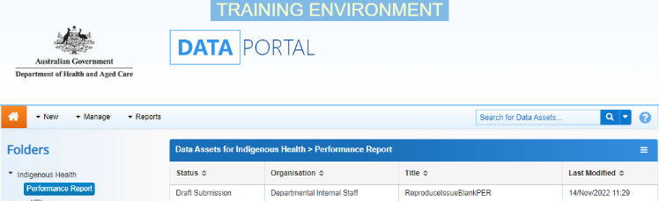
- From the Data Portal home screen, search for the data asset to be processed.
For more information on how to search for a data asset, see the Get Started in the Health Data Portal QRG.
To be eligible for processing, the data asset’s status will need to be Submission Approved.
- Select the data asset to be processed.
The Data Asset Details screen will display.
- Review the details of the data asset as required.
To review the contents of the file, select the file title link under File Name in the Files section.
- Select either or the workflow progress bar at the top of the screen and, in the Change Data Asset Status dialog box, in the Action field, select and select Ready for Processing to move the data asset to the next step of the process.

If there are errors in the data asset and/or the attached file:
  - In the Change Data Asset Status dialog box, in the Action field, select and select Return to Uploader.
  - In the Comment field, enter details regarding why the data asset has been returned.
  - To send the data asset back to the uploader, select .

- Enter any comments regarding the data asset in the Comment field, if needed.
- To set the data asset to Ready for Processing, select .
The Data Asset’s status will change to Ready for Processing and it is ready to be processed.
Step 2 – Process the Data Asset
Once a data asset has the status of Ready for Processing, it can be processed and prepared for publishing as required.
To process a data asset in the Data Portal:
- Ensure the Data Portal home screen is displayed.
- From the home screen, search for the data asset to be processed.
For more information on how to search for a data asset, see the Get Started in the Health Data Portal QRG.
- Select the data asset to be processed.
The Data Asset Details screen will display.
- To review the attached file, select the file title link under File Name in the Files section.
- Review the contents of the attached file and then close the file as needed.
- In the Data Asset Details screen, select either or the applicable area of the workflow progress bar at the top of the screen and, in the Change Data Asset Status dialog box, in the Action field, select and select Process.
Process a Data Asset Submission
- To process the data asset, select .
The data asset’s status will change to Processed and the processing of the data asset is now complete. The data asset can now be published if required.

