There are several tasks that can be completed within an Indigenous health data reporting form to help health service users submit their data through the Data Portal as quickly and accurately as possible.
Navigate Forms in the Health Data Portal
The screenshot below displays the nKPI form but each of the form sections detailed below are also present in the OSR, IAHP PHC Performance Report and IAHP PHC Activity Work Plan (AWP) forms.
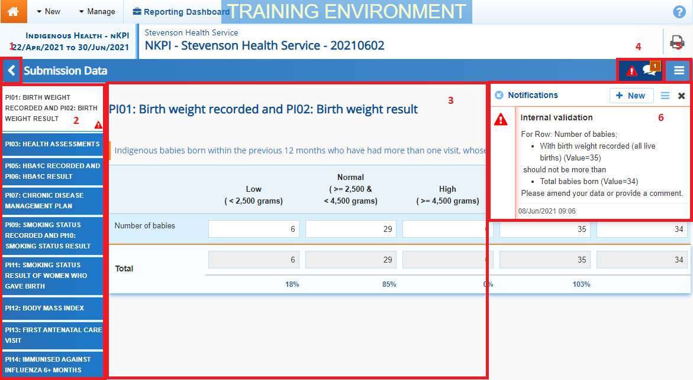

1. Cancel and Go Back to Overview
- Allows the user to quickly navigate away from the form, back to the Data Portal home screen.
2. The Indicators/Sections Tabs
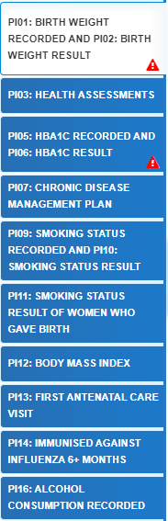
Allow the user to move through the different sections of the form by selecting the appropriate tab from the left-hand side of the form.
A will display on any indicators/sections containing data validation flags that need to be addressed.
The tabs can be hidden if needed by selecting at the bottom of the list (not shown here). The tabs can then be reopened when needed by selecting .
3. Main Form Window
This section of the form contains the data entry cells for the selected indicator/section on the left-hand side of the form.
This is where data is entered in the form.

4. Open Notifications – Some comments require action
Navigate Forms in the Health Data Portal
If there are any data validation flags that need to be addressed in a particular indicator/section of the form, 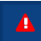 will display in the blue Submission Data bar at the top of the form.
If there are any explanatory comments that have been added to the indicator/section by a user, will display in this section.
To view the data validation flag/comment in the Notifications Tray, simply select the applicable button.
5. The Options Menu
The Options Menu groups together additional functions that can be completed from within the forms. Some functions will only be available in certain forms.
The functions available through the Options Menu are:
- - Displays all indicators/sections of the form in read-only mode on the one screen (replacing the old Preview tab) so the whole form can be printed if needed.
- - Adds zeros to any empty cells in the selected indicator/section.
- - Clears all data that has been entered into the cells in the selected indicator/section.
- - Allows the user to open all the indicators/sections when in Summary View.
- - Allows the user to collapse all the indicators/sections when in Summary View.
- - Allows the user to upload their completed Workforce Profile spreadsheet to populate the Paid and Unpaid FTE tabs of the OSR form (OSR only).
- 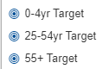 - Displays on PI03 in the nKPI form and, when selected, highlights the cells used to calculate the applicable Value in current collection (%) value on the nKPI Targets tab.
- - Displays on P105, 14, 18 and 23 in the nKPI form and, when selected, highlights the cells used to calculate the applicable Value in current collection (%) value on the nKPI Targets tab.
6. The Notifications Tray
All data validation flags and user entered comments in the forms are displayed in the Notifications Tray.
To open the Notifications Tray if it doesn’t display by default in the form, select either or in the blue Submission Data bar at the top of the form.
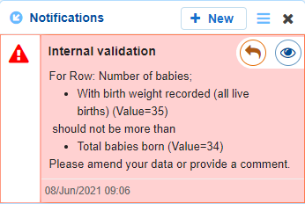
- To respond to a data validation flag/user comment, hover the mouse pointer to the right of the title so the available buttons display, and then select .
- To view any highlighted cells accompanying the flag/comment, select .
- To search for a particular data validation flag/comment, or to show completed comments in the tray, select at the top of the Notifications Tray.
- To add a new comment, select at the top of the Notifications Tray.
- To dock the tray at the bottom of the indicator/section or undock it so it can be moved around the screen, select in the top left-hand corner of the Notifications Tray.
- To close the tray, select in the top right-hand corner of the Notifications Tray.
When the Notifications Tray is undocked, it can be moved around the screen by hovering the mouse pointer over the top of the tray, until the cursor appears as a four headed arrow, holding the left mouse button down and then dragging the tray to any part of the screen.
Navigate Forms in the Health Data Portal

