When your DSS Funding Agreement Manager (FAM) returns your IAHP PHC Activity Work Plan (AWP) to you for amendment, you will receive an email notification informing you your AWP is ready for you to review and update as required.
To amend your AWP in the Data Portal:
Amend your IAHP PHC AWP based on DSS FAM Feedback (Submission Uploader)
- Open the Data Portal through Health Data Portal.
- Log in using the information provided in the Register for and Log in to the Health Data Portal QRG.
The Data Portal home screen will display with your Reporting Dashboard open.
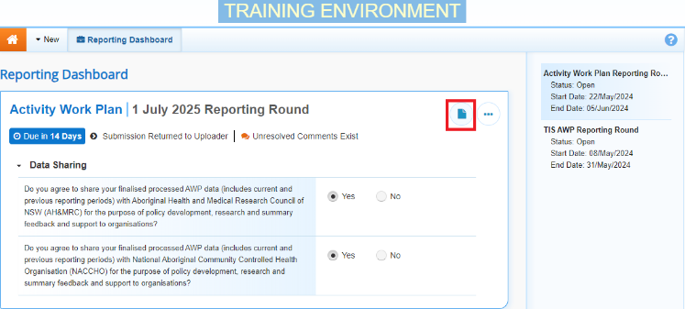
- To open your IAHP PHC AWP form, hover your mouse pointer to the right of the Activity Work Plan reporting round text in the Reporting Dashboard and select .
Your IAHP PHC AWP form will open.
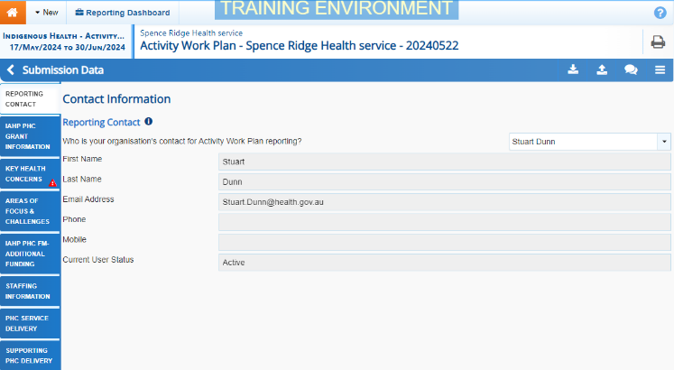
Any sections of your form containing DSS FAM comments will display a on the corresponding tab. The Notifications Tray will display as open for each of these sections in the top right-hand corner of the form, so you can see the detail of the comments/suggestions your DSS FAM has made.
- For each section of your form with data validation flags, review the comment/suggestion made by your DSS FAM in the applicable Notifications Tray.
- If text needs to be updated to address the comment made by your DSS FAM, make the changes in the applicable cell(s) as needed.
When you add text to a cell in your form at this stage of the process, it will look the same as the previous text you have entered, so please add some detail regarding the changes you have made in the response you have to make to your DSS FAM’s comment.
Once you have made the required text changes, you will need to respond to the comment your DSS FAM left.
- To do this, select next to the applicable FAM comment/suggestion in the Notifications Tray.
- In the Notifications window, select in the Reason field and select Other (specify).
- In the Additional Information field, enter text explaining the amendments you have made.
- To save your response, select .
Your response has now been added to your DSS FAM’s comment and the on the section should now have been replaced by .
- Repeat steps 4 to 9 for any other comments your DSS FAM has left in the form.
- To exit the form and return to the Data Portal home screen, scroll to the bottom of the form, and select .
The Data Portal home screen will again display with the Reporting Dashboard open.
- To commence the process of sending your updated IAHP PHC AWP back to your DSS FAM, select .
- In the Change Data Asset Status dialog box, select the in the Action field and select the action required.

The available actions are:
- Request Review – Select this action to send your AWP to your Submission Reviewer for review again.
- Request Approval – Select this action to send your AWP back to your CEO or their representative for approval.
If you can approve the AWP yourself, you will also see the Approve for Submission option in the action list. This allows you to approve your AWP and submit it directly to your DSS FAM for processing again.
- In the Comment field, enter any comments regarding the action being performed on your AWP.
- One of the following buttons can now be selected when submitting your AWP, depending on the action you have selected:
  - To send your AWP to your Submission Reviewer for review again, select . See the Review your IAHP PHC AWP based on DSS Feedback (Submission Reviewer) QRG for the next step in the process.
  - To send your AWP back to your CEO or their representative for approval, select .See the Approve your IAHP PHC AWP based on DSS Feedback (Submission Approver) QRG for the next step in the process.
Amend your IAHP PHC AWP based on DSS FAM Feedback (Submission Uploader)
Your IAHP PHC AWP has now been amended and either sent back to your health service’s Submission Reviewer for further review or sent straight on to your CEO or their representative for approval.
An automated email will be sent to all staff within your health service that have been assigned the applicable role in the Data Portal (Submission Reviewer or Submission Approver) notifying them the AWP has been submitted to them again for action.

