To amend your nKPI submission as a *Submission Uploader* once it has been sent back to you by your *Submission Reviewer* or *Approver*:

**Amend your nKPI Submission (Submission Uploader)**

1. Open the Data Portal through [Health Data Portal](https://dataportal.health.gov.au/).
2. Log in using the information provided in the *Registering for and Logging in to the Health Data Portal* QRG.

The Data Portal home screen will display with the *Reporting Dashboard* open.

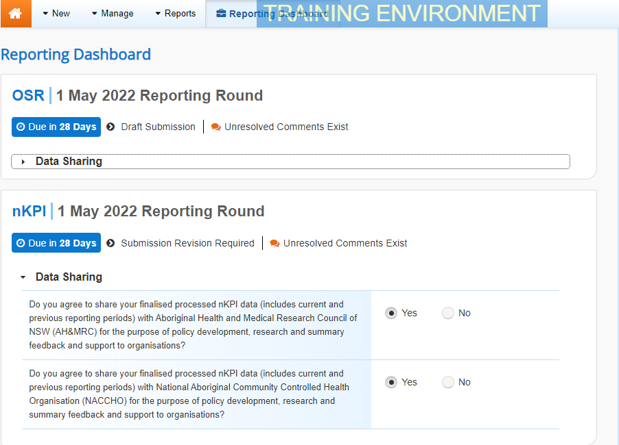

1. To open your nKPI form, hover your mouse pointer to the right of the nKPI reporting roundtext in the Reporting Dashboard and select Open Submission Form.

 If you need to change the *Title* or *Description* of the submission or switch it to a *Trial Submission*, you can do this in the Data Asset Details screen by selecting Nore Details next to Open Submission Form and then selecting *Open Data Asset*.

The nKPI form will display.

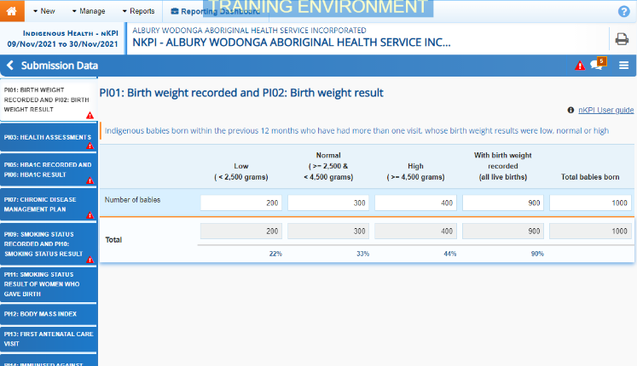

Any indicators that still have data validation flags to be responded to will display a data validation flag on the corresponding tab. If an indicator has a data validation flag that has been responded to or a new comment entered by your *Submission Reviewer* or *Submission Approver*, it will show a speech bubble on the corresponding tab.

1. Review the data in the applicable indicator as needed, focussing on any comments made by your *Submission Reviewer* or *Submission* *Approver* asking you to amend values.
2. If required, update the value(s) in the required cell(s) based on your *Submission* *Reviewer*/*Approver’s* comments.
3. To respond to a particular comment made by the *Submission* *Reviewer/Approver* rather than amending the identified value(s), in the *Notifications Tray*, hover your mouse pointer to the right of the data validation flag title, and select the Respond button.

 If the *Notifications Tray* doesn’t display, select Open Notification tray - some comments require action or Open Notification tray - some comments require action at the top of the form to open it so you can address the data validation issues/read the comments that display.

1. Select the drop down arrow in the **Reason** field that displays and select the reason you are adding a response from the drop-down list.
2. Enter your response in the **Additional Information** field.
3. To save the comment, select the Save button.
4. Repeat steps **5** to **9** for any other values in the form that need to be addressed.

 If you wish to add a comment for your colleagues explaining the changes you have made to the values, select Create New Comment at the top of the *Notifications Tray* and add the details.

1. To exit the nKPI form and return to the Data Portal home screen, scroll to the bottom of the form, and select Close.

The Data Portal home screen will again display with the *Reporting Dashboard* open.

1. Before progressing your nKPI submission through the submission workflow, answer either **Yes** or **No** to the data sharing consent questions that display under **Data Sharing** if the questions have not already been answered.
2. To save the changes, select Save.
3. To progress your nKPI submission through the submission workflow, select the Submission Revision Required link.

**Amend your nKPI Submission (Submission Uploader)**

The Change Data Asset Status dialog box will display, informing you that your submission cannot be removed.

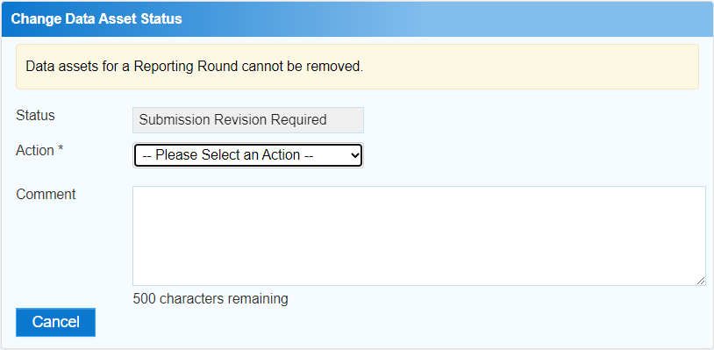

1. In the **Action** field, select the down arrow and select the appropriate action.

The available actions are:

* **Request Review** – Select this action to send your nKPI submission to your *Submission Reviewer* for review again.
* **Request Approval** – Select this action to send your nKPI submission directly to your CEO or their representative for approval.

Note If you can approve your nKPI submission yourself, you will also see the *Approve for Submission* option in the action list. This allows you to approve the submission and submit it directly to the AIHW for processing.

1. In the **Comment** field, enter any comments about the action being performed on the submission.
2. One of the following options can now be selected when submitting your nKPI report, depending on the action you have selected:
   1. To send your nKPI submission to your CEO or their representative for approval, select the Request Approval. See the *Approve your nKPI Submission (Submission Approver)* QRG for the next step in the process.
   2. To send your nKPI submission to your *Submission Reviewer* for review again, select the Request Review button. See the *Review your nKPI Submission (Submission Reviewer)* QRG for the next step in the process.

Your nKPI submission has now been amended and either sent back to your *Submission Reviewer* for review or sent straight on to your CEO or their representative for approval.

An automated email will be sent to all staff within your health service that have the applicable role in the Data Portal (*Submission* *Reviewer* or *Submission* *Approver*) letting them know your report has been submitted to them for action.