Interim Processing of an IAHP PHC AWP

Initiate Interim Processing (Health Service)
To start interim processing of your IAHP PHC AWP in the Data Portal:
- Open the Data Portal through Health Data Portal.
- Log in using the information provided in the Register for and Log in to the Health Data Portal QRG.
The Data Portal home screen will display with the Reporting Dashboard open.
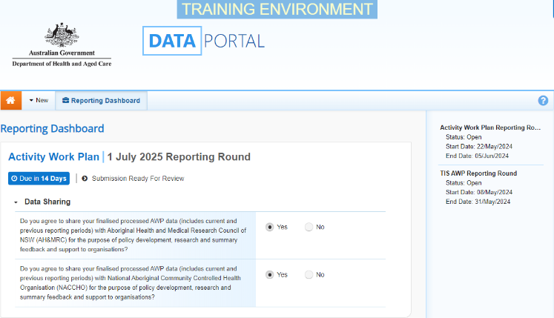
To be eligible for interim processing, your IAHP PHC AWP’s status will need to be at either Draft Submission or Submission Ready for Review, if you have the Submission Reviewer role.
- Before progressing the AWP through the interim submission workflow, answer either Yes or No to the data sharing consent questions that display under Data Sharing if the questions have not already been answered.
- To save the changes, select .
- To start interim processing, select in the Reporting Dashboard and, in the Change Data Asset Status dialog box, in the Action field, select and select Request Interim Processing.
- In the Comment field, enter any comments you wish to add for your DSS FAM.
- To send your IAHP PHC AWP to your DSS FAM for interim processing, select.
The status of the AWP has now been set to Interim Submitted and your DSS FAM can review the submission as needed to assess its suitability before it goes to your CEO, or their representative, for approval.
Review the AWP (DSS FAM)
To review the health service’s IAHP PHC AWP:
- Ensure the Date Portal home screen is displayed.
- From the Data Portal home screen, search for the AWP to be reviewed.
For more information on how to search for a submission, see the Get Started in the Health Data Portal QRG.
The AWP will have the status of Interim Submitted.
- Select the AWP to be reviewed.
The Data Asset Details screen will display.
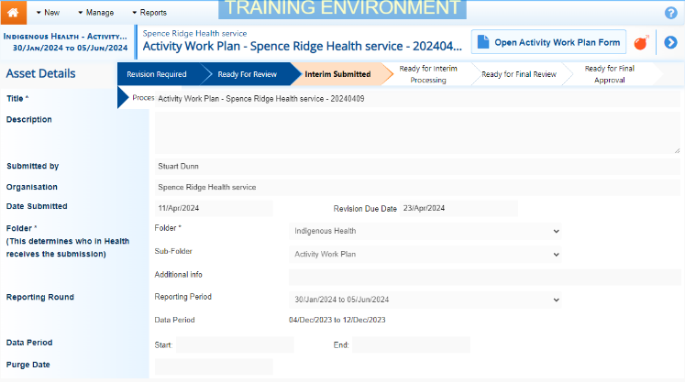
- Review the details of the AWP as needed.
- To review the contents of the AWP form, select at the top of the screen.
- Once finished, select at the bottom of the AWP form to exit the form and return to the Data Asset Details screen.
- To action the service’s AWP, select either or the workflow progress bar at the top of the screen and, in the Change Data Asset Status dialog box, in the Action field, select and select Ready for Interim Processing.
If the health service has asked you to return the submission as it has been submitted in error, select Return to Uploader.
Interim Processing of an IAHP PHC AWP

- In the Comment field, enter any comments about the action being performed on the AWP.
- To prepare the submission for processing, select .
Process the AWP (DSS FAM)
To complete interim processing on the IAHP PHC AWP in the Data Portal:
- Ensure the Date Portal home screen is displayed.
- From the Data Portal home screen, search for the applicable IAHP PHC AWP with the status of Ready for Interim Processing.
For more information on how to search for a submission, see the Get Started in the Health Data Portal QRG.
- Select the IAHP PHC AWP to be processed.
The Data Asset Details screen will display.
- Review the details of the AWP as needed.
- To review the contents of the service’s AWP form, select at the top of the screen.
- Once finished, select at the bottom of the AWP form to exit the form and return to the Data Asset Details screen.
- To action the submission, select either or the workflow progress bar at the top of the screen and, in the Change Data Asset Status dialog box, in the Action field, select and select Request Review to send the submission back to the health service’s Submission Reviewer, who will review the AWP and move it to the next stage of the process. This action will progress the submission to the status of Submission Ready for Final Review.
- In the Comment field, enter any comments about the action being performed on the AWP.
- To send the IAHP PHC AWP on to the health service’s Submission Reviewer, select .
Conduct a Final Review of your AWP (Health Service)
To conduct a final review of your IAHP PHC AWP in the Data Portal:
- Ensure the Date Portal home screen is displayed, and the Reporting Dashboard is open.
The submission will have the status of Submission Ready for Final Review.
- To open the Data Asset Details screen for the AWP, hover your mouse pointer to the right of the Activity Work Plan reporting round text in the Reporting Dashboard, select and then select Open Data Asset.
- Review the details of the AWP as needed.
- To review the contents of your AWP form, select .
- Once finished, select at the bottom of the AWP form to exit the form and return to the Data Portal home screen.
- To action your AWP from the Reporting Dashboard, select and, in the Change Data Asset Status dialog box, in the Action field, select and select Request Approval.
If changes need to be made to any of the information in your AWP, select Revision Required to send the submission back to your Submission Uploader for amendment.
- To send your IAHP PHC AWP on to the CEO or their representative for approval, select .
Your IAHP PHC AWP has now been sent to your CEO or their representative for final approval.

Approve your AWP (Health Service)
Interim Processing of an IAHP PHC AWP

To approve the IAHP PHC AWP that has been through interim processing in the Data Portal:
- Ensure the Date Portal home screen is displayed.
The submission will have the status of Submission Ready for Final Approval.
- To open the Data Asset Details screen for the submission, hover your mouse pointer to the right of the Activity Work Plan reporting round text in the Reporting Dashboard, select and then select Open Data Asset.
- Review the details of the AWP as needed.
- To review the contents of the AWP form, select .
- Once finished, select at the bottom of the AWP form to exit the form and return to the Data Portal home screen.
- To action the AWP for submission from the Reporting Dashboard, select and, in the Change Data Asset Status dialog box, in the Action field, select and select Approve for Submission.
If changes need to be made to any of the information in your IAHP PHC AWP, select Revision Required to send the submission back to your Submission Uploader for amendment.
- In the Comment field, enter any comments about the action being performed on your AWP.
- To approve your AWP, select.
Your IAHP PHC AWP has been progressed to the status of Processed and the submission process is now complete.

