To approve your IAHP PHC Performance Report in the Data Portal as your health service’s Submission Approver:
Approve your IAHP PHC Performance Report (Submission Approver)
- Open the Data Portal through Health Data Portal.
- Log in using the information provided in the Register for and Log in to the Health Data Portal QRG.
The Data Portal home screen will display with the Reporting Dashboard open.
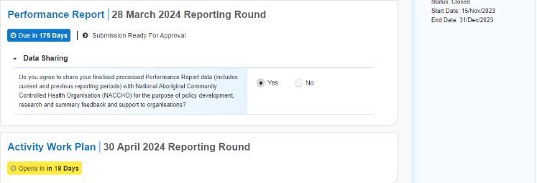
To be eligible for approval, the Performance Report’s status will need to be Submission Ready for Approval.
- To open your IAHP PHC Performance Report form, hover your mouse pointer to the right of the Performance Report reporting round text in the Reporting Dashboard and select .
The IAHP PHC Performance Report form will display.
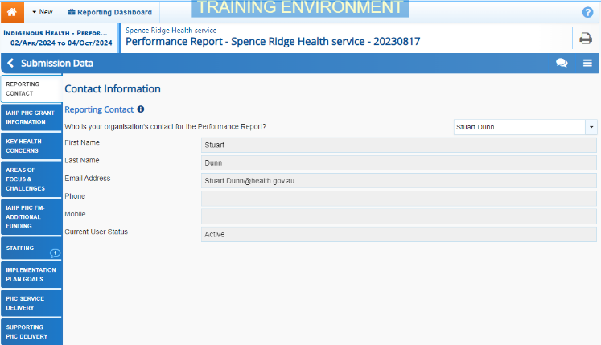
- Review the information in the IAHP PHC Performance Report form, focussing on any sections with a displaying on the corresponding tab, if there are any.
If any sections in the form contain a , you should send your Performance Report back to your Submission Uploader and ask them to address the issue before returning the report to you for approval.
- In the first section of the form displaying a , read the comment that has been left for you in the Notifications Tray.
If the Notifications Tray doesn’t display, select in the top right-hand corner of the form to open it.
- If the comment is just for your information or you’re happy it has been addressed as needed through the information in the section, select at the top of the comment in the Notifications Tray.
- In the Notifications window that displays, select
The comment has now been removed from the form.
- Repeat steps 4 to 7 as needed for each comment that has been left in the form by your Submission Uploader/Reviewer.
If you need to respond to one of the comments that has been left, select in the comment in the Notifications Tray. In the window that displays, select a reason, and enter your response in the Additional Information field and select . Your response has now been added and can be addressed by your Submission Uploader as needed once you send the Performance Report back to them.
- To exit your Performance Report form and return to the Data Portal home screen, scroll to the bottom of the form, and select .
The Data Portal home screen will again display with the Reporting Dashboard open.
- To approve your IAHP PHC Performance Report, select .
The Change Data Asset Status dialog box will display.
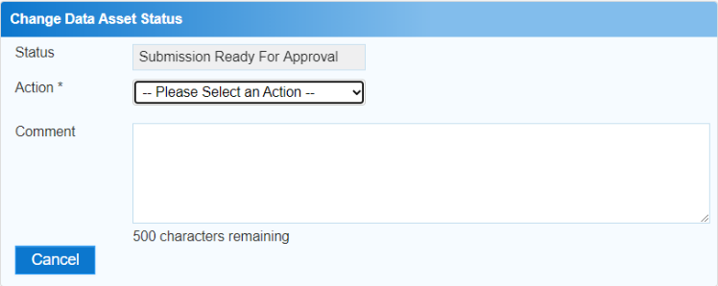
- In the Action field, select and select Approve for Submission.
Approve your IAHP PHC Performance Report (Submission Approver)
If you responded to one of the comments in the form and need to send your Performance Report back to your Submission Uploader so they can address your response, select Revision Required and then select .
- In the Comment field, enter any comments about the action being performed on your Performance Report.
- To approve your IAHP PHC Performance Report and send it for processing by your DSS FAM, select . See the Process an IAHP PHC Performance Report QRG for the next step in the process.
Your IAHP PHC Performance Report has now been approved and sent to your DSS FAM for processing.

