To update and submit your *direct load* nKPI submission in the Data Portal as a *Submission Uploader*:

1. Open the Data Portal through [Health Data Portal](https://dataportal.health.gov.au/).
2. Log in using the information provided in the *Register for and Log in to the Health Data Portal* QRG.

The Data Portal home screen will display with the *Reporting Dashboard* open.

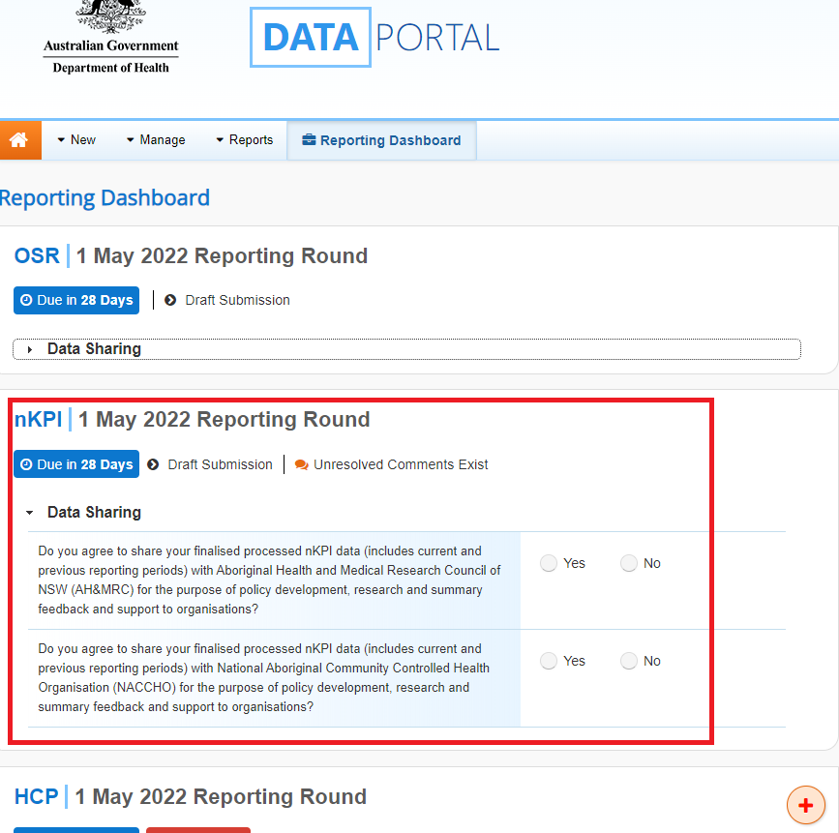

The nKPI submission that has been created as part of the Direct Load transfer from your Clinical Information System (CIS) will display here (*as highlighted in red above*).

 The submission’s status will be *Draft Submission*.

1. To open your nKPI form, hover your mouse pointer to the right of the nKPI reporting round text in the Reporting Dashboard and select Open Submission Form.

 If you need to change the *Title* or *Description* of your nKPI submission or switch it to be a *Trial Submission*, you can do this in the Data Asset Details screen by selecting More optionsNore Details next to Open Submission Form in the *Reporting Dashboard* and then selecting *Open Data Asset.*

The nKPI form will display

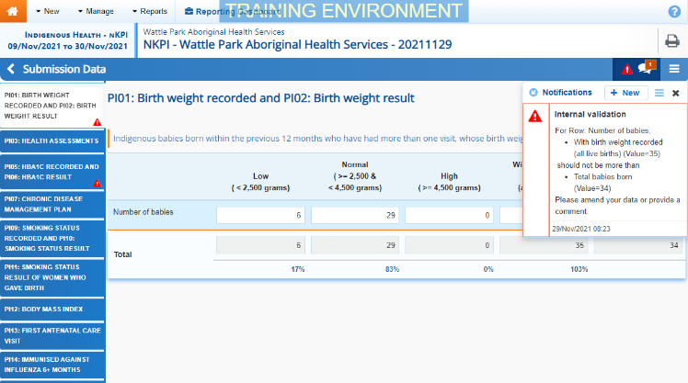

Each section of the nKPI form is displayed on a separate tab on the left-hand side of the form. You will notice that any indicators with data validation issues will display a data validation flag on the applicable tab on the left-hand side of the form for easy identification.

 Only the indicators you report on will display in your nKPI form. For example, if you are a Maternal and Child Health service, you will only see indicators 01 and 02, 03, 11 and 13.

1. On the left-hand side of the form, select the first indicator with data validation issues to be resolved.

The floating *Notifications Tray* will display on the right-hand side of the form, and any data validation flags for the indicator will display here. To “dock” the tray at the bottom of the indicator, underneath the cells, select Dock/undock Comments dialog.

 If the *Notifications Tray* doesn’t display, select Open Notification tray - some comments require action or Open Notification tray - some comments require action in the blue *Submission Data* bar at the top of the form to open it so you can address the data validation issues/read the comments that display.

1. Read the data validation flags displayed in the Notifications Tray to determine whether any values in the indicator are incorrect and need to be amended, or if the values referred to are correct in your view but require further explanation.

**If values need to be amended:**

* 1. Update the incorrect value(s) in the required cell(s) to address the applicable data validation flag(s).

 If you are unsure which value(s) needs to be amended, hover your mouse pointer to the right of the applicable data validation flag title in the *Notifications Tray*, select the Eye button and the applicable cell(s) will be highlighted in red.

* 1. To save the amendment and run data validation again, select Save at the bottom of the form.

The data validation flag relating to the data value(s) you have just amended should now have disappeared from the *Notifications Tray*.

* 1. If the data validation flag hasn’t disappeared, repeat the process of making amendments to the data and selecting Save until this occurs.

 If you wish to add a comment for your colleagues explaining the changes you have made to the data values, select Create New Comment at the top of the *Notifications Tray* and add the details.

**If explanatory comments are to be added to the data:**

* 1. In the **Notifications Tray**, hover your mouse pointer to the right of the data validation flag title and select the Respond button.
  2. Select the Down Arrow in the **Reason** field that displays and select the reason you are adding a comment from the drop-down list.
  3. Enter your comment in the **Additional Informatio**n field.
  4. To save the comment, select the Save button.
  5. Repeat this process for any other value(s) in the indicator that need to be explained.

 The data validation flag on the tab on the left-hand side of the form will change to a speech bubble if all data validation flags on the indicator have been responded to. This shows that you have responded as required to the data validation flags on the indicator, and you can now submit your nKPI report to the AIHW if there are no flags to be actioned on any other indicators.

The comment(s) has been added and can be viewed by anyone accessing the report in the Data Portal.

* 1. To save the changes made to the indicator, select Save at the bottom of the form if needed.

1. Repeat the above steps for all indicators in the form displaying a data validation flag.
2. Once all data validation issues in the nKPI form have been addressed, to exit the form and return to the Data Portal home screen, scroll to the bottom of the form and select Close.

The Data Portal home screen will again display with the *Reporting Dashboard* open.

1. Before progressing the nKPI submission through the submission workflow, answer either **Yes** or **No** to the data sharing consent questions that display under **Data Sharing**.
2. To save the changes, select Save.
3. To progress the nKPI submission through the workflow, select the Draft Submission link in the nKPI section of the Reporting Dashboard.

The Change Data Asset Status dialog box will display, informing you that your draft submission cannot be removed.

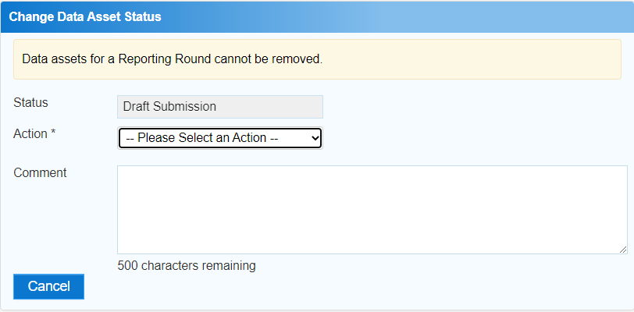

1. In the **Action** field, select the down arrow and select the appropriate action.

The available actions are:

* **Request Review** – Select this action to send your nKPI submission to the *Submission Reviewer* within your health service for review prior to it being submitted for approval.
* **Request Approval** – Select this action to send your nKPI submission directly to your CEO or their representative for approval.
* **Request Interim Processing –** If you are a *Submission Reviewer* as well as a *Submission* *Uploader*, you can select this action to send your nKPI submission to the AIHW for review prior to it going to your CEO or their representative for approval. This process is known as *Interim Processing*.

 If you can approve nKPI submissions yourself, you will also see the *Approve for Submission* option in the list. This allows you to approve the submission and submit it directly to the AIHW for processing.

1. In the **Comment** field, enter any comments about the action being performed on the submission, if needed.
2. One of the following buttons can now be selected when submitting your nKPI report, depending on the action you have selected in the **Action** field:
   1. To send your nKPI report for internal review, select the Request Review button. See the *Review your nKPI Submission* QRG for the next step in the process.
   2. To submit your nKPI report directly for approval to your CEO or their representative, select the Request Approval. See the *Approve your nKPI Submission* QRG for the next step in the process.

Your *direct load* nKPI submission has now been updated and sent to either your *Submission Reviewer* for review or your CEO or their representative for approval.

An automated email will be sent to all users within your health service that have been assigned the applicable role in the Data Portal (*Submission Reviewer* or *Submission Approver*) notifying them the nKPI report has been submitted to them for action.

 For a more detailed description of how to submit an nKPI direct load submission in the Data Portal, see *Submit your nKPI Report (Direct Load)* in the *nKPI Reporting in the Health Data Portal* user guide in the *User Support* section of the Data Portal.

Refresh your nKPI Submission

If there have been updates made to your data for the current data collection period in your Clinical Information System (CIS) (or perhaps an error in the CIS has been fixed) you can transfer the data across to the Data Portal again, and the values in your existing nKPI submission in the Data Portal for the matching/current reporting round will be updated to reflect the new values.

The updated submission can then be progressed through the submission workflow as normal.

 For this refresh process to be possible, your nKPI submission in the Data Portal needs to be “with” you as the *Submission Uploader*. That is, it needs to be at one of the following statuses: *Draft Submission*, *Submission Revision Required* or *Submission Returned to Uploader*.

 If you need to complete the Direct Load process again to update your data in the Data Portal, **DO NOT** try to remove the submission, just follow the process above.