**Submit your IAHP PHC Performance Report**

To submit your IAHP PHC Performance Report through the Data Portal:

1. Open the Data Portal through [Health Data Portal](https://dataportal.health.gov.au/).
2. Log in using the information provided in the *Register for and Log in to the Health Data Portal* QRG.

The Data Portal home screen will display with the *Reporting Dashboard* open.

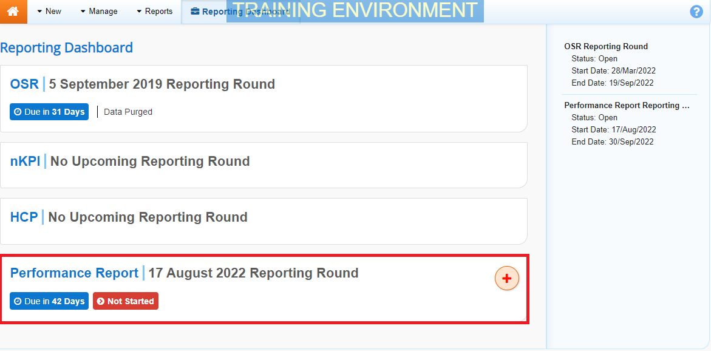

1. To commence the creation of your IAHPPHC Performance Report, select Start Submission to the right of the Performance Report reporting round text in the **Reporting Dashboard** (*as highlighted above in red*).

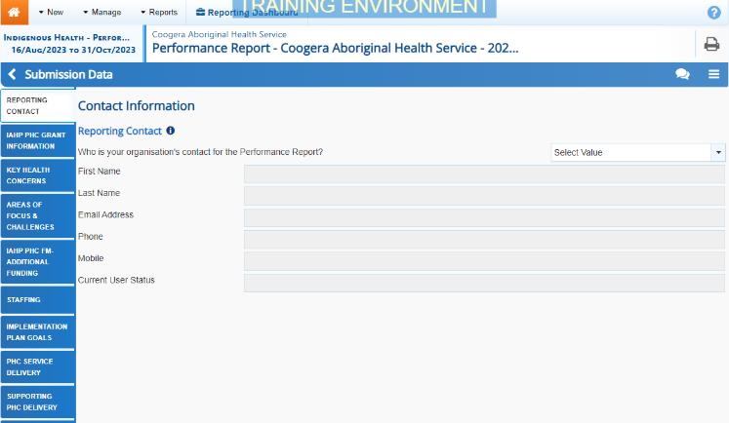

1. You can now start entering your IAHP PHC Performance Report information into the first section (*Reporting Contact – Contact Information*) of the form as needed.

Some tips for completing the IAHP PHC Performance Report in the Data Portal are:

* Enter data for each section of the form by selecting the applicable tab on the left-hand side of the form.
* If your health service doesn’t report on an element of the *Performance Report*, simply select the **Not Applicable** option.
* You can enter 15000 characters (around 800 words) in each cell in the form so you should be able to fit all the information you need.
* If you have any documentation you wish to add to your IAHP PHC Performance Report, you can upload the additional information as an attachment. For more information, see the *Attach a Supporting Document to your Performance Report* QRG.
* The *Implementation Plan Goals* tab will pre-populate with the applicable targets and results from the *nKPI targets* tab of your most recent nKPI forms. If your latest results for the applicable indicators have not met your targets, you will need to enter reasons here as to why. If any of your results or targets are missing, you will be asked to explain why. If you don’t report on the nKPis, simply state as such in the text box that displays.
* You can add comments for your colleagues on any section of the form by selecting Create New Comment at the top of the *Notifications Tray*, adding in the comment or question for your colleagues and then selecting *Save*.

1. Once the required data has been entered for the first section, select Save at the bottom of the form.

The simple completeness data validations will now run on the cells you have completed in the first section of the form, and if any of the cells have been left blank, a data validation flag will appear in the *Notifications Tray*.

1. If a data validation flag has been generated, you can either respond to the message in the **Notifications Tray** explaining why the cell has been left blank or you can complete the empty cell.

 To open the *Notifications Tray* if it doesn’t display,select Open notifications tray - Some comments require action in the blue *Submission Data* bar at the top of the form.

**If the cell needs to be completed:**

* 1. Enter the required data in the applicable cell.

 If you are unsure which cell has been left blank, in the *Notifications Tray*, hover your mouse pointer to the right of the data validation flag title, select the Eye button and the applicable cells will be highlighted in red.

* 1. To save the amendment and run data validation again, select Save at the bottom of the form.

The data validation flag relating to the cell you have just completed should now have disappeared from the *Notifications Tray*.

**If the cell is to be left empty:**

1. In the **Notifications Tray**, hover your mouse pointer to the right of the data validation flag title, and select the Respond button.
2. Select the down arrow in the **Reason** field that displays and select *Other (specify)*.
3. Enter a comment in the **Additional Informatio**n field, explaining that you don’t provide the service relating to the cell/option you have left blank.
4. To save the comment, select the Save button.
5. Repeat this process for any other blank cells on the tab that need to be explained.

The comment(s) has been added and can be viewed by anyone accessing the submission in the Data Portal.

1. Repeat the above steps for each section of the form as required.
2. Once you have finished entering your data into the different sections of the form and have saved the data, select Close at the bottom of the form.

The Data Portal home screen will again display with the Reporting Dashboard open.

1. Before progressing the submission through the submission workflow, answer either **Yes** or **No** to the data sharing consentquestions that display under **Data Sharing** and then select Save.

**Submit your IAHP PHC Performance Report**

 If needed, you can attach supporting documentation to your IAHP PHC Performance Report before sending it to your DSS FAM. For more information, see the *Attach a Supporting Document to your Performance Report* QRG.

1. To progress the IAHP PHC Performance Report through the submission workflow, select the Draft Submission link.

The Change Data Asset Status dialog box will display.

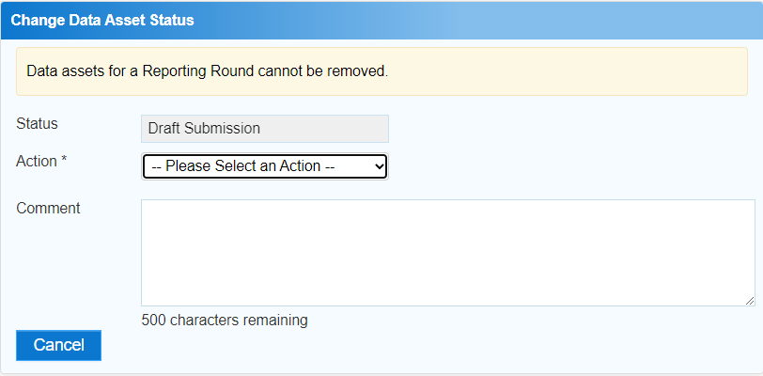

1. In the **Action** field, select the down arrow and select the appropriate action.

The available actions are:

* **Request Review** – Select this action to send the Performance Report to someone within your health service for review prior to it being submitted for approval.
* **Request Approval** – Select this action to send the Performance Report to your CEO or their representative for internal approval.
* **Request Interim Processing –** If you are a *Submission* *Reviewer* as well as a *Submission* *Uploader*, you can select this action to send the submission to your DSS FAM for review prior to it going to your CEO or their representative for approval. This process is known as *Interim Processing*.

 If you can approve the Performance Report yourself, you will also see the *Approve for Submission* option in the *Action* list. This allows you to approve the submission and submit it directly to your DSS FAM for processing.

1. In the **Comment** field, enter any comments regarding the action being performed on the submission.
2. One of the following buttons can now be selected when submitting the report, depending on the action you have selected:

**Submit your IAHP PHC Performance Report**

* 1. To send the submission for internal review, select the Request Review button. See the *Review an IAHP PHC Performance Report* QRG for the next step in the process.
  2. To submit the report directly for approval to your CEO or their representative, select the Request Approval. See the *Approve an IAHP PHC Performance Report* QRG for the next step in the process.

The Performance Report has now been created and submitted to either the internal *Submission Reviewer* for review or your CEO or their representative for approval.

An automated email will be sent to all staff within your health service that have been assigned the applicable role in the Data Portal (*Submission Reviewer* or *Submission Approver*) notifying them the report has been sent to them for action.

 For a more detailed description of how to submit your IAHP PHC Performance Report in the Data Portal, see *Submit an IAHP PHC Performance Report* in the *IAHP PHC Performance Report Reporting in the Health Data Portal* user guide on the *User Support* page of the Data Portal.