At any stage during the submission of an IAHP PHC Activity Work Plan (AWP) through the Data Portal, you can save a PDF version of your form, so you can file it or share it with colleagues as needed:
Save your IAHP PHC Activity Work Plan as a PDF
- Open the Data Portal through Health Data Portal.
- Log in using the information provided in the Register for and Log in to the Health Data Portal QRG.
The Data Portal home screen will display.
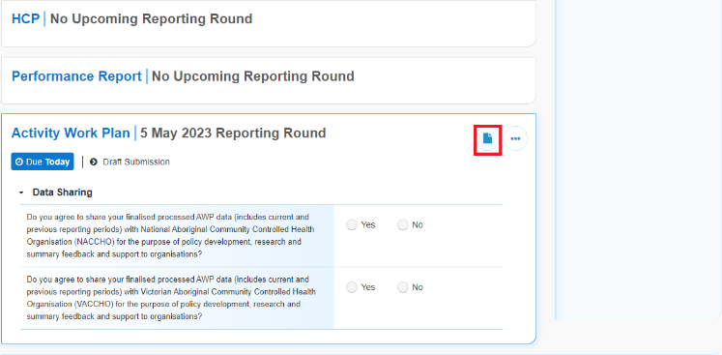
- To open the AWP form, hover your mouse pointer to the right of the Activity Work Plan reporting round text in the Reporting Dashboard and select .
The IAHP PHC Activity Work Plan form will open.
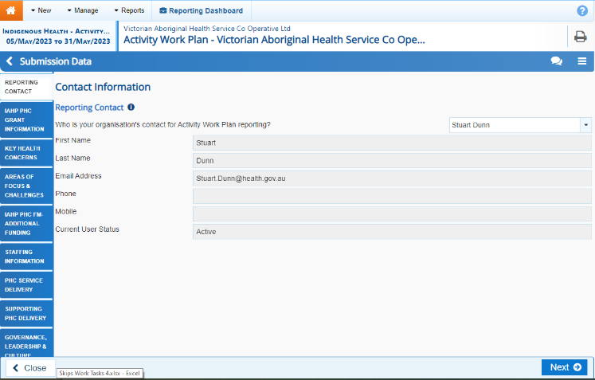
- To open all sections of the form in the one screen, select in the blue Submission Data bar in the top right-hand corner of the form and select Summary View.

The IAHP PHC AWP will now open in summary view, in read-only mode.
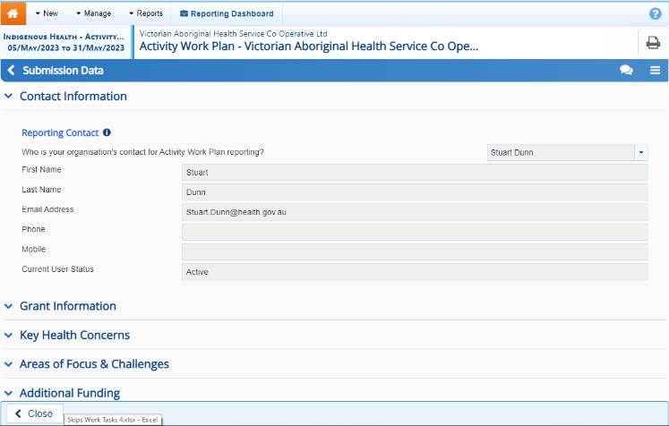
- Expand all the sections of the form by selecting again and then Expand all tabs.
If you want any comments in the form to be included in the PDF, please select to display the Notifications Tray containing any comments.
- Once all sections of the form have been expanded, select .
The Print dialog box will display.
- Ensure Save as PDF is showing in the destination field.
A preview of your PDF will display on the left-hand side of the Print dialog, showing the contents of your form, including any comments that have been added.
To print the form, select your printer in the Destination field and then select Print.
- To save the PDF, select .
- Navigate to where you would like to save the form, rename the form as needed, and then select .
Your PDF will now be saved to the selected destination and can be shared as needed.

