To review your OSR submission after it has been amended by your Submission Uploader at the request of the AIHW:
Review your OSR Submission based on AIHW Feedback (Submission Reviewer)
- Open the Data Portal through Health Data Portal.
- Log in using the information provided in the Register for and Log in to the Health Data Portal QRG.
The Data Portal home screen will display with the Reporting Dashboard open.
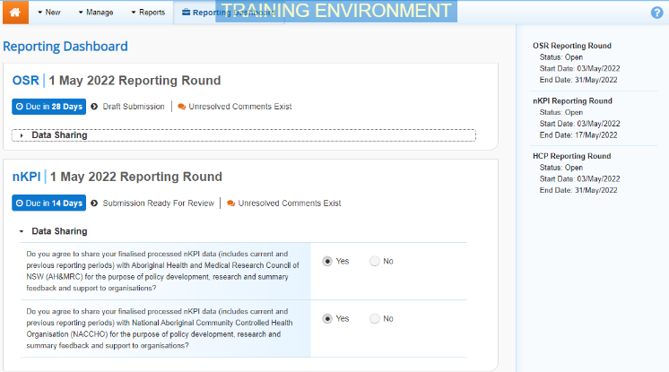
To be eligible for review, your OSR submission’s status will need to be Submission Ready for Review.
- To open your OSR form, hover your mouse pointer to the right of the OSR reporting round text in the Reporting Dashboard and select .
The OSR form will display.
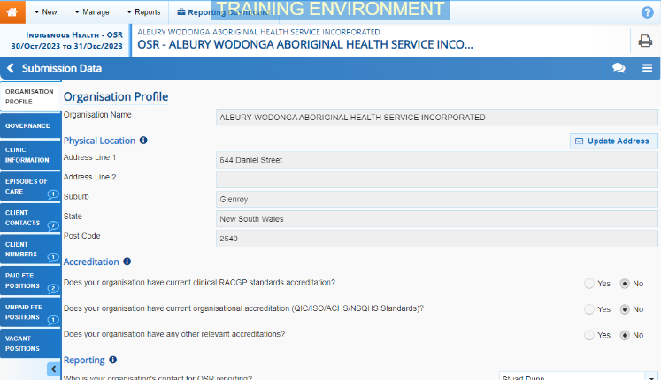
If your Submission Uploader responded to an AIHW comment in a particular section of the form rather than amending the values as requested, a will display on the corresponding tab.
- Review the data in each section of your OSR, focussing where applicable on any comments left by the AIHW and your Submission Uploader.
- If needed, update any values in the required cells.
- To save your changes, select at the bottom of the form.
If you have made changes to any values and would like to add a comment explaining this, select at the top of the Notifications Tray, select a Reason, add your comment in the Additional Information field and then select .
- To exit your OSR form and return to the Data Portal home screen, scroll to the bottom of the form, and select .
The Data Portal home screen will again display with the Reporting Dashboard open.
- To progress your OSR submission through the submission workflow, select .
- In the Change Data Asset Status dialog box, in the Action field, select and select the required action.
The available actions are:
- Request Approval – Select this action to send your OSR submission to your CEO or their representative for approval.
- Approve for Submission – Select this action if you are the health service’s CEO, or nominated representative, and are approving the submission as well as reviewing it.
- Request Interim Processing – Select this action to send your OSR submission to the AIHW for review prior to it going to your CEO or their representative for approval. This process is known as Interim Processing.
- Revision Required – Select this action to return your OSR submission back to your Submission Uploader for further amendment.
- In the Comment field, enter any comments regarding the action being performed on your nKPI submission.
- One of the following buttons can now be selected when submitting your OSR, depending on the action you have selected:
  - To send your OSR submission to your CEO or their representative for approval again, select . See the Approve your OSR Submission based on AIHW Feedback QRG for the next step in the process.
Review your OSR Submission based on AIHW Feedback (Submission Reviewer)
  - To approve your submission and send it directly to the AIHW for processing, select . See the Process an OSR Submission QRG for the next step in the process.
  - To send your submission to the AIHW for initial review prior to sending it to your CEO or their representative for approval, select . See the Interim Processing of an OSR Submission QRG for the next step in the process.
  - To send your submission back to your Submission Uploader for amendment, select . See the Amend an OSR Submission based on AIHW Feedback (Submission Uploader) QRG for the next step in the process.
Your OSR submission has now been reviewed and either sent for re-approval or sent back to your Submission Uploader for further revision as required.

