To amend your HCP submission in the Data Portal as a Submission Uploader, once it has been returned to returned by the AIHW:
Amend your HCP Submission based on Health Feedback (Submission Uploader)
- Open the Data Portal through Health Data Portal.
- Log in using the information provided in the Register for and Log in to the Health Data Portal QRG.
The Data Portal home screen will display with the Reporting Dashboard open.
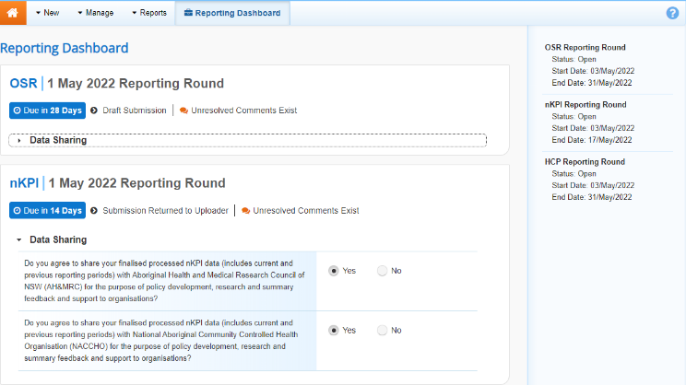
- To open your HCP form, hover your mouse pointer to the right of the HCP reporting round text in the Reporting Dashboard and select .
The HCP form will display.
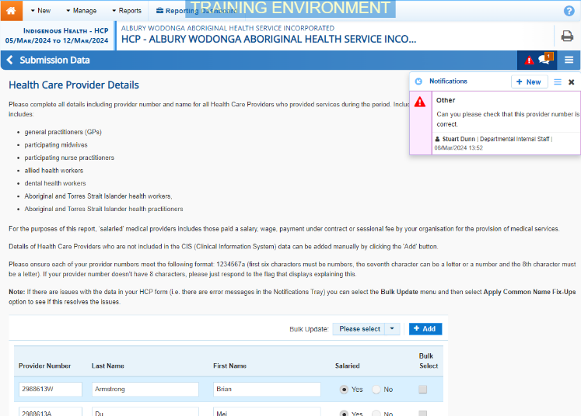
Any FNHD Health Data Portal team comments that need responding to will display in the Notifications Tray in the top right-hand corner of the form.
- For each data validation flag, review the comments made by the Health Data Portal team in the Notifications Tray.
If you are unsure which cell the comment refers to, select for the applicable data validation flag and the applicable cell(s) will be highlighted in red.
- If a value needs to be changed to address the comment, update the value(s) in the required cell(s).
- To respond to a comment made by the FNHD Health Data Portal team, in the Notifications Tray, select .
- Enter your comment in the Additional Information field.
- To save the comment, select .
- Repeat the process for each FNHD Health Data Portal team comment in the form.
- To exit your HCP form and return to the Data Portal home screen, scroll to the bottom of the form, and select .
The Data Portal home screen will again display with the Reporting Dashboard open.
- To progress the submission, select .
- In the Change Data Asset Status dialog box, select the in the Action field and select the action needed.
The available actions are:
- Request Review – Select this action to send your HCP submission to your Submission Reviewer for review again.
- Request Approval – Select this action to send your HCP submission back to your CEO or their representative for approval.
If you can approve the HCP submission yourself, you will also see the Approve for Submission option in the action list. This allows you to approve the submission and submit it directly to Health and Aged Care for processing again.
- In the Comment field, enter any comments about the action being performed on the submission.
- One of the following buttons can now be selected when submitting your HCP report, depending on the action you have selected:
  - To send your HCP submission to the Submission Reviewer for review again, select . See the Review your HCP Submission based on Health Feedback (Submission Reviewer) QRG for the next step in the process.
  - To send the submission back to your CEO or their representative for approval, select .See the Approve your HCP Submission based on Health Feedback (Submission Approver) QRG for the next step in the process.
Amend your HCP Submission based on Health Feedback (Submission Uploader)
Your HCP submission has now been amended and either sent back to your Submission Reviewer for further review or sent straight on to your CEO or their representative for approval.
An automated email will be sent to all staff within your health service that have been assigned the applicable role in the Data Portal (Submission Reviewer or Submission Approver) notifying them the HCP report has been submitted to them again for action.

