Best Practice Security Token Tip Sheet
Health services using the Clinical Information System (CIS) Best Practice will need to add Security Token information for the Health Data Portal into Best Practice, to link it to the Data Portal for Indigenous health data reporting purposes.
A Security Token is a device that is used in order to obtain access to an electronic or digital system. The Security Token is used in addition to your password and can be thought of like an electronic key. The Security Token will connect Best Practice to the Data Portal.
This Security Token information was issued to your practice by the Department of Health and Aged Care when you registered for nKPI reporting.
If you upgrade to a new version of Best Practice or need to re-enter your security token information for any other reason, please email indigenousreporting@health.gov.au and the Health Data Portal team will send you your security token.

To prepare for entering Portal Security Token information into Best Practice:
- Ensure you are running Best Practice Premier edition Indigo or later so you can use the nKPI Report Utility.
- To see which version of Best Practice Premier you are running:
  - Select Help.
  - Select About from the main menu.
  - Check the Version field. The most recent version prior to Indigo was Lava Edition Service Pack 3.
To download and install Indigo, visit Best Practice, select Resources > Bp Premier Downloads from the menu at the top of the screen and then select the applicable download.

- Once you have downloaded and installed the latest release of Bp Premier, you can install the Reporting Tool at: Bp Premier Reporting Tool.

To enter Portal Security Token information into Best Practice:
- Ensure you are at Step 2 Login of the Reporting Utility Set-up process in Best Practice.
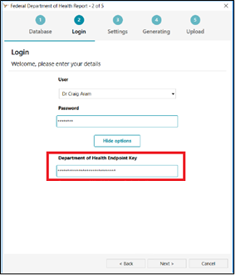
- If it is your first time running the reporting tool, in the Department of Health Endpoint Key field, enter the Security Token details that were issued to your practice. You do not need to enter any information into the Department of Health and Aged Care Legacy Endpoint Key field.
If you need to change a previously entered token, simply use the More Options button to show the Endpoint Key fields again.

You have now successfully connected Best Practice to the Data Portal by entering in the Security Token information provided.

